A new interpretation of the core
principles of quantum mechanics

– Reinterpretation of quantum computers' 'quantum entanglement' as the complementary wave nature of quantum mechanics
– AVS Quantum Science paper lays the foundation for the realization of future quantum information and communication technology

▲ School of Electrical Engineering and Computer Science Professor
Byoung S. Ham (Director of the Center for Photon Information Processing)

GIST (Gwangju Institute of Science and Technology, President Kiseon Kim) School of Electrical Engineering and Computer Science Professor Byoung S. Ham (Director of the Center for Photon Information Processing), a scholar in the field of quantum memory, presented a new interpretation of the origin of non-local quantum correlation* in quantum entanglement pair**, one of the core principles of quantum mechanics, in a paper published in an international journal.

* non-local quantum correlation: a key principle in quantum mechanics that quantum correlation is maintained even at non-relativistic distances that violate local physical laws and often called the EPR paradox

** quantum entangled pair: a pair entangled with two or more qubits (photons, atoms, superconductors, ions, etc.) as a key resource in quantum mechanics such as quantum computing, quantum cryptography, and quantum sensing

Non-local quantum correlation has been fully demonstrated experimentally over the past half century. The limitation of existing quantum field was that the principle of generating a single photon pair itself was veiled, so the quantum correlation based on it could not be fully understood.

Professor Ham laid the academic foundation about quantum entanglement in the field of quantum mechanics that is difficult to understand intuitively because phase information cannot be confirmed with existing complementary particle nature* but with wave analysis with phase information, entangled photon pairs** can be easily understood as well as materially implemented.

* complementary particle nature: When analyzing microscopic particles such as light, atoms, and electrons in quantum mechanics, the interpretation that the position of electrons is not determined with time but is distributed by a stochastic wave function.

** entangled photon pair: In the wavefunction product in which two particles are combined, the product has a quantum correlation that cannot be separated into its original state.

The quantum mystery, which was veiled in understanding entanglement pairs, which are key principles in existing quantum information research, is now necessary to understand it conclusively as in classical information.

According to the current quantum-mechanical interpretation of quantum entanglement pairs, it is not possible to definitively create an entangled qubit* pair at a desired time, and there have been serious limitations in the scalability of the qubit, which is a material unit of information in quantum information. In other words, to process information with just one execution, as in classical information, it is necessary to change the primitive and probabilistic quantum information base to a deterministic one.

* entanglement qubit: One of the main characteristics of quantum computers is quantum entanglement. Quantum entanglement refers to a phenomenon in which two or more qubits are correlated as if one were one, enabling remote transmission, quantum communication, quantum computing, or quantum sensing.

** qubit: A quantum information unit that corresponds to a bit in classical computing. Unlike bits in which one qubit is expressed only as 0 or 1, 0 and 1 are overlapped, so infinite cases including 0 and 1 can be expressed.

In addition, existing theories based on complementary particulate nature have shown that inter-qubit phase control is virtually impossible, so it has been helpless against the inevitable accelerated loss of coherence* among multiple qubits.

* accelerated loss of coherence: For individual qubits, coherence gradually disappears over time due to an inevitable interaction with the surrounding environment. For entangled qubits in which two or more qubits are combined, this loss of coherence is exponentially accelerated by the number of qubits, which is an essential phenomenon in nature.

Unlike the mainstream analysis of the existing quantum science world, Professor Ham interprets the quantum base pair in a wave-like manner and identifies the principle that can be used to definitively implement quantum entanglement using a general laser. As a concrete implementation method, 'Franson-type nonlocal quantum correlation' based on classical coherence was presented, thus laying the new foundation for the macro-quantum worldview.

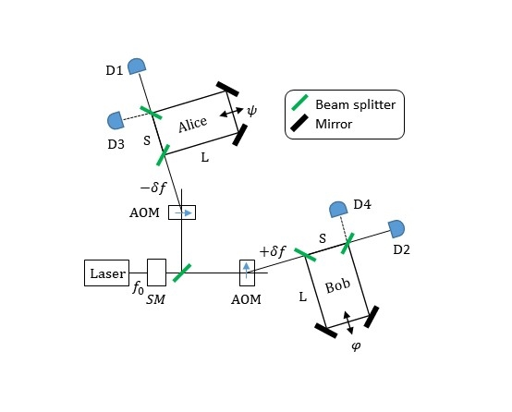
▲ Non-local quantum correlation scheme based on light: macroscopic quantum entanglement light pair generation

Professor Byoung S. Ham said, "Based on the wave interpretation of light, our understanding of the generation of single photon pairs was clarified, and the origin of the non-local quantum correlation of entangled photon pairs was revealed. The results of this study will clarify the understanding of non-local quantum correlation and ultimately lay the foundation for future quantum information and communication technologies compatible with current optical devices and optical communication technologies."

This study was conducted with the support of the ITRC Quantum Internet project of the Ministry of Science and ICT and was published in the AVS Quantum Science online edition (April 1, 2022).



