Development of a color sensor platform that quickly and accurately diagnoses COVID-19

– Rapid detection without gene amplification process and immune markers... Possible to diagnose a patient's infection status in real time through color analysis

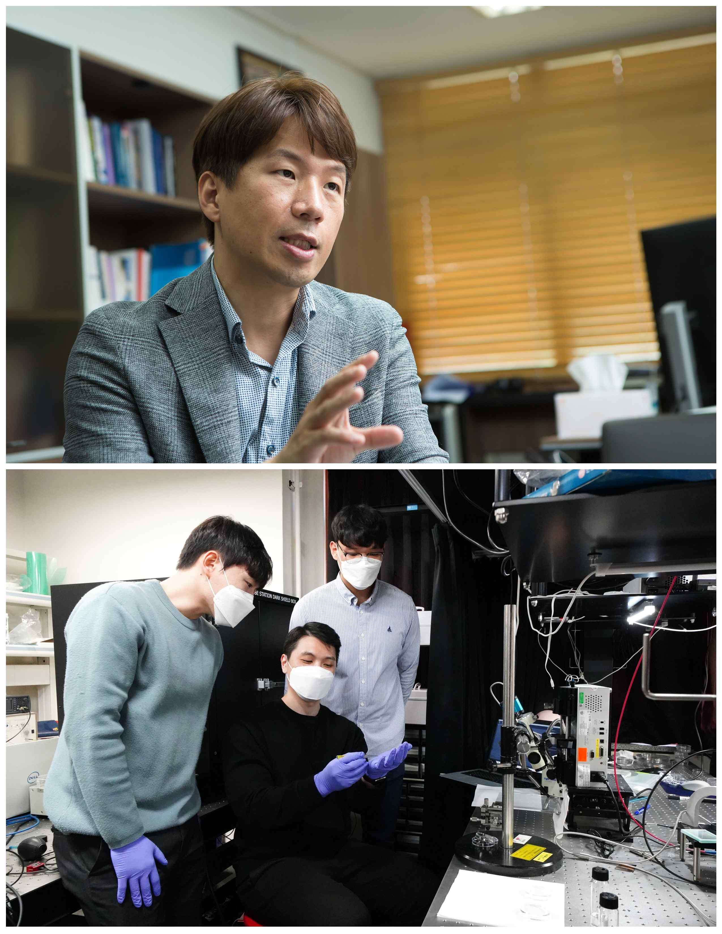
▲ Professor Young Min Song's joint research team: (top) Professor Young Min Song (bottom from left) Ph.D. student Joo Hwan Ko, post-doctoral researcher Young Jin Yoo, and master's student Jiwon Kang

Korean researchers have developed a biosensor platform that can quickly detect virus infection through color changes and predict infection levels through color analysis. It is expected as a next-generation virus detection and analysis platform that can complement the complexity of PCR tests and the low accuracy of rapid diagnostic kits.

GIST (Gwangju Institute of Science and Technology, President Kiseon Kim) School of Electrical Engineering and Computer Science Professor Young Min Song and Seoul National University Professor Dae-Hyeong Kim announced that they have developed a bio-color sensor platform that can quickly and accurately observe and analyze viruses.

This biosensor platform can identify the patient's infection level by concentration through color analysis of a microscope image, allowing medical staff to more accurately identify the infection status. In addition, since it has a simple structure, it can be manufactured in the form of a kit, and color changes can be intuitively identified, so that general users can easily check whether or not they are infected.

Existing rapid virus detection methods without gene amplification and labeling* attachment detect viruses by changes in electrochemical signals when they are attached, but they have the disadvantage of requiring complex electrode structures and separate analysis equipment.

* labelling: Immunoassay-based sensors are divided into labeled and label-free techniques. The dual labeling-based immunosensor is a technique that causes an immunochemical reaction by attaching a specific biomolecule to the surface of a medium so that it can react with a target antigen.

Optical methods such as the plasmonic* effect, which are relatively intuitive methods, are difficult to fabricate due to their complex nanostructures. Because the optical change is subtle, a separate optical analysis equipment is required for accurate detection.

* plasmonic: A plasmon refers to a similar particle in which free electrons in a metal vibrate collectively and refers to a structure that generates a strong resonance by locally generating a greatly increased electric field.

Recently, a simple film-type optical structure has been developed to overcome this fabrication method and complexity. Because most of them were implemented using materials with a high refractive index, it was difficult to detect bio-particles such as viruses that have a low refractive index.

The Gires-Tournois* resonance structure for virus detection developed by the research team freely modulated its optical properties by inserting a porous complex refractive index layer between the low refractive index layer and the metallic reflective layer. As a result, a single absorption with a slow light effect** was achieved in the low refractive index layer.

* Gires-Tournois resonator: An optical structure in which the front resonator partially reflects while the back resonant exhibits high reflectivity and produces a specific wavelength reflection and narrow color dispersion spectrum.

** Slow light effect: The effect of slowing light by induced very low group velocities of light waves under the influence of the very narrow spectral resonant properties of the medium.

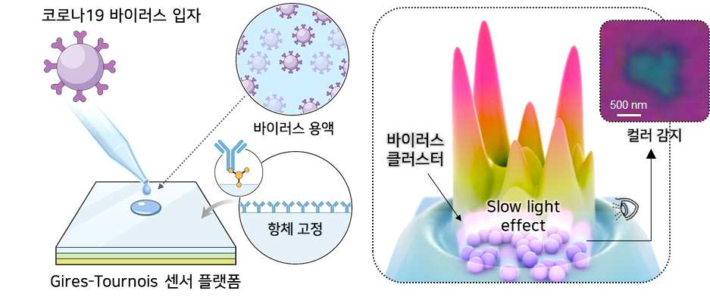
▲ Gires-Tournois sensor platform capable of color detection of COVID-19 virus particles

This technology intuitively detected a very low concentration (100 pg/ml) of virus without gene amplification and labeling by antigen-antibody reaction through simple surface treatment for antibody immobilization. In addition, they succeeded in deriving the distribution and density of virus particles within the detection area through chromaticity analysis through microscope scanning, realizing a biosensor platform capable of quantitative analysis.

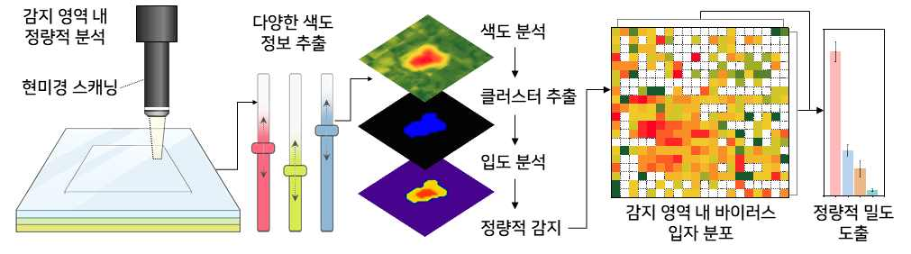
▲ Quantitative density derived from chromaticity analysis through microscope scanning of the detection area

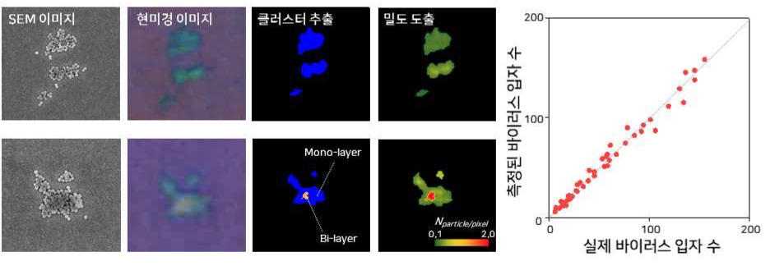
▲ Comparison of the number of virus particles measured by quantitative analysis and the number of actual virus particles

GIST Professor Young Min Song said, "This study is the first case in which viruses can be observed by color change. Medical staff can find out the exact concentration of the virus very quickly through microscopic observation and color analysis, making it possible to simultaneously detect various viruses and harmful factors. Sooner or later, the public will be able to identify the virus with the naked eye."

This research is a nano and material technology development project promoted by the Ministry of Science and ICT and the National Research Foundation of Korea with support from the Future Materials Discovery Business, Basic Research Laboratory Project, Support Project for the Next Generation of Academics, Sejong Science Fellowship, GIST GRI, and the Institute for Basic Science and was published online on March 26 in the international scientific journal Advanced Materials (IF: 30.849).



