Development of a compact spectrometer
that can be mass-produced

– Realization of high resolution with a small number of filters... Reduced cost by mass production of filter arrays through wafer deposition process


▲ From left: Professor Heung-No Lee and researcher Cheolsun Kim

A Korean research team has developed a technology that can increase the resolution of a spectrometer and mass-produce it, which can be used for self-diagnosis of skin conditions and real-time substance detection.

GIST (Gwangju Institute of Science and Technology, President Kiseon Kim) School of Electrical Engineering and Computer Science Professor Heung-No Lee's research team developed a high-resolution compact spectrometer that operates in a wide wavelength range of visible/ultra-near infrared rays by supplementing the low-resolution problem of the existing filter array-type spectrometer with mathematical calculation technology.

A spectrometer is a device that measures the intensity of light according to wavelength, and it can analyze the characteristics of light that passes through a material or is reflected, so it is used in various research and industrial fields. However, due to its high price and large size, there are limits to its practical use.

The research team designed/manufactured a single optical filter to detect light in multiple wavelength ranges, unlike the bandpass type optical filter, which is designed to transmit only light in a specific wavelength range. 36 of these filters were made in the form of an array, and, by attaching the array on a CMOS image sensor, it succeeded in measuring the light intensity in the wavelength band of 500 – 850 nm.

The 36 light intensities measured through the CMOS image sensor were reconstructed into 350 spectral information in the wavelength range of 500 – 850 nm using mathematical optimization techniques. The spectral performance of various light sources such as monochromatic light, LED light source, and halogen light source was verified through optical experiments.

The spectrometer manufactured by the research team is small and light, so it can be used as a portable spectrometer for skin self-diagnosis and real-time material detection. In addition, because it is possible to mass-produce filter arrays through the wafer deposition process, it is expected that high-performance compact spectrometers can be manufactured at a low price.

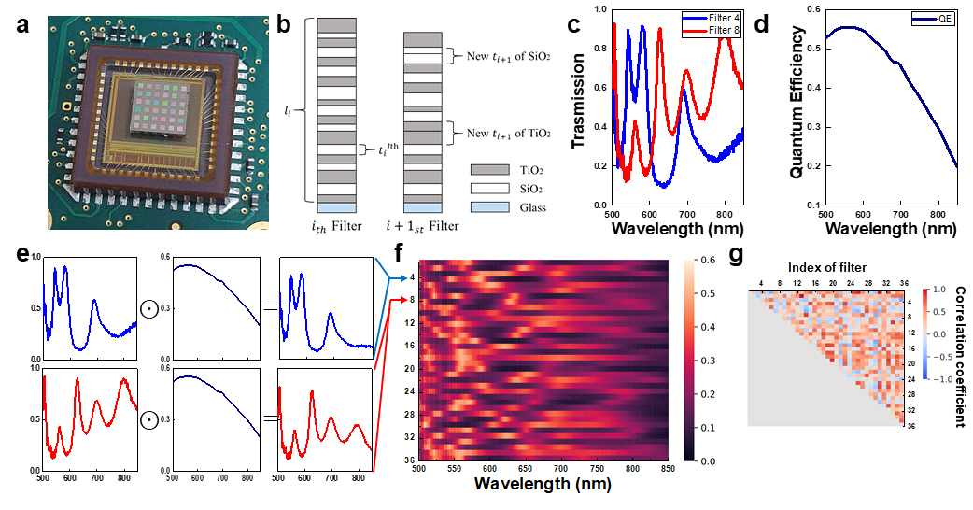
▲ Filter array-based computational spectroscopy: (a) photograph of the filter array attached to the CMOS image sensor. (b) filter array design, (c) filter transmission characteristics, (d) CMOS image sensor quantum efficiency. (e) spectral sensitivity of filter and CMOS image sensor, (f) heat map of 36 spectral sensitivities, (g) triangle matrix of correlation coefficients between spectral sensitivity

The conventional method of fabricating a filter array for a computational spectrometer has difficulty in producing a uniform filter array. Using a stencil lithography technique using a shadow mask, it was possible to uniformly mass-produce 36 arrays.

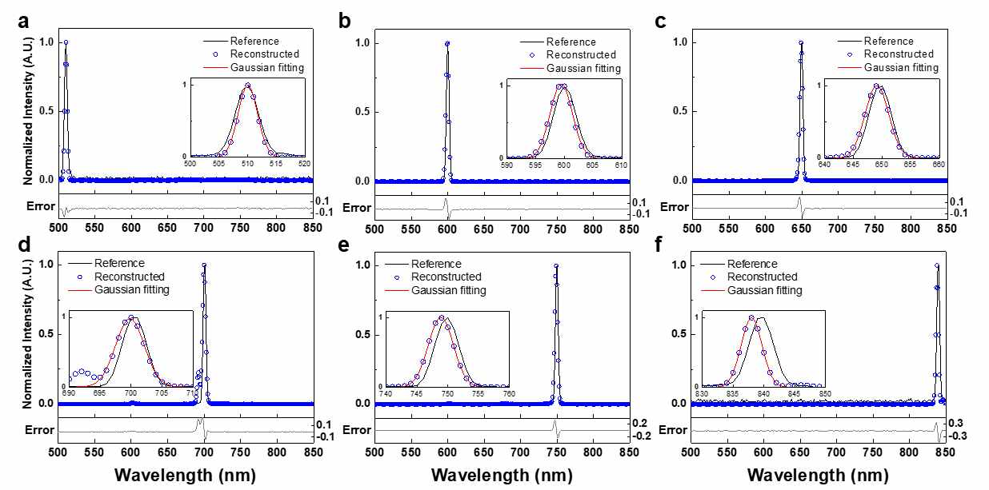
▲ Monochromatic light source recovery test results: (a) 510 nm, (b) 600 nm, (c) 650 nm, (d) 700 nm, (e) 750 nm, (d) 840 nm

Professor Heung-No Lee said, "Through this research, we succeeded in making a computational spectrometer that can be mass-produced. We want to make a module that can be mounted on a mobile phone like a camera with the goal of attracting investment for technology commercialization and exporting it around the world."

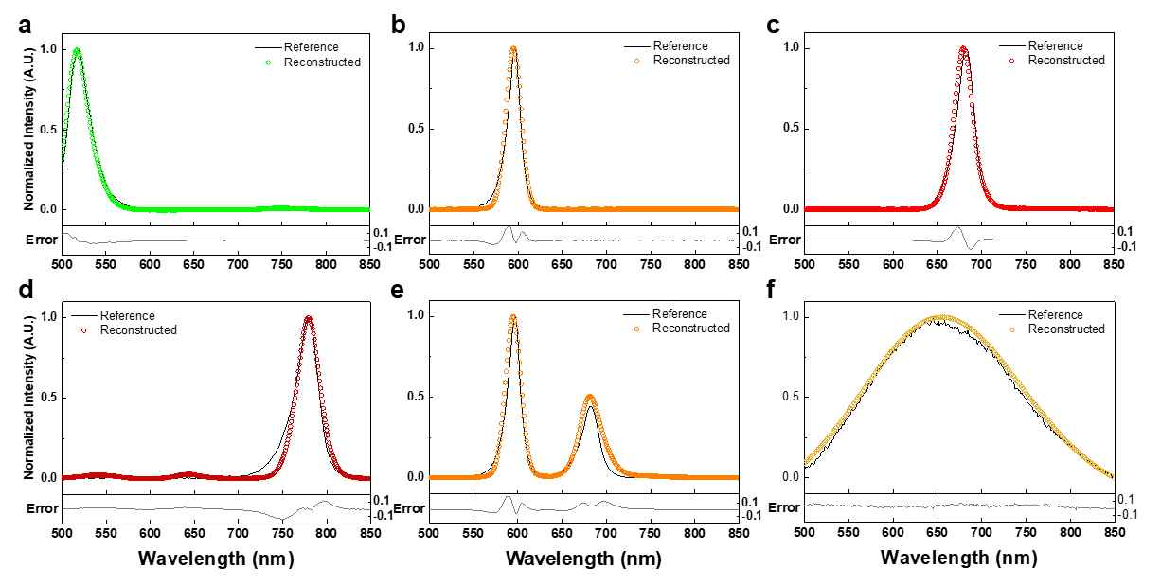
▲ Results of restoration of spectral information for LED and halogen light sources: (a) green LED, (b) orange LED, (c) red LED, (d) infrared LED, (e) orange and red LED, (f) halogen light source

This research was led by GIST School of Electrical Engineering and Computer Science Professor Heung-No Lee (corresponding author) and conducted by researcher Cheolsun Kim (first author) with support Leap Research Support Project funded by the National Research Foundation of Korea and was published online on March 8, 2022, in the international academic journal Scientific Reports.



