Development of dementia diagnosis
method with simple olfactory stimulation

– Diagnosis of Alzheimer's dementia within 5 minutes based on the prefrontal near-infrared signal that changes upon olfactory stimulation


▲ From left: GIST Ph.D. student Jaewon Kim, Kyung Hee University College of Medicine Professor Dong Keon Yon, Gwangju Alzheimer’s & Related Dementia Cohort Research Center Director Kun Ho Lee, and GIST Professor Jae Gwan Kim

A Korean research team has developed a new dementia diagnosis technology that can differentiate the complex Alzheimer's dementia diagnosis process within 5 minutes through simple olfactory stimulation.

GIST (Gwangju Institute of Science and Technology, President Kiseon Kim) Department of Biomedical Science and Engineering Professor Jae Gwan Kim and Chosun University Professor Kun Ho Lee's research team developed a diagnostic technology that can distinguish normal/cognitive dysfunction/Alzheimer's dementia based on near-infrared signals measured in the prefrontal cortex during olfactory stimulation.

They found a way to differentiate the dementia stage through simple olfactory stimulation within 5 minutes, which can be accurately judged only by synthesizing the results of a cognitive function test, brain MRI, or amyloid PET-CT*, which takes up to several hours to diagnose Alzheimer's.

* amyloid PET-CT: It is a technique that simultaneously takes amyloid PET (positron emission tomography) and CT (computed tomography) images, and it is a very useful technique for accurate diagnosis of Alzheimer's disease by quantitatively measuring the amount of amyloid beta protein in brain tissue with 3D images.

The Alzheimer's dementia diagnosis technology using fNIRS* presented by the research team was confirmed to diagnose mild cognitive impairment faster and more accurately than brain MRI or amyloid PET-CT. This is expected to be of great help to dementia management and clinical application by detecting Alzheimer's dementia patients at an early stage in a situation where there is no effective treatment for dementia.

* fNIRS (functional near-infrared spectroscopy): It is a functional near-infrared spectroscopy method that irradiates near-infrared wavelength light (650-100 nm) with good permeability to human tissues on one side of the head and passes through the skull at a distance of 3 cm or more from the light irradiation source. A technique that detects light that passes through the cerebral cortex and measures blood flow and oxygen saturation in the brain. Although fMRI contrast systems are much simpler and provide useful information for brain research, they are being actively used in the study of brain diseases and brain function.

Alzheimer's dementia patients account for 60-70% of all dementia patients, and previous studies show that Alzheimer's dementia patients have reduced olfactory function compared to normal people before the onset of cognitive decline symptoms.

In the past, there were insufficient points in quantitatively measuring the deterioration of the olfactory function. In this study, the stage of Alzheimer's dementia was diagnosed by quantitatively measuring changes in olfactory function in the frontal lobe of the brain through near-infrared spectroscopy.

To confirm the superiority of the newly developed diagnostic technique, the research team attached a near-infrared measuring probe to the frontal lobe of the brain for a total of 97 people and gave them four scents (unscented, downy, mint, leather) stimulation. Then a clinical trial was conducted to measure the changed hemoglobin value in the prefrontal cortex of the brain using fNIRS.

As a result, it was confirmed that the new diagnostic technique has superior diagnostic capabilities than brain MRI or amyloid PET-CT and has similar diagnostic accuracy to existing dementia tests such as various dementia questionnaires (MMSE, SNSB).

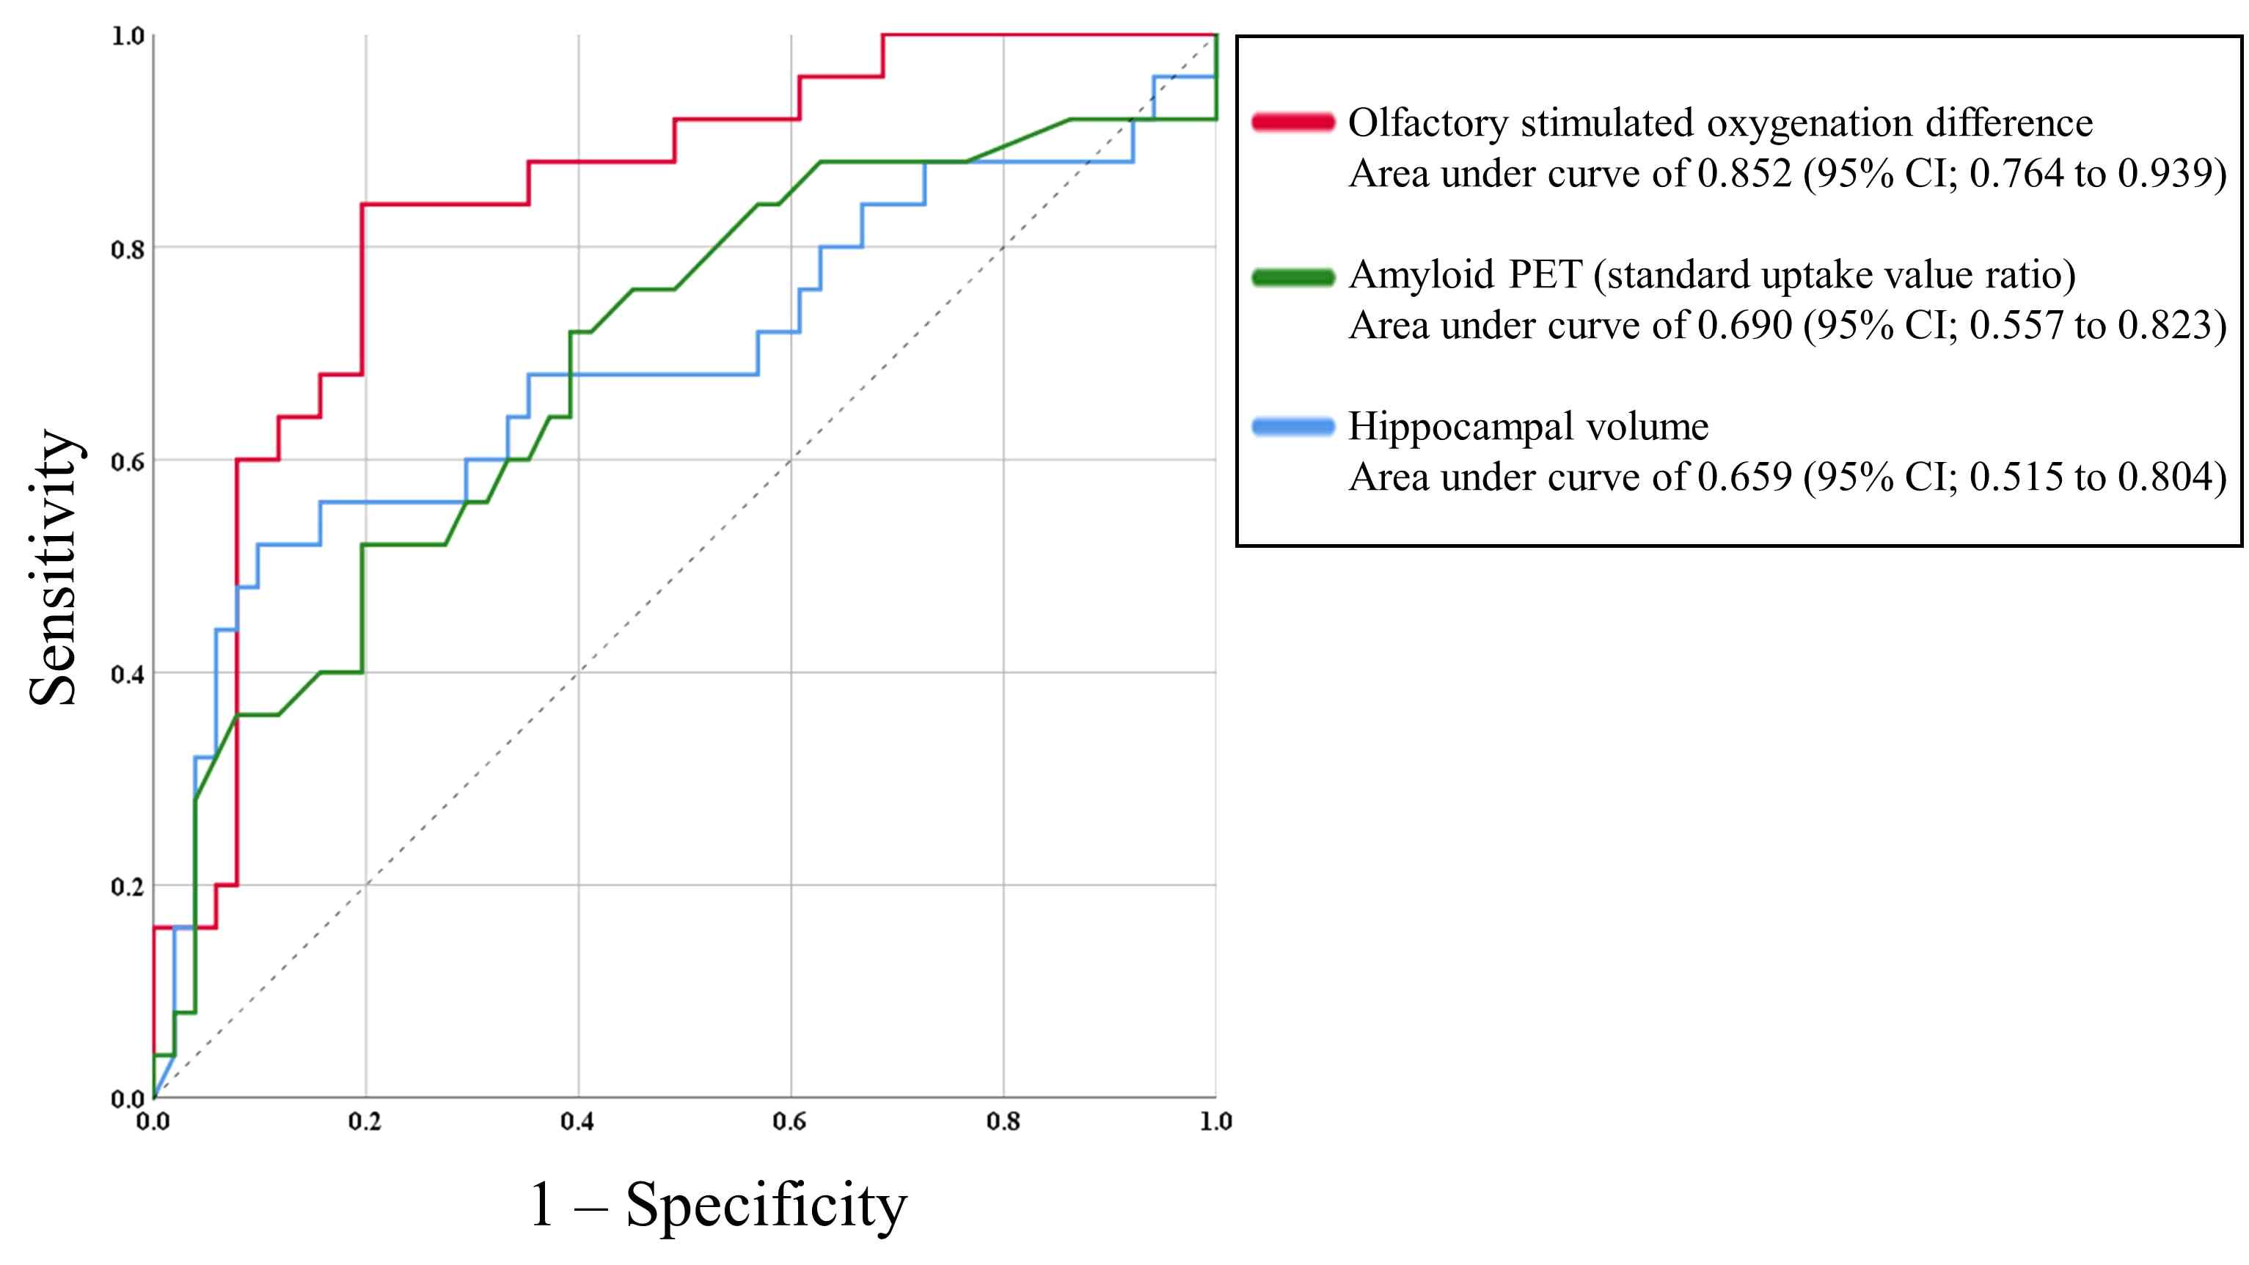
▲ MRI (light blue), amyloid PET-CT (green), and fNIRS (red) comparison graph of ability to distinguish between normal people and patients with mild cognitive impairment. It can be seen that the fNIRS graph shows a much wider area under the line than the other two graphs.

Professors Jae Gwan Kim and Kun Ho Lee, who were co-corresponding authors, said, "According to the results of this study, the diagnosis process is very easy and the time required is as short as 5 minutes. Its cost is much lower and shows excellent results, so it is expected to be applied in clinical practice."

This research was led by GIST Professor Jae Gwan Kim and Chosun University Professor Kun Ho Lee and was conduced by GIST Ph.D. student Jaewon Kim and Kyung Hee University College of Medicine Professor Dong Keon Yon with support from the MD-PhD/Medical Scientist Training Program through the Korea Health Industry Development Institute, the Brain Research Program funded by the National Research Foundation of Korea, and the Original Technology Research Program for Brain Science of the National Research Foundation and was published online on March 9, 2022, in Alzheimer’s Research & Therapy (top 10% in clinical neurology), an authoritative journal in the field of neuroscience and published by the British Society for Dementia Research.



