Regeneration of inflamed tissue using biocompatible chain reaction nanoreactors

– Intestinal disease inflammation treatment
with 2 types of antioxidant enzymes


▲ School of Materials Science and Engineering Professor Giyoong Tae

GIST (Gwangju Institute of Science and Technology) Professor Giyoong Tae's research team succeeded in treating inflammatory bowel disease (IBD) using a biocompatible nanoreactor that can cause an effective chain reaction in vivo.

The research team designed a nanocarrier capable of highly efficient collection of two types of antioxidant enzymes as a nanoreactor that continuously causes a chain reaction. This nanoreactor converts the excessively increased reactive oxygen species into oxygen in the inflamed tissue site, showing that it is possible to effectively restore the inflamed tissue.

Reactive oxygen species (ROS) are involved in regulating cell functions at appropriate concentrations. Excessive production by internal/external factors causes damage to cells and tissues, leading to various diseases such as inflammatory bowel disease (IBD) as well as cardiovascular disease, neurological disease, and histopathology.

SOD (superoxidase dismutase) and CAT (catalase) are representative antioxidant enzymes in the body that can reduce the production of free radicals around inflamed tissues and prevent cell damage.

SOD reacts with superoxide ions (O2⁻) to convert it into hydrogen peroxide (H₂O₂). This hydrogen peroxide (H₂O₂) can be converted into oxygen gas by CAT, so that active oxygen is removed and oxygen can be supplied through the chain reaction of SOD and CAT.

The nanoreactor developed by the research team can be selectively delivered to the inflammatory site when injected in vivo, and it enhances the chain reaction of two antioxidant enzymes to selectively detoxify only the inflammatory site.

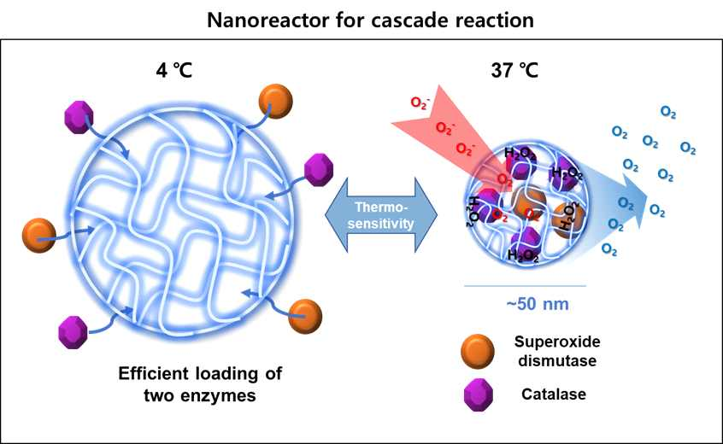
▲ Simultaneous capture of two types of antioxidant enzymes in a nanocarrier with high efficiency through a simple temperature control reaction

The research team injected these nanoreactors into a mouse model of intestinal inflammatory disease, one of the main inflammatory reactions, and reduced the inflammatory response in the nanoreactor group carrying two types of antioxidant enzymes, SOD and CAT, compared to other comparison groups, proving that they can recover quickly.

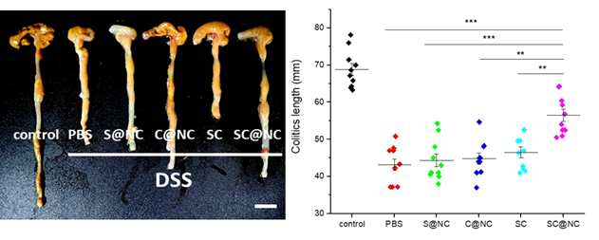
▲ Comparison of intestinal inflammation recovery through colon length in inflammatory bowel disease mouse model injected with nanoreactor

GIST Professor Giyoong Tae said, "The results of this study can be applied to the treatment of various inflammatory tissues, including intestinal inflammatory diseases. This can help in the recovery of damaged tissues, suggesting an important possibility to improve the overall effect as an anti-inflammatory agent."

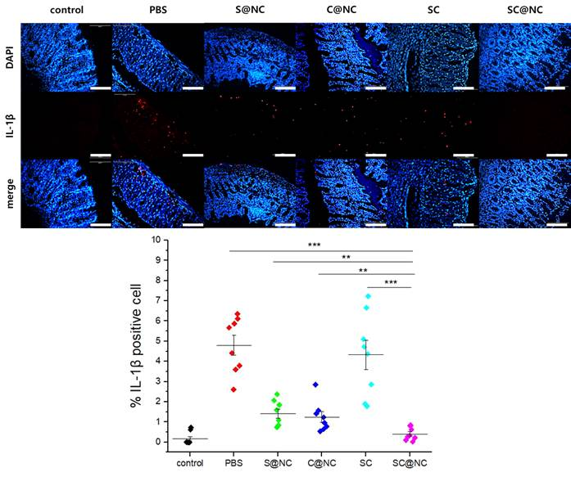
▲ Inflammation treatment effect confirmed by comparing the expression of IL-1β, an inflammation-inducing protein caused by nanoreactors in colon tissue in an inflammatory bowel disease model

This research was supported by the National Research Foundation of Korea's Mid-Sized Researcher Project and Basic Research Laboratory Project and was published online on March 3, 2022, in the Journal of Controlled Release, a renowned journal in the field of pharmacology, and it was selected as a cover paper for the April issue.



