Publication of a review paper on a novel peptide mimicking polymer platform

– Professor Jae-Suk Lee's team presents the prospect of polyisocyanate as a peptide-like platform


▲ From left: Professor Jae-Suk Lee, Dr. In Gyu Bak, and Dr. Chang-Geun Chae

Polyisocyanate is a rod-shaped polymer with a helical structure. Due to its high degradability, it has potential as an environmentally friendly bioactive material.

GIST (Gwangju Institute of Science and Technology, President Kiseon Kim) School of Materials Science and Engineering Professor Jae-Suk Lee has been conducting research for 30 years on the synthesis of polyisocyanates, which are similar to biopolymer peptides.

As a result of this research, an invitation review paper was recently published in Macromolecules, the most prestigious journal in the field of polymers. In addition, he was invited to give a keynote lecture at the International Symposium on Ionic Polymerization to be held in Belgium in September of this year.

So far, many studies have been done on the function and monomer arrangement of polyisocyanates, but they have not yet reached the research stage at the level of peptide mimicry. In this review paper, the research team summarized and reported the existing research on polyisocyanate, and at the same time suggested the research direction of polyisocyanate that can be applied as a peptide mimicking platform.

Although polyisocyanate has a structure very similar to that of a peptide, peptide simulation studies have not been conducted. To simulate a peptide, it is necessary to simulate the chemical functional group and amino acid sequence of a peptide, and it is very difficult to realize these two by using the existing polymer polymerization method.

In the meantime, researchers at home and abroad, including Professor Jae-Suk Lee's team, have been trying to give polyisocyanates various functions. Professor Jae-seok Lee's research team attempted to apply it to living organisms when he published a study on amphiphilic* polyisocyanate in 2014.

* amphiphilic polyisocyanate: a polyisocyanate that has both a hydrophilic part and an oleophilic part

In addition, the diversity of the monomer* arrangement of polyisocyanates published in academia is increasing every year. Isocyanate, a monomer of polyisocyanate, has various functionalities and properties, and by combining these monomers, various peptide-like structures can be made.

* monomer: The basic unit structure of a polymer; in the case of a peptide, it corresponds to an amino acid.

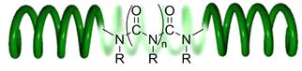
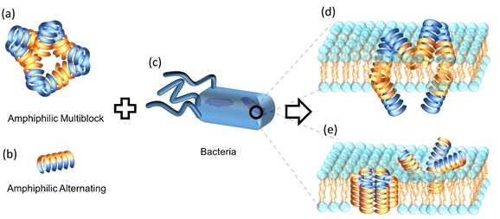
▲ A figure explaining the basic structure of polyisocyanate (top) and its potential as a platform for simulating peptides (antibiotics) of polyisocyanate (bottom).

Polyisocyanates have the advantage of being easy to mass-produce and chemically modified compared to peptides. Combining this with antibiotic and anti-freezing functions of the peptide opens a new path for mass production of useful protein for humanity.

Professor Jae-Suk Lee said, "Although polyisocyanate has a structure very similar to that of a peptide, it has not been applied to the field of peptide simulation research. It will be possible to realize a new polymer platform with polyisocyanate, which is the same as the antibiotic function of peptides but has various functions that peptides do not have."

This review paper was led by GIST Professor Jae-Su Lee (corresponding author) and conducted by GIST Dr. In Gyu Park and Dr. Chang-Geun Chae (co-first authors) from the Korea Research Institute of Chemical Technology (KRICT) with support from the National Research Foundation of Korea, GIST's Grubbs Center for Polymers and Catalysis funded by the GIST, and KRICT. The research results were published online on February 22, 2022, in Macromolecules, a renowned academic journal of the American Chemical Society.



