Finding the cause of the longterm effects of COVID-19 with machine learning

– Proposes the possibility that a protein in the human body structurally similar to the COVID-19 virus can induce an autoimmune reaction

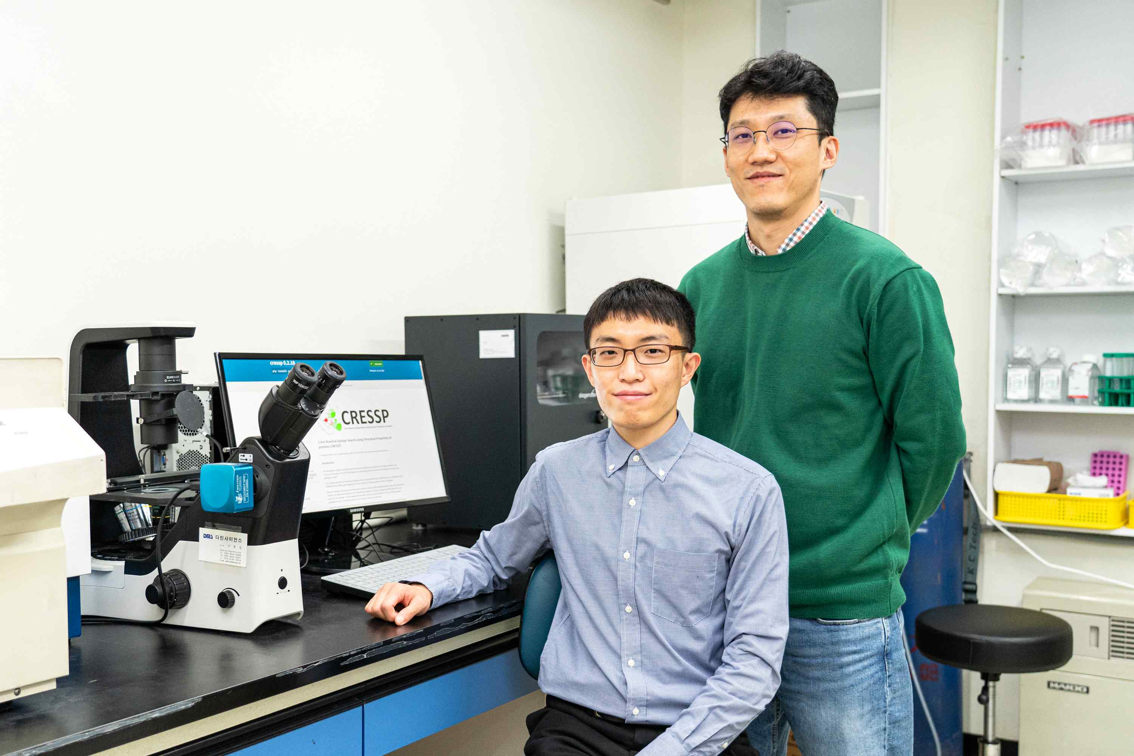
▲ From left: Student Hyunsu An (first author) and Professor Jihwan Park

It has been reported that COVID-19 causes various longterm effects, such as memory loss, blood clots, chest pain, kidney disease, and multi-organ inflammatory syndrome, as well as respiratory symptoms such as shortness of breath and cough for several months after recovery. A Korean research team has discovered the cause of the aftereffects of COVID-19 through machine learning technology.

GIST (Gwangju Institute of Science and Technology, President Kiseon Kim) School of Life Sciences Professor Jihwan Park's research team used machine learning technology and the latest single-cell analysis technology* to suggest an autoimmune reaction as a cause of various longterm effects reported in a large number of patients who have recovered from COVID-19.

* single cell analysis technology: A technology that can analyze the expression of all genes expressed in tens of thousands of individual cells in a single experiment, and it has recently been evaluated as one of the most important next-generation technologies in the fields of biology and medicine.

Through the development of a technology that can predict proteins in the human body that are structurally similar to viral proteins, the research team revealed that autoantibodies* can cause autoimmune reactions in tissues such as lungs and kidneys and cause longterm effects.

* autoantibodies: Antibodies are substances made in the body primarily to eliminate external bacteria, viruses, toxic substances, etc., sometimes producing autoantibodies that damage certain tissues or body organs due to abnormal immune systems.

Recently, the University of Washington reported that the longterm effects of COVID-19 are closely related to the amount of autoantibodies in the blood, and researchers in Korea have revealed the types and production mechanism of these autoantibodies, suggesting the possibility of developing therapies.

In this study, tens of thousands of human proteins and proteins of all COVID-19 virus mutations, including omicron mutations, were compared on a three-dimensional structure using machine learning technology.

As a result, candidate proteins capable of causing an autoimmune reaction were discovered, and, in fact, these proteins were observed to be significantly increased in the lung tissue of COVID-19 patients.

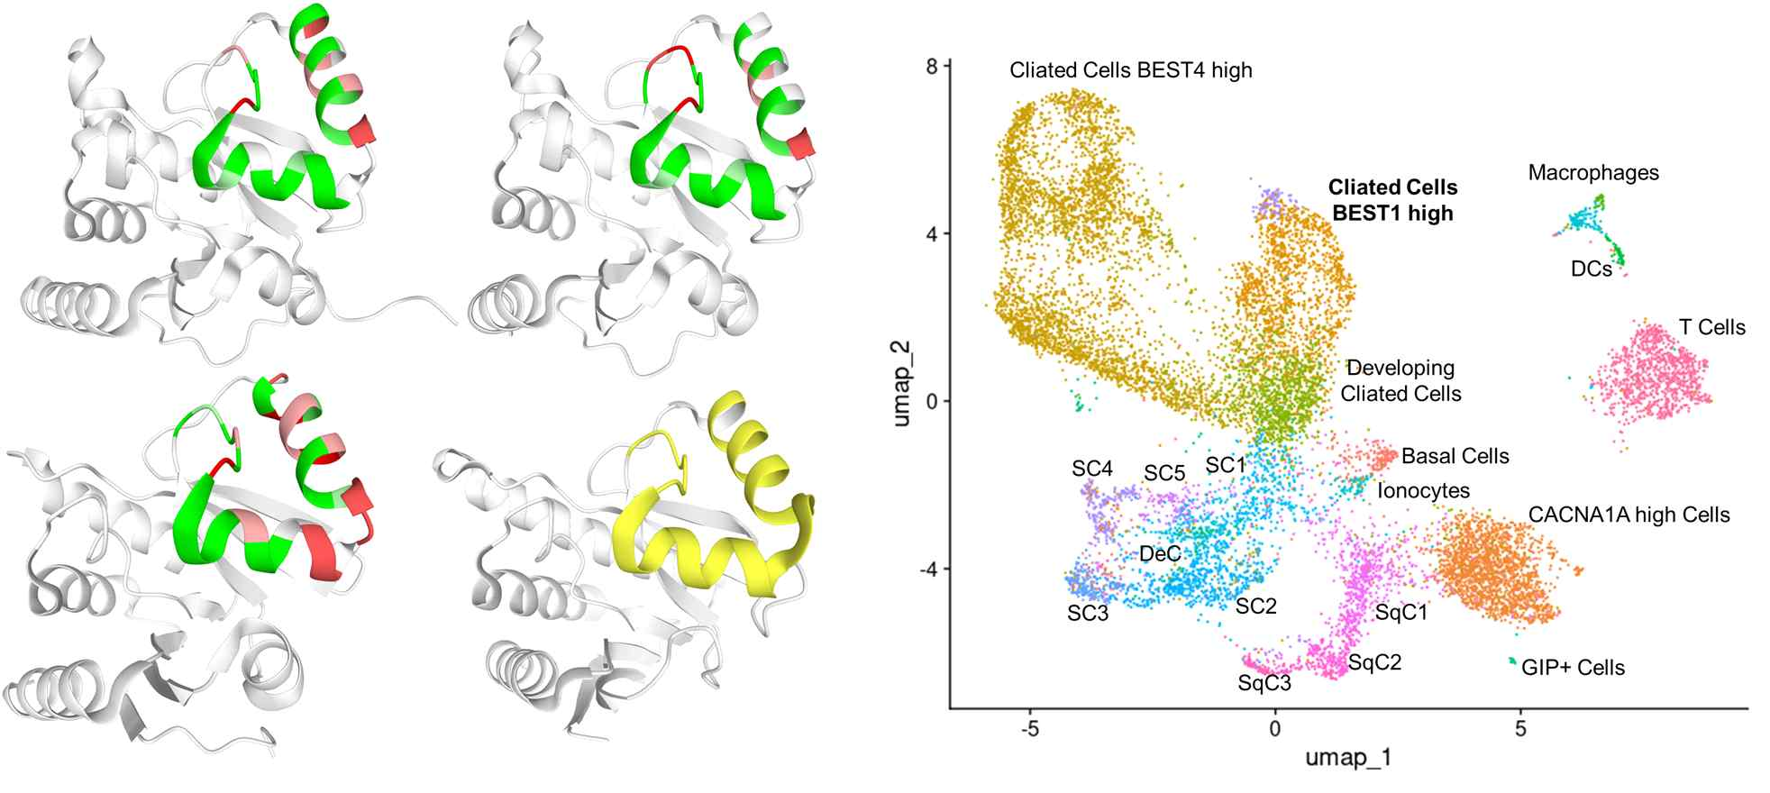
▲ Structure and expression pattern of the protein that induces longterm effects of COVID-19 predicted through research

Professor Jihwan Park said, "Although autoimmune reactions have been suggested as the cause of the longterm effects of COVID-19 only through clinical observation, this study is meaningful in that it discovered a candidate protein that can actually cause an autoimmune reaction and suggested a causal relationship with the sequelae. It can be used not only for the development of a treatment for the aftereffects of COVID-19 but also for the development of vaccines for other viruses in the future."

First author Hyunsu An said, "We also want to determine the cause of other autoimmune diseases, such as systemic lupus erythematosus, through this analytical technique."

This research was conducted by GIST student Hyunsu An and Professor Jihwan Park with support from the National Research Foundation of Korea, the GIST Anti-Virus Research Center, and the GIST Laboratory for Cell Mechanobiology and was published on February 28, 2022, in the internationally renowned journal Briefings in Bioinformatics.



