Development of low-cost
next-generation fuel cell catalyst

– Contributing to cost reduction and
commercialization of hydrogen fuel cells

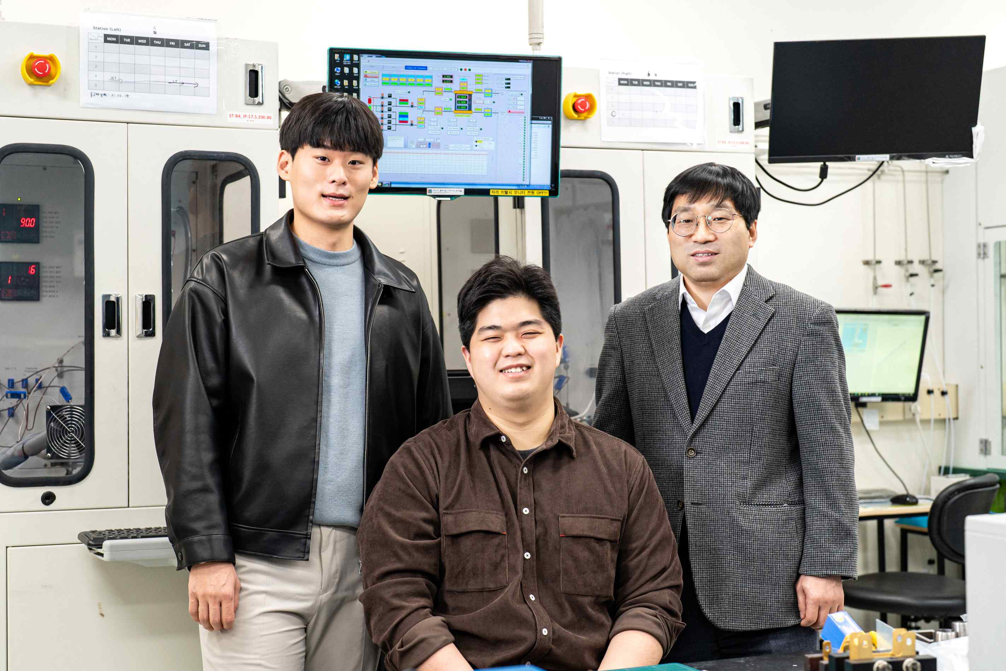
▲ From left: Master's student Sunghoon Han, integrated student
Jong Gyeong Kim, and Professor Chanho Pak

A non-precious metal catalyst that can increase stability while reducing the cost of anion exchange membrane fuel cells has been developed by a Korean research team.

GIST (Gwangju Institute of Science and Technology, President Kiseon Kim) Graduate School of Energy Convergence Professor Chanho Pak's research team improved catalytic activity by introducing a heterogeneous element into a non-precious metal oxygen reduction catalyst that is cheaper than platinum.

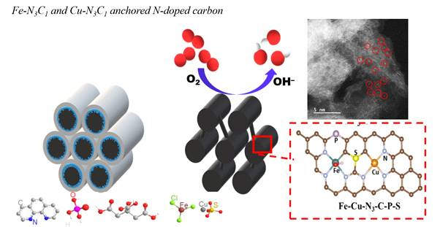
▲ Representation of the structure of a non-precious metal catalyst containing iron, copper, nitrogen, sulfur and phosphorus: Improving the oxygen reduction reaction rate by controlling the oxidation and energy state of the active catalyst site.

Platinum was preferred as an oxygen reduction catalyst due to its high activity and durability; however, due to its rarity and high cost, a catalyst with high activity to replace platinum and high efficiency compared to unit cost is required. In particular, the anion exchange membrane fuel cell, which in recent years is being developed as a next-generation low-cost fuel cell, is required to develop a low-cost catalyst that can cope with the rapid development of the anion exchange membrane.

Existing research has improved the performance by adding a relatively expensive transition metal such as cobalt to a non-noble metal catalyst, but, in this study, a heterogeneous element* was introduced into a non-noble metal catalyst whose main component is cheap iron, which was optimized without significantly increasing the catalyst manufacturing cost. The catalytic activity was achieved, and a dual catalytic site was proposed.

* heterogeneous elements: elements other than carbon and hydrogen

In addition, this catalyst was implemented as an electrode in cooperation with Dr. Byungchan Bae's research team at the Korea Institute of Energy Research to evaluate the unit cell performance.

As a result of the half-cell test, the research team presented a non-precious metal catalyst that performed better than platinum under basic conditions. This catalyst was prepared by a nanocasting method**** in which iron, copper, sulfur, phosphorus, and nitrogen precursors* were supported on regular mesoporous silica** and then carbonized***. It was confirmed that the oxygen reduction reaction catalyst in which the energy state of iron was controlled with copper, sulfur, phosphorus, and nitrogen showed superior performance compared to platinum.

* precursor: a compound with a specific element

** regular mesoporous silica: silicon oxide composed only of mesopores of the same size

*** carbonization: A method of producing a carbon-rich material by heating organic matter at a high temperature to pyrolyze it.

**** nanocasting method: uses a hard metal oxide with pores as a mold, put the precursor of the material to be manufactured into the pores and solidify it in various ways, then selectively remove only the mold to produce a porous material with the reverse phase How to

The research team analyzed the catalyst activity and structure by changing the ratio of iron and copper and the presence or absence of heterogeneous elements. These results were analyzed when copper was introduced into a non-precious metal catalyst by computational chemistry with the help of Professor Seung Soon Jang's research team at Georgia Tech, and the cause of the increase in activity was identified.

It was confirmed that the oxidation state of iron was changed according to the introduction of the heterogeneous element, and the reaction rate was improved by changing the adsorption state of the reaction intermediate during the oxygen reduction reaction. In addition, when iron is more than copper, it is easily agglomerated, and when more copper is added, the number of catalytically active sites is insufficient, so that it has the highest activity when the ratio of iron to copper is 1:1.

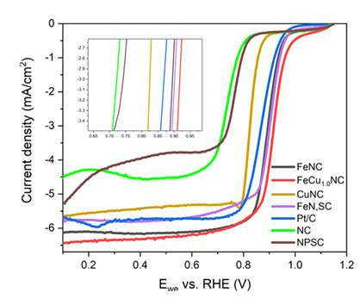
▲ Oxygen reduction reaction half-cell test result: When the ratio of iron to copper is 1:1, it was confirmed that the highest activity was shown.

Professor Chanho Pak said, "This research is significant in that it developed a non-noble metal catalyst that is applied to the next-generation anion exchange membrane fuel cell. In addition to suggesting the direction of catalyst development in the future, it is expected that electrode optimization will contribute to cost reduction of anion exchange membrane fuel cells."

This research was led by GIST Professor Chanho Park and conducted by integrated student Jong Gyeong Kim and master's student Sunghoon Han with support from the National Research Foundation of Korea's Climate Change Response Technology Development Project and the GIST Research Institute, and the results were published online on February 7th in the Journal of Materials Chemistry A, an internationally renowned academic journal in the field of energy and fuel.



