Development of high-stability perovskite solar cells that are resistant to heat and light

– Realization of high-efficiency, high-stability perovskite solar cells resistant to heat, light, and air by eliminating thin-film defects with an ultra-thin electrolyte layer


▲ From left: Professor Heejoo Kim, Professor Kwanghee Lee, and Dr. Yong Ryun Kim

A domestic research team has developed a perovskite solar cell that maintains high stability despite prolonged exposure to external environments such as heat, light, and air.

GIST (Gwangju Institute of Science and Technology, President Kiseon Kim) Graduate School of Energy Convergence Professor Heejoo Kim and School of Materials Science and Engineering Professor Kwanghee Lee's joint research team, along with the research team of Pusan National University Department of Chemistry Professor Hongsuk Suh, introduced an ultra-thin electrolyte layer that absorbs ionic defects inside perovskite solar cells*
that dramatically improves stability.

* perovskite solar cell: a next-generation solar cell made of perovskite crystals based on a mixture of organic materials and metals that can absorb sunlight over a wide area with high absorbance and has the highest reported energy conversion efficiency among high-efficiency thin-film solar cells due to solution processing

Although the perovskite thin film produced by the solution process is a polycrystalline thin film with high crystallinity, ionic defects exist between crystals or on the surface of the thin film.

When a perovskite solar cell is exposed to heat, light, or air, the ionic defects migrate from the inside surface to the top and corrodes the upper electrode, which deteriorates the performance of the solar cell and causes low stability.

Various methods have been applied and developed--such as adding metal ions or organic materials to the perovskite precursor solution to harden the crystal or replacing the upper and lower functional layers with new materials--to realize high-stability perovskite solar cells. However, a simpler approach is needed for perovskite solar cells aimed at commercialization through a continuous process.

The research team is developing a new polymer electrolyte in which ion defects and highly reactive amine functional groups are introduced into carbazole molecules with high thermal stability. This was introduced as an ultra-thin film between the perovskite upper electrode and the perovskite thin film.

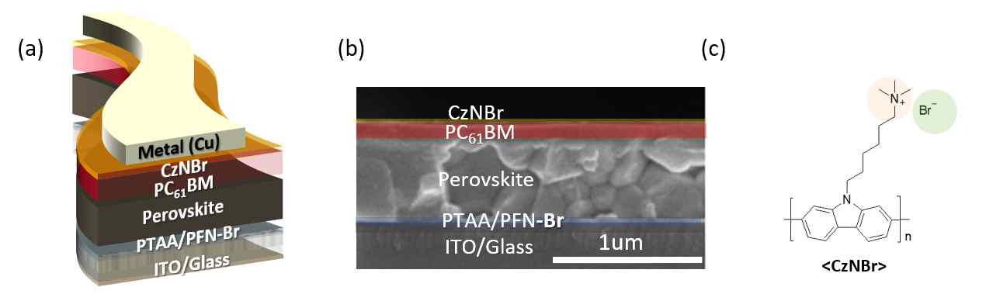
▲ (a) Structure of a perovskite solar cell with a polymer electrolyte layer (CzNBr), (b) cross-section of the solar cell measured with a scanning electron microscope, and (c) chemical structure of a polymer electrolyte

The new polymer electrolyte layer exhibited high electrical properties to improve charge transfer between the upper electrode and the perovskite layer while effectively adsorbing ionic defects on the surface and inside of the perovskite thin film. In addition, the novel structure of the perovskite solar cell showed excellent stability in that the performance of the solar cell was maintained even after exposure to heat at 85°C for 1000 hours, light for 350 hours, and exposure to air for 1500 hours or more.

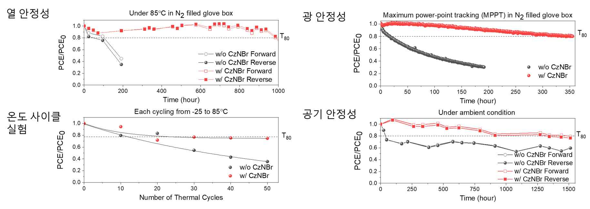
▲ Stability measurement results of perovskite solar cells incorporating a polymer electrolyte layer; changes in solar cell performance over time when exposed to heat, light, and air, and changes in performance with the number of temperature cycle experiments

Professor Heejoo Kim said, "By introducing an organic electrolyte capable of single-layer solution processing into a perovskite solar cell, the thermal, light and air stability of the perovskite solar cell was dramatically improved. This is expected to be applied to the development of perovskite solar cells with high stability in various external environments in the future."

This research was supported by the GIST Research Institute, the Basic Science Research Program through the National Research Foundation of Korea (NRF), the NRF Global Research Laboratory Program, and the NRF Future Hydrogen Original Technology Development Program and was published online on February 2, 2022, in Journal of Materials Chemistry A, which is the top 7.02% journal in the energy field.

