Identification of key enzyme activity mechanism for DNA damage repair

– The mechanism of action of AP nuclease, which is essential for the DNA damage repair process, is revealed... Expected to contribute to cancer treatment, anti-aging, and new drug development for genetic diseases

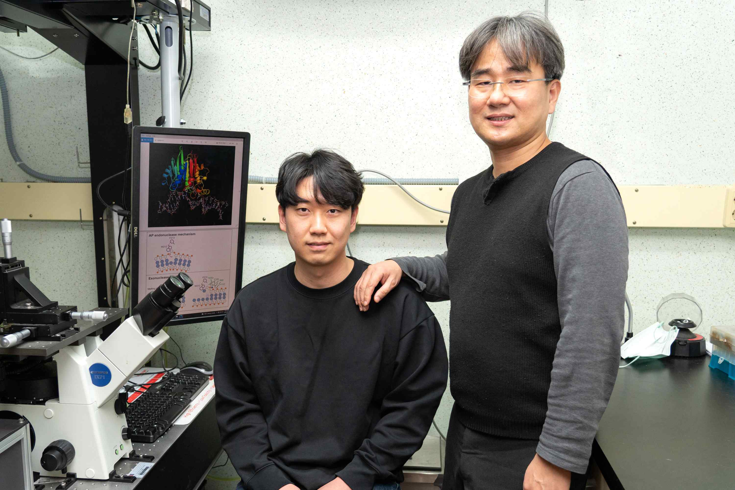
▲ From left: Integrated student Donghun Lee and Professor Gwangrog Lee

DNA in our body is damaged by various factors. DNA damage is the main cause of aging, cancer and genetic diseases. To solve this problem, our body maintains homeostasis by using the DNA damage repair system. However, the mechanism of activation of AP nuclease, a key enzyme in DNA repair, is not well known.

GIST (Gwangju Institute of Science and Technology, President Kiseon Kim) School of Life Sciences Professor Gwangrog Lee's research team determined the two activities (internal cleavage nucleolytic activity and external cleavage nucleolytic activity) of AP nuclease, which plays a key function in the DNA repair process, and identified at the level of a single amino acid residue*.

* amino acid residue: a structural unit of a polypeptide to which amino acids are bound

AP nuclease is one of the enzymes receiving the most attention in cancer treatment. Mutations of this enzyme have been found in many cancer patients, and there is a report that this enzyme is overexpressed at an early stage of cancer, so it is being used as a biomarker for early cancer detection.

The research team used AP nucleolytic enzyme and used site-directed muta genesis* and single-molecule FRET** to observe AP internal nucleolytic activity and external nucleolytic activity, which revealed the fundamental mechanism of action at the molecular level.

* site-directed muta genesis: a method of inducing mutation by changing a specific region of a gene to compare protein activity

** fluorescence resonance energy transfer (FRET): a fluorescence technique that can observe the movement of single molecules in real time by using a physical phenomenon and is a key technology that allows us to know how AP nuclease and DNA interact

The research team found that the 213th tryptophan and the 213th phenylalanine of the AP nuclease have AP internal nucleolytic activity through π-interaction with the AP site. In addition, it was confirmed that the 213th phenylalanine not only participates in the AP internal nucleolysis activity but also stabilizes the 3' end of the dissociated DNA to maintain a structure capable of catalyzing the exonucleolytic activity (catalytically competent state: cleavable state).

[Figure] Schematic diagram of two activation mechanisms of AP nucleolytic elements
Left figure: AP intranucleolytic activity (internal cleavage at the AP site); Middle and right figures: External cleavage nucleolytic activity (continuous cleavage from the 3' end)

It was confirmed that the arginine at position 90, tyrosine at position 109, lysine at position 121, and asparagine residues at position 153 of the enzyme should interact with the phosphate group of DNA to stabilize the DNA helix in order to exhibit exonucleolytic activity.

Professor Gwangrog Lee said, "This study revealed the fundamental mechanism behind the principle of external and internal DNA cleavage, two key cutting functions essential for the DNA damage repair process. This is expected to contribute to the development of new drugs for cancer treatment, aging inhibition, and genetic diseases in the future."

The GIST research conducted by Professor Gwangrog Lee's team was supported by the GIST Research Institute, the National Research Foundation of Korea, the Korean Health Technology R&D Project, and the Ministry of Health and Welfare and was published online on February 7, 2022, in the world-renowned scientific journal Nucleic Acids Research, which ranks in the top 2.6% of journals in the field of biochemistry and molecular biology.



