Professor Yong Gu Lee's research team develops international standard technical document for autonomous driving data management

– Adoption of new items for self-driving data classification system standard technical documents... Expected to increase compatibility between autonomous driving data

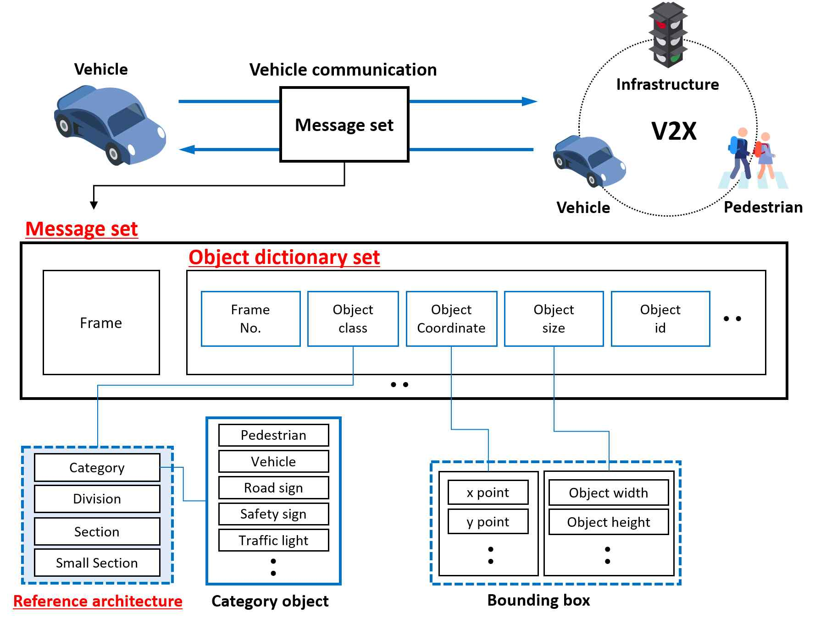
▲ [Figure] Overview of autonomous driving object classification system

With the development of the artificial intelligence industry, the amount of data for autonomous driving is increasing rapidly. Currently, Tesla and Google Waymo are leading the autonomous driving industry by securing technological competitiveness based on numerous data. Korea urgently needs to secure source data in the autonomous driving field.

GIST (Gwangju Institute of Science and Technology, President Kiseon Kim) School of Mechanical Engineering Professor Yong Gu Lee's research team developed an international standard technical document for the systematic management of big data for autonomous driving.

The data expression method for on-road cognitive processing for autonomous driving proposed by Professor Yong Gu Lee's research team was presented at an international conference in 27 countries including Korea, the United States, China, Germany, and Canada on January 28th in the Telecommunication Standardization Sector* of the International Telecommunication Union and was adopted as a new item.

International standard technical documents are expected to be highly useful in the artificial intelligence industry and to increase compatibility between autonomous driving data.

* International Telecommunication Union Telecommunication Standardization Sector (ITU-T): This is a standardization division of the International Telecommunication Union (ITU), an international organization for information and communication technology under the United Nations (UN). 900 members in industries, academia, and research institutes in 190 member countries are active.

Professor Yong Gu Lee's research team has succeeded in building the world's largest hand signal recognition dataset by building an autonomous vehicle dataset. In addition, a new standard technology item was proposed through consideration of the object expression method of the construction data set, and a bridgehead for the establishment of the next international standard was secured through the adoption of this new item.

This standard technical document proposed by Professor Yong Gu Lee's research team can systematically and scalably manage the form of artificial intelligence (AI) data sets. In addition, it can be used in various fields such as smart city, digital forensics, and autonomous driving learning data as well as V2X communication protocol.

Professor Yong Gu Lee is currently active in Study Group 16 of the International Telecommunication Union's Telecommunication Standardization Sector to develop the relevant standard technical document as the Korean national delegation to the International Telecommunication Union.

Professor Yong Gu Lee said, "Recently, various artificial intelligence datasets have been built around Google Waymo and Nussin, but there is a problem with different expressions, so it is expected that this standard technology will increase the efficiency of data compatibility by integrating the data set into one. This will be the first step toward securing national competitiveness in the field of autonomous driving data."

The development of this standard technical document was carried out with the support of the Institute of Information and Communications Technology Planning and Evaluation (IITP) along with School of Mechanical Engineering researchers Sungjae Lee and Hojin Son of the Department of Mechanical Engineering, led by Professor Yong Gu Lee. The standard technical document will be continuously developed until 2023.



