Development of technology to reduce
charging time for electric vehicles

– Minimize charging standby time by verbally
expressing (fuzzy) ambiguous figures


▲ From left: Professor Yun-Su Kim and Dr. Shahid Hussain

Recently, interest and demand for electric vehicles that are eco-friendly and inexpensive to maintain are increasing significantly. A technology that can shorten the charging time of electric vehicles has been developed by Korean researchers. This is expected to contribute to the popularization of electric vehicles.

GIST (Gwangju Institute of Science and Technology, President Kiseon Kim) Graduate School of Energy Convergence Professor Yun-Su Kim's research team developed a technology to reduce the waiting time for charging at public electric vehicle charging stations using fuzzy theory*.

* fuzzy: A theory that expresses a state in which objective judgments such as temperature, waiting time, and age are ambiguous. (Example – 30 minutes of charging time may be long for some and short for others.)

As the demand for electric vehicles increases, the penetration rate of electric vehicle chargers is increasing, but the temporary concentration of fast charging may cause problems in the power system that supplies electricity. Therefore, it is necessary to connect a large number of electric vehicles to the charger, but to selectively charge the electric vehicle so as not to exceed the capacity of the power system facility.

However, prioritizing charging is not an easy task. This is because the length of time the electric vehicle stays at the charging station and the remaining amount of charge of the electric vehicle are uncertain, and the criteria for determining the condition are ambiguous. To overcome this problem, the research team developed a technology to minimize the waiting time for charging electric vehicles by applying fuzzy theory.

The research team fuzzified the estimated stay time (ST), the remaining amount of electric vehicle charge (SoC), and the charging priority (P). Fuzzyization is a linguistic expression of numerical values that cannot be objectively determined. In this study, stay time (ST) and remaining charge (SoC) are divided into five states: very low, low, normal, high, and very high). [Figure 1]

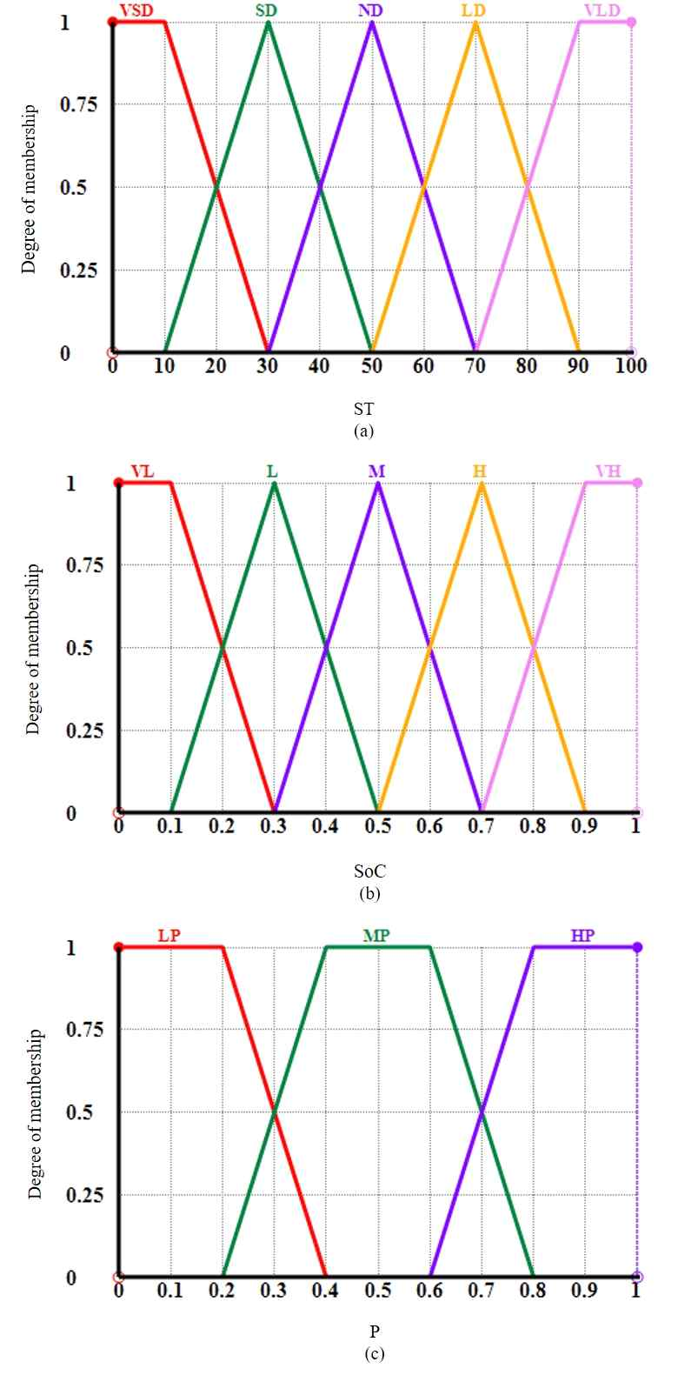
[Figure 1] Fuzzy input/output variables. (a) the length of time the electric vehicle stays at the charging station, (b) the remaining amount of charge, and (c) the charging priority. (In Fig. 1(a), if the main charging time (ST) is 20 minutes, it is expressed as a very short time (VSD) to a certain degree (0.5) and a short time (SD) to a certain degree (0.5). If the stay time is 30 minutes, it is definitely (1) expressed as a short time (SD).)

The charging priority is set using the stay time and remaining charge information expressed in language [Figure 2]. The charging priority is also expressed as low (LP), normal (MP), and high (HP) in the fuzzy reasoning process, and the priority is expressed as an accurate number through defuzzification. Finally, such a fuzzy inference system (FIS) is used to determine the charging priority of electric vehicles [Figure 3].

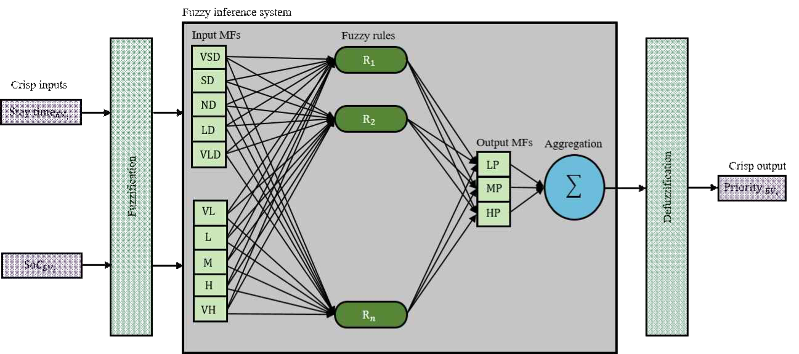
[Figure 2] Structure of Fuzzy Inference System that correlates input (residence time, remaining charge) and output (charge priority)

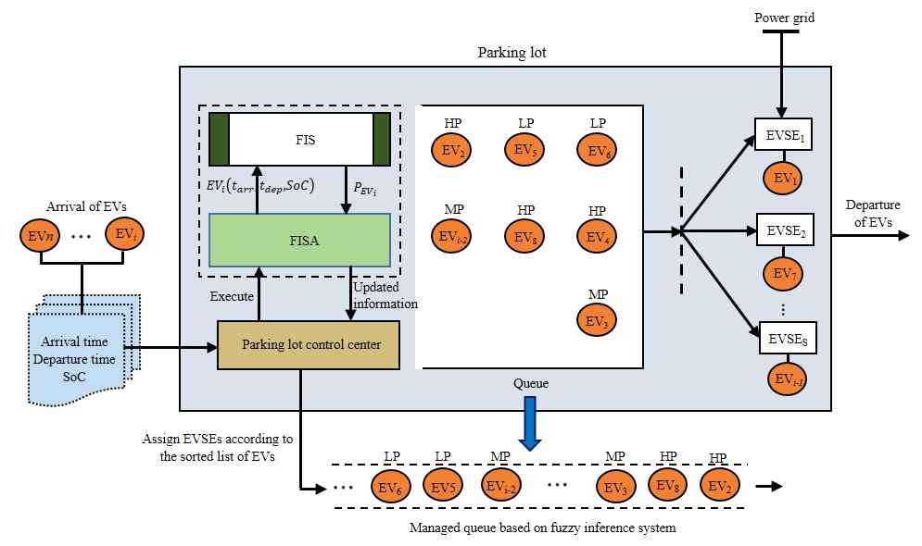
[Figure 3] Electric Vehicle Charging Priority Determination Model Applying Fuzzy Inference System-based Algorithm

The developed technology was verified in a simulation environment considering 200 electric vehicles with random stay time and remaining charge. It was compared with 7 other techniques that were commonly used through simulations or that were recently presented in research papers.

As a result, it was confirmed that the average waiting time was reduced from at least 16% to a maximum of 28% compared to other technologies, and the charging service efficiency was also improved from a minimum of 7% to a maximum of 16%.

Professor Yun-Su Kim said, "No matter how many electric vehicle chargers are supplied, it is difficult to temporarily supply a large number of chargers at the same time due to the facility capacity of the power system. As the amount of intermittent renewable energy in power generation increases, the problem of electric vehicle charger and power system facility capacity is expected to increase further, so this is expected to shorten the electric vehicle charging time and increase efficiency."

The research was conducted by GIST Professor Yun-Su Kim's research team with support from the GIST Research Institute and was published online on January 13, 2022 in IEEE Transactions on Intelligent Transportation Systems, which is the top 3.6% (rank: 5/137) paper in civil engineering.



