Development of protein adsorbent that extracts rare earth elements from waste

– Proposal for solving the shortage of rare
earth elements with steel waste

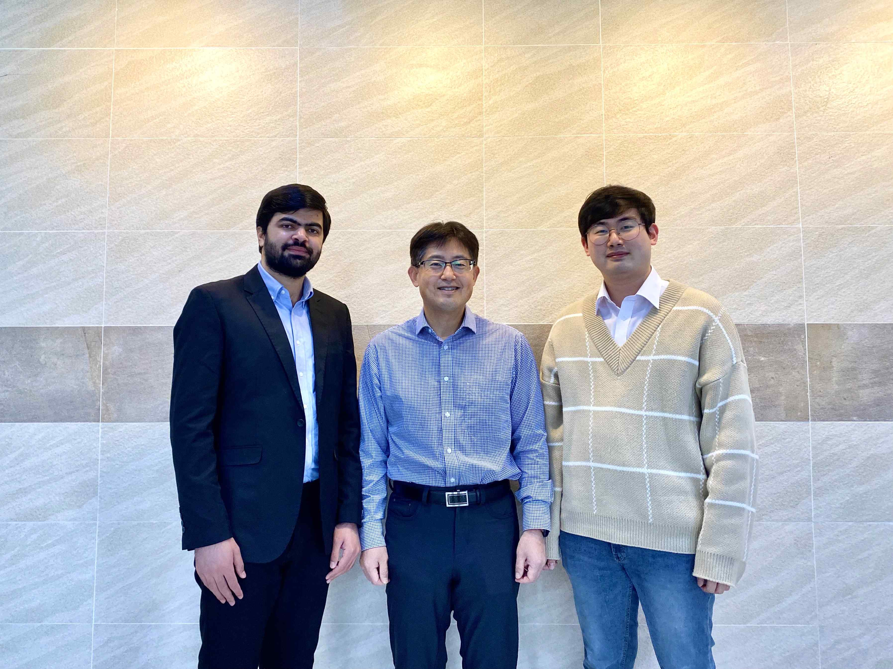
▲ From left: Ph.D. student Zohaib Hussain, Professor Inchan Kwon, and Ph.D. student Seoungkyun Kim

Rare earth elements have properties of conducting heat and electricity. A protein adsorbent has been developed that can selectively recover rare earth metals, which are required in various industries such as electricity, electronics, catalysts, optics, and superconductors, but whose production is limited, from steel slag, a waste.

* rare earth elements: a generic term for elements used in high-tech industries (smartphones, semiconductors, automobiles, aerospace industries, etc.) with unique chemical, electrical, magnetic, and luminous characteristics and include the the lanthanides from scandium (21) to yttrium (39)

** steel slag: non-metallic residue left after smelting iron or steel

GIST (Gwangju Institute of Science and Technology, President Kiseon Kim) School of Materials Science and Engineering Professor Kwon In-chan's research team has has developed a protein adsorbent that can recover rare earth elements without solvents use fusing proteins reported to be reusable through temperature control.

Recently, studies have been conducted to solve the problem of production shortages by recovering rare earth elements from industrial waste. Existing technologies have limitations in that the used adsorbents or solvents cause environmental pollution.

In addition, it is difficult to selectively recover only the rare earth elements because rare earth elements are present in a small amount in industrial waste and non-rare earth elements, such as magnesium and copper are included in large amounts.

Accordingly, the research team developed a protein adsorbent that can selectively recover only rare earth elements and that can be used repeatedly without using a solvent by fusing proteins that can be selectively bound and absorb rare earth elements with proteins that vary in Sol-Gel phase according to temperature. The developed protein adsorbent is decomposes naturally to minimize the problem of environmental pollution.

* Sol-Gel phase change: a phenomenon in which particles can change into dispersion (Sol) and specific form (Gel) according to stimulation (temperature, pH, etc.)

The developed protein adsorbent was applied to a mixture of 13 rare earth elements and an excess of non-rare earth elements, which are relatively widely distributed on Earth. It was confirmed that more than 90% of rare earths were recovered under laboratory conditions and that non-rare earths were hardly recovered, confirming that selective recovery was possible.

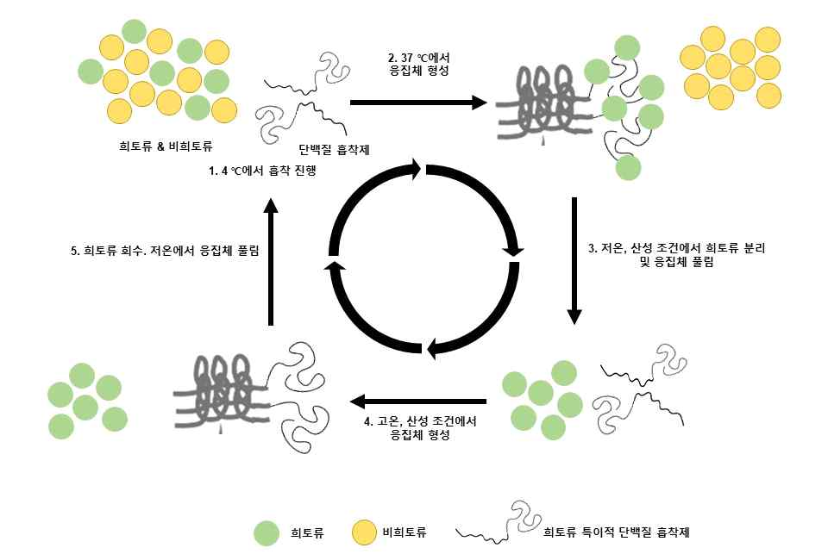
▲ Selective rare earth recovery cycle through the developed protein adsorbent

In addition, the efficiency of recovery of rare earth was maintained even after a certain number of repeated use, confirming the possibility of utilizing the adsorbent.

Furthermore, the possibility of use in industry is expected by confirming the results of recovering more than 80% of 15 types of rare earths present in steel slag, an industrial waste.

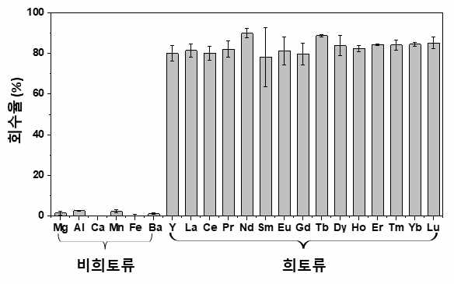
▲ Steel slag rare earth element recovery rate through the developed protein adsorbent

However, more research is needed to expand the production and application scale of the protein adsorbent for practical application.

The research was supported by the National Research Foundation of Korea (NRF), the Ministry of Science, and ICT, and the C1 Gas Refinery Project Group and was published online on December 26 in the international scientific journal Advanced Functional Materials.



