Development of a new conductive
polymer-based electrochemical diode device

– Realization of an aqueous electrolyte polymer diode device with the world’s highest current density and analog/digital electrolyte circuit configuration

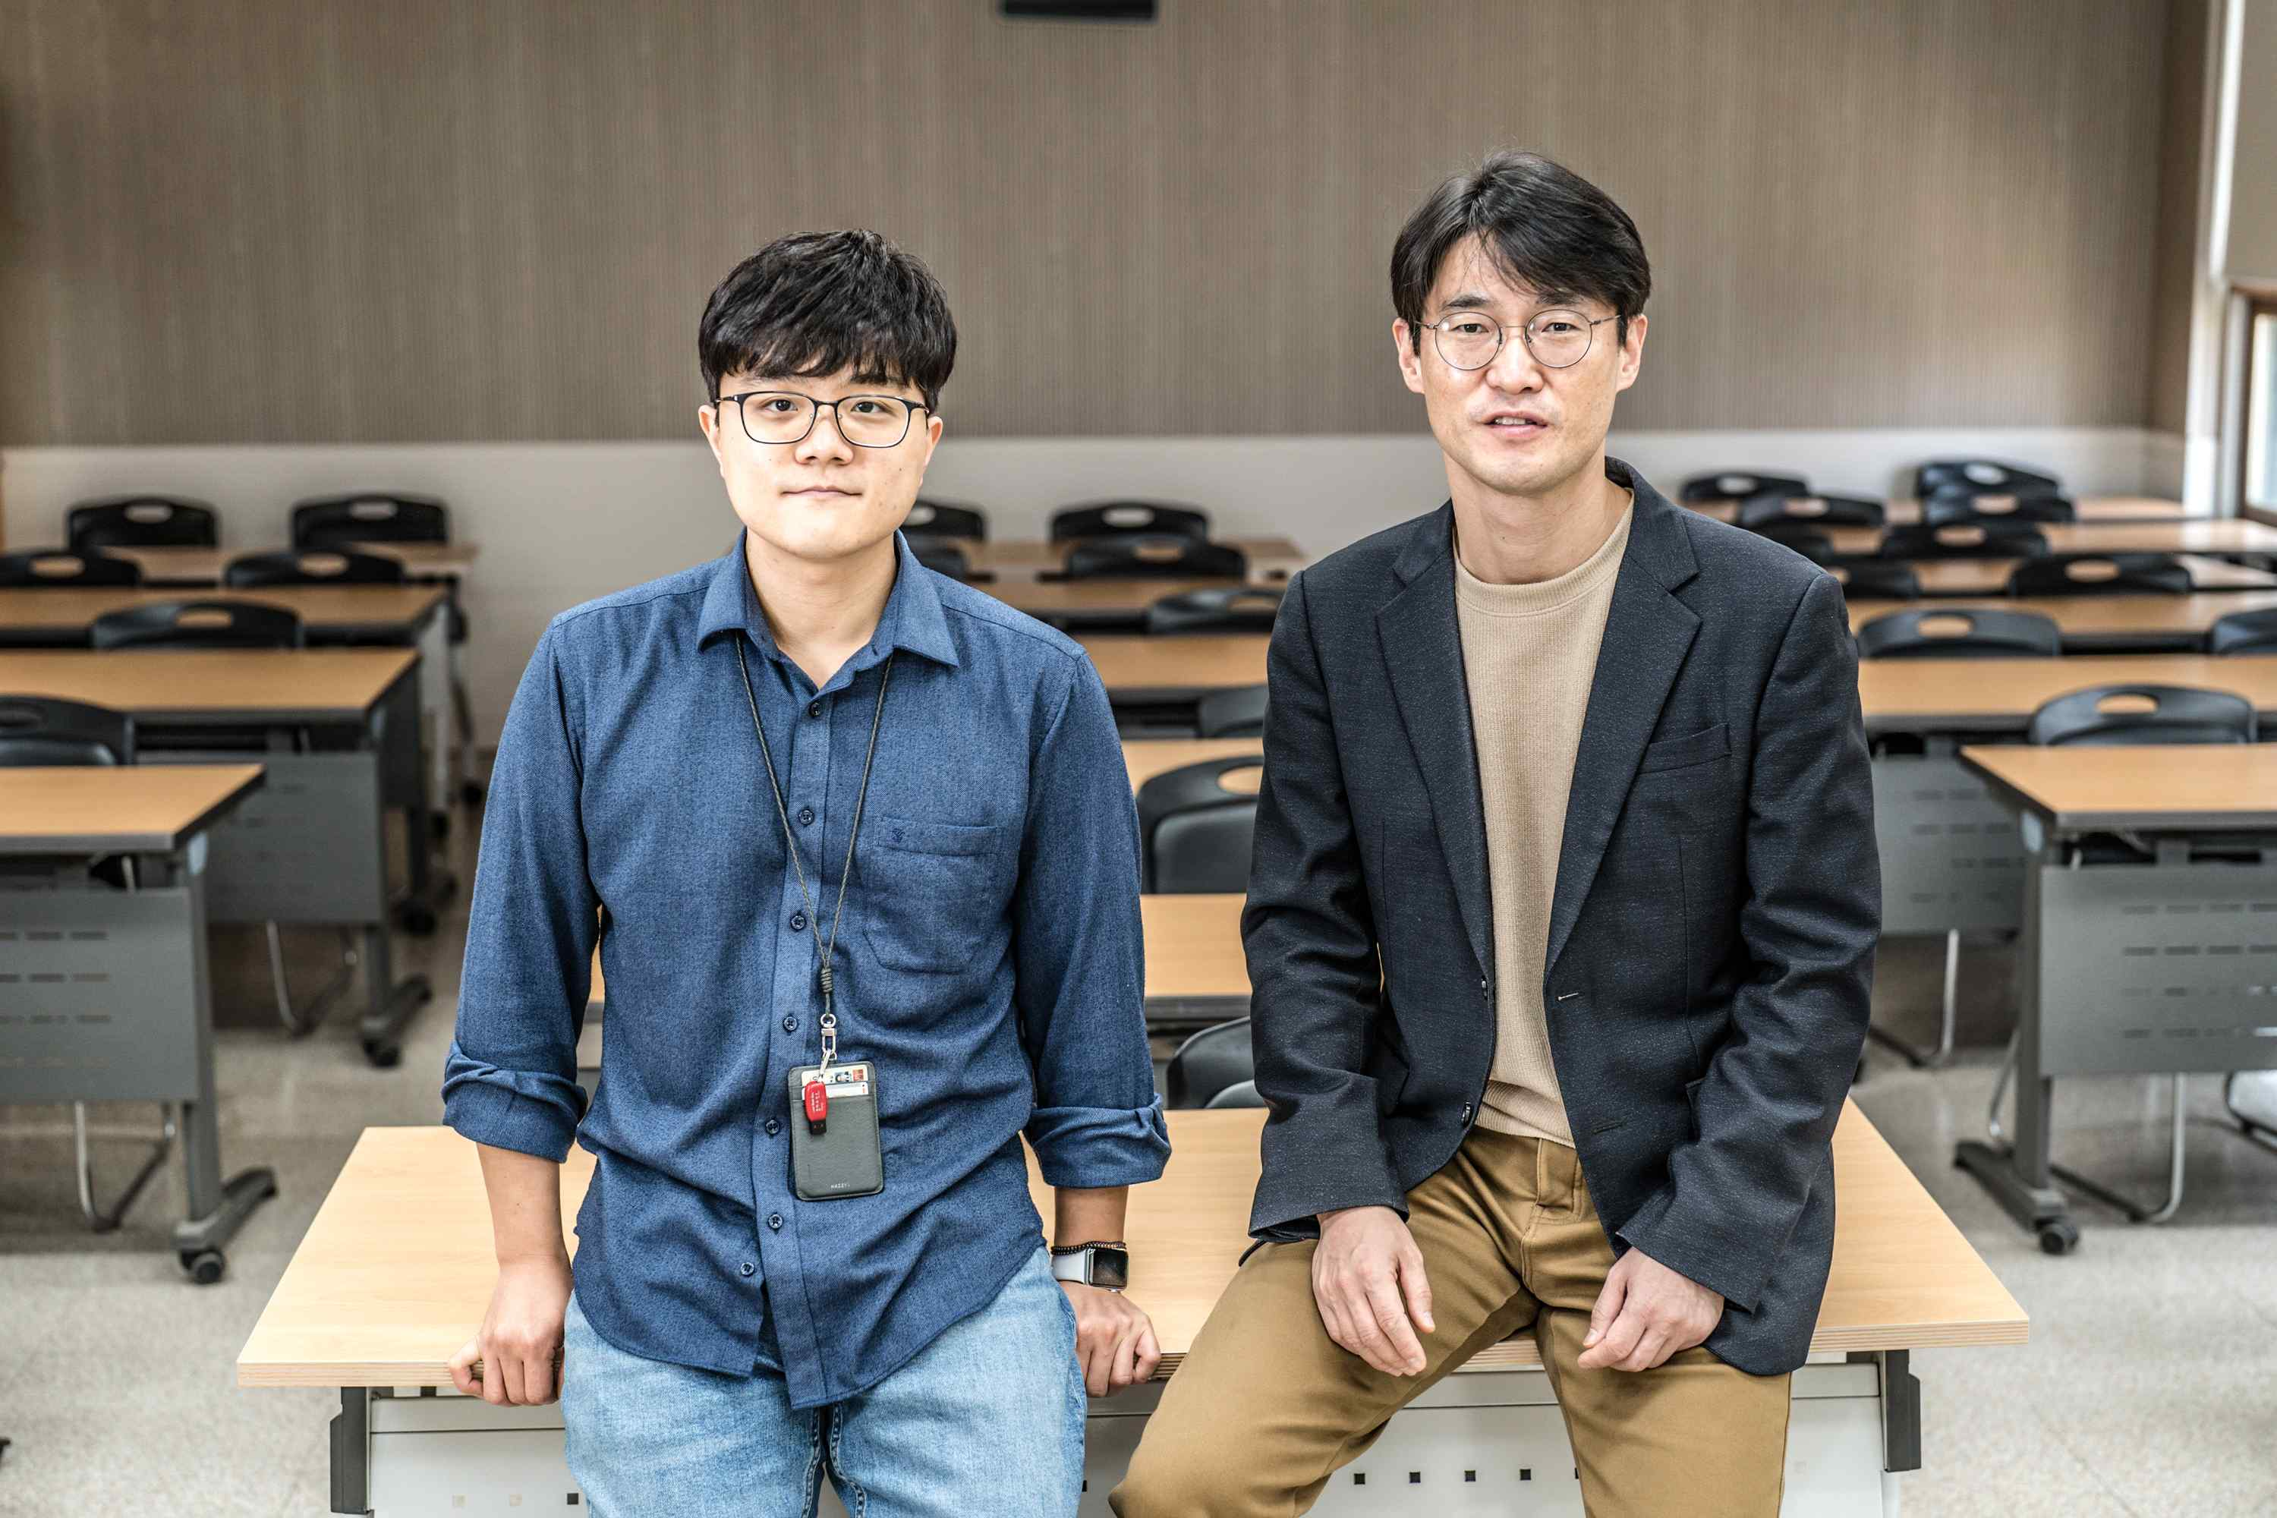
▲ From left: Ph.D. student Youngseok Kim and Professor Myung-Han Yoon

A conductive polymer-based electrochemical diode device with a new driving principle that can be applied to various bioelectronic devices and circuits was developed through international research collaboration. As an aqueous electrolyte polymer diode device with the world's highest current density, it is expected to contribute to the realization of next-generation implantable devices and circuits.

GIST (Gwangju Institute of Science and Technology, President Kiseon Kim) School of Materials Science and Engineering Professor Myung-Han Yoon's research team collaborated with Imperial College London Professor Martin Heeney's (currently a visiting professor at the GIST School of Materials Science and Engineering) research team to develop a new rectifying device using an organic mixed ionic-electronic conductor*.

* organic mixed ionic-electronic conductor (OMIEC): It is not a simple electrical conductor like a metal. As a material having both ion conductivity and electrical conductivity in an electrolyte, it is used as a semiconductor material for devices that amplify bioelectrical signals in an electrolyte environment and for flexible electronic devices

A typical organic-based diode is a junction of a p-type-n-type organic semiconductor. While it can be implemented through metal-organic semiconductor bonding, it requires sophisticated energy level control and has disadvantages in that it has low driving stability and low current characteristics.

The organic mixed conductor proposed in this study was able to realize high electrical properties due to the higher charge density compared to the existing organic semiconductor materials. Due to the nature of driving in the electrolyte, the rectification function could not be realized with the existing junction-type diode structure.

Rather than the current rectification driving principle through the bending of the energy level of existing junction diodes, the research team introduced a new current rectifying device using the concentrated/distributed doping/de-doping phenomenon according to the fabrication of an asymmetric active layer that can be realized by simple patterning.

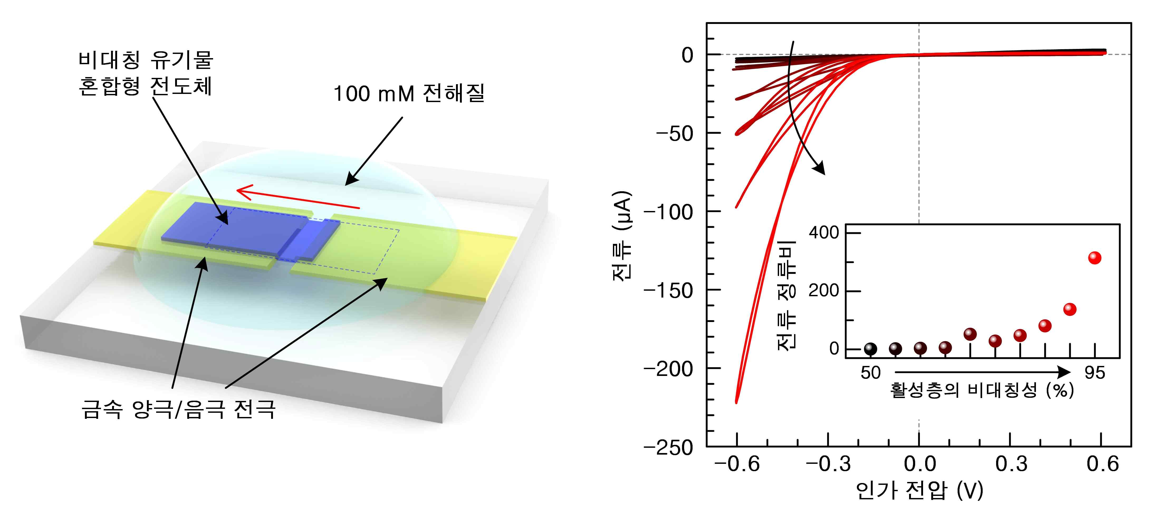
▲ Left: Schematic diagram of the device proposed in this study and (right) current rectification characteristic graph through asymmetric active layer formation

The feasibility of implementing this was confirmed using computer numerical analysis, and the driving mechanism was identified by experimentally measuring the potential distribution in the active layer using the real-time optical potential mapping technology during device operation and comparing it with the results of numerical analysis.

Finally, the organic electrochemical diode based on the organic mixed conductor succeeded in realizing a device with a high current density of 30,000 A/cm-2 even within a voltage range as low as 0.6 volts.

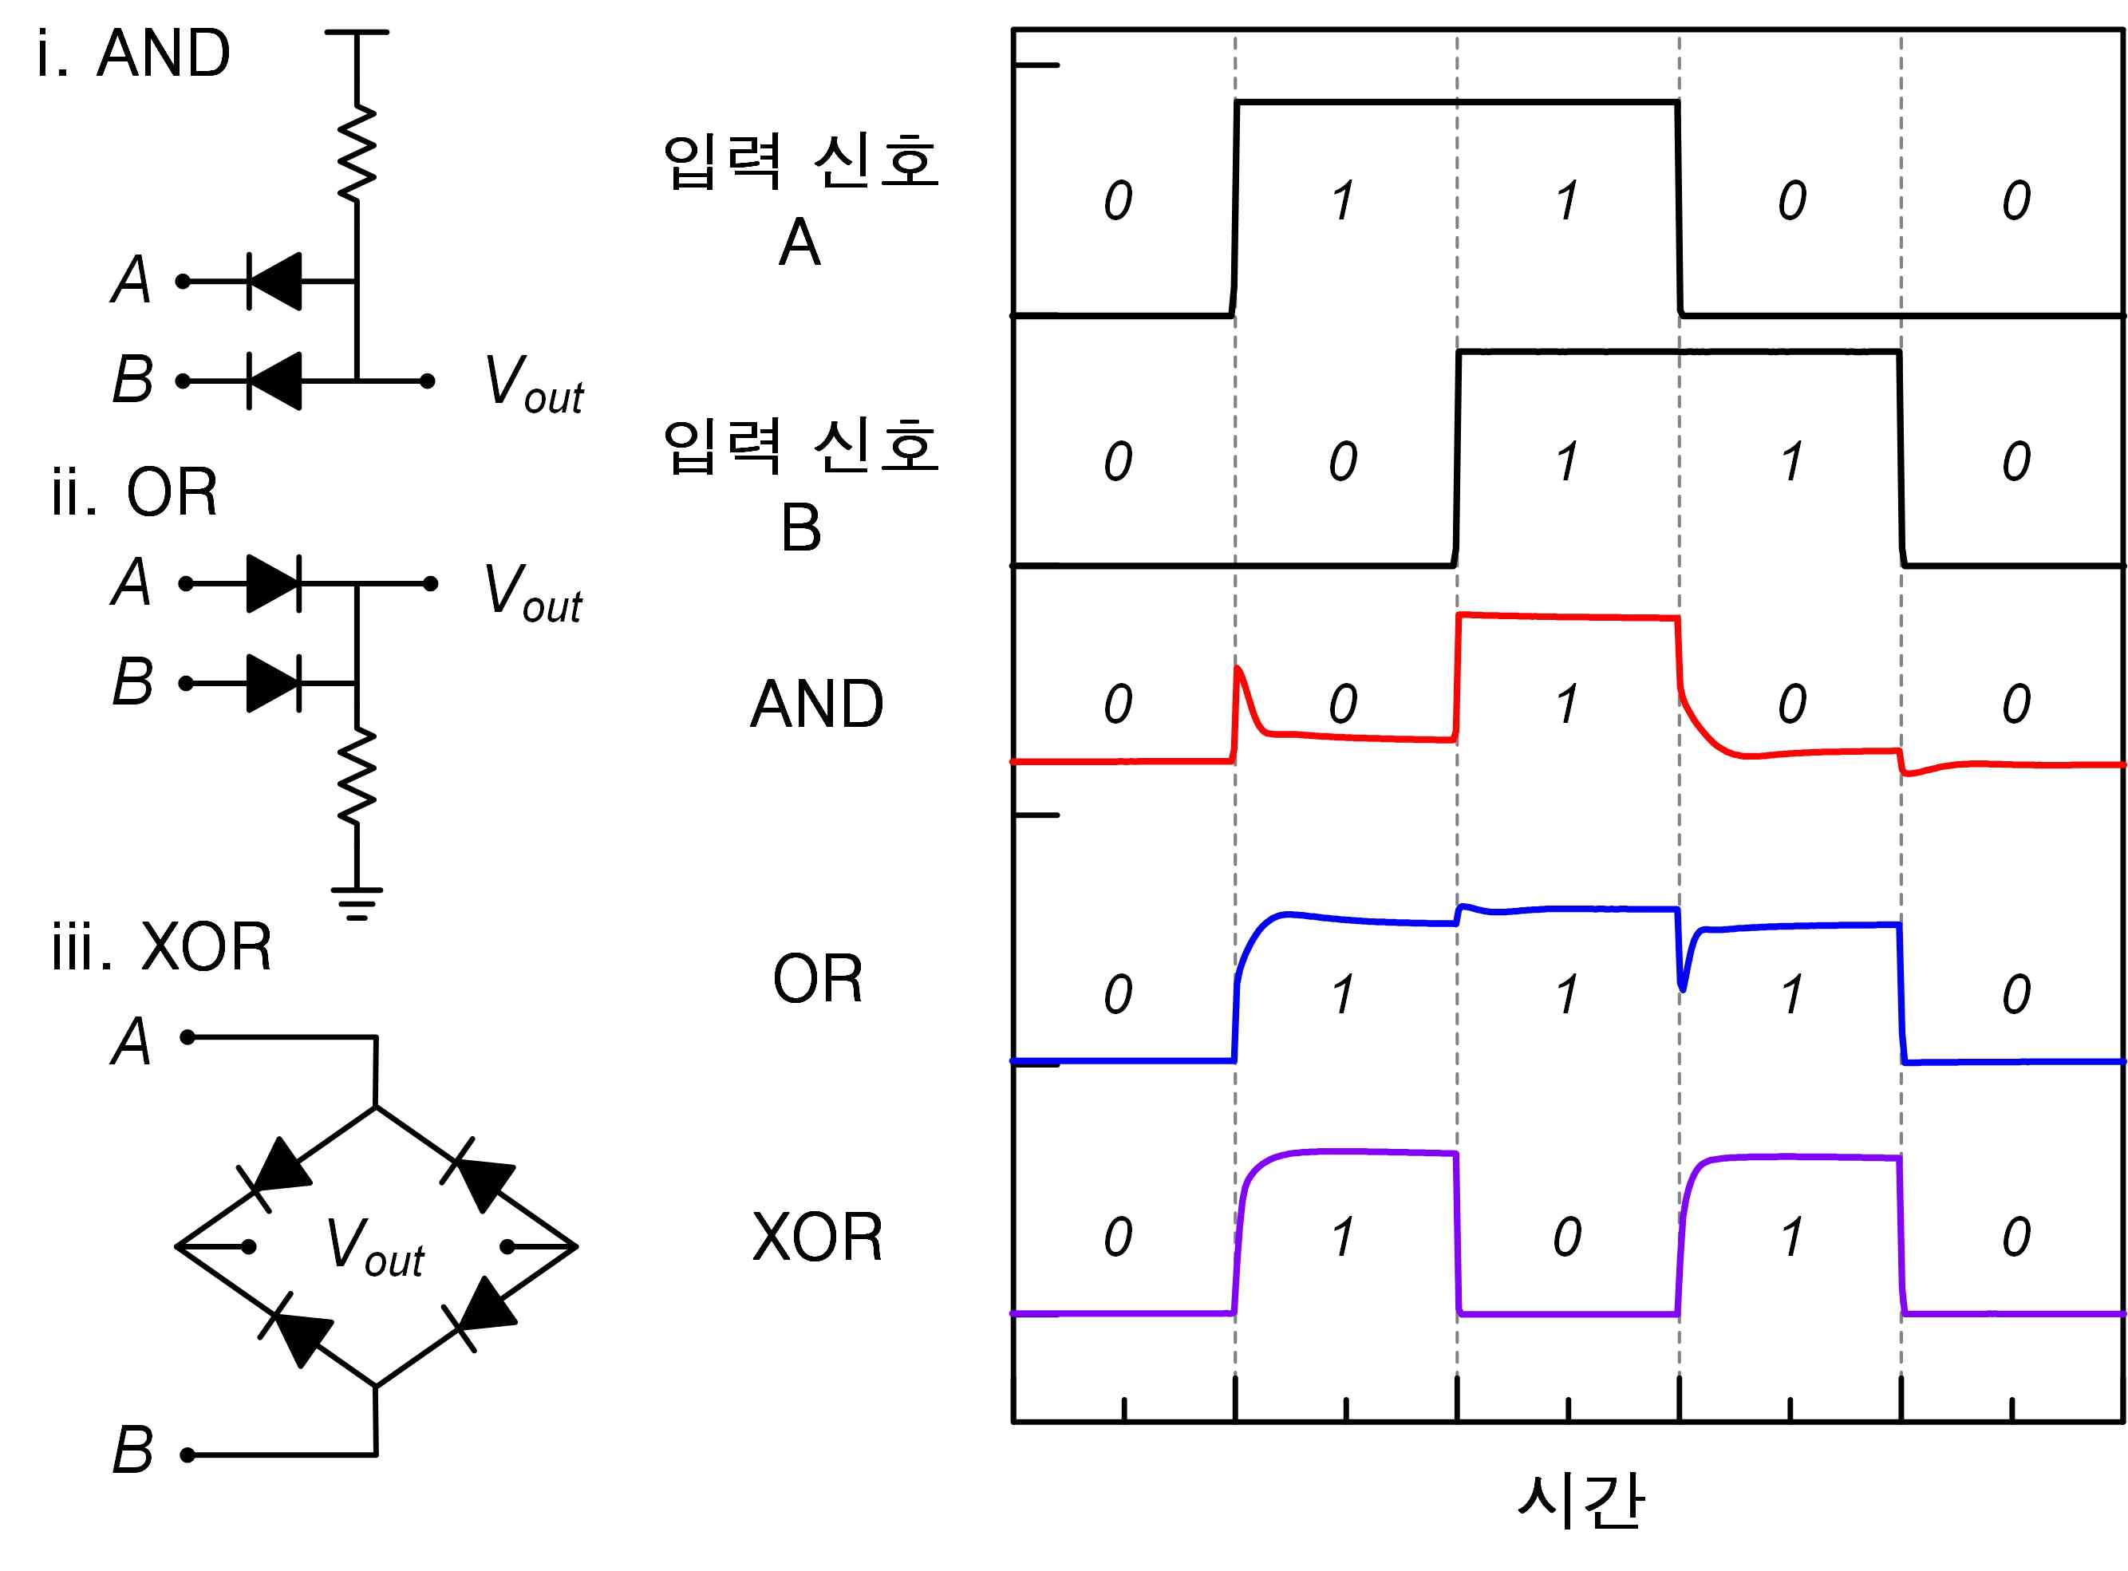
▲ Left: Schematic (AND, OR, XOR gate operation) of the digital signal processing circuit of the rectifier device manufactured in this study and (right) measurement result graph

Professor Myung-Han Yoon said, "Because it can be used in various application devices and application circuits that cannot be driven by organic electrochemical transistors alone, this is expected to greatly contribute to the realization of next-generation implantable bioelectronic devices."

This research was led by GIST Professor Myung-Han Yoon and Imperial College London Professor Martin Heeney and was conducted by GIST Ph.D. student Youngseok Kim, master's student Gunwoo Kim, and Imperial College London Ph.D. student Bowen Ding with support from the National Research Foundation of Korea and the GIST Research Institute and was published online on January 10, 2022, in Advanced Materials, a prestigious scientific and technological journal.



