Development of high-performance, eco-friendly mixed conductors for human transplants

– Development of n-type electrochemical material using an eco-friendly aqueous solvent with improved electrical properties of three of more times compared to the existing organic solvent process
– Expected to greatly contribute to the realization of next-generation complex circuit-type healthcare devices


▲ From left: GIST Professor Myung-Han Yoon, KAIST Professor Bumjoon J. Kim, GIST Ph.D. student Il-Young Jo, KAIST integrated M.S./Ph.D student Dahyun Jeong, and Ph.D. student Seungjin Lee

A Korean research team has succeeded in developing a high-performance, eco-friendly mixed conductor that maximizes the performance required for an implantable electronic device and this is attracting attention for next-generation bioelectronic interface devices.

GIST (Gwangju Institute of Science and Technology, President Kiseon Kim) School of Materials Science and Engineering Professor Myung-Han Yoon's research team collaborated with KAIST (President Kwang-Hyeong Lee) Department of Chemical and Biomolecular Engineering Professor Beom-Jun Kim's research team and developed a high-performance n-type organic mixed ionic-electronic conductor (OMIEC)* capable of eco-friendly water-based solvent processing, and they also investigated the effect of water-based solvents on polymer microstructure as well as electrical/electrochemical performance improvements.

* organic mixed ionic-electronic conductor (OMIC): It is not a simple electrical conductor like a metal. As a material having both ion conductivity and electrical conductivity in an electrolyte, it is used as a semiconductor material for devices that amplify bioelectrical signals in an electrolyte environment and for flexible electronic devices.

Because the organic compound-type conductor-based electrochemical transistor can amplify and switch signals by injecting ions in the electrolyte, it is possible to check various bioelectrical signals such as brain, heart, and muscle through implants and attachments inside and outside the body. Research is being actively conducted to apply them to next-generation biohealthcare.

However, most electrochemical transistor devices are based on p-type organic semiconductors*, and n-type organic semiconductors** studies are rare. Until now, in the case of organic mixed-type conductors, as the carrier mobility*** in the n-type is more than 100 times lower than the charge mobility in the p-type, research is essential for the manufacture of various transistor-based applied devices and logic circuits in the future.

* p-type organic semiconductors: an organic semiconductor having a main chain of a conjugated structure and a hole as a main carrier

** n-type organic semiconductors: organic semiconductors with electrons as main carriers and a conjugated main chain

*** carrier mobility: mobility of charged electrons and holes in semiconductors

The joint research team developed an amphiphilic conductor material to improve the low electron mobility problem of an n-type organic compound-type conductor and manufactured an electrochemical transistor device.

By applying a large amount of oligo ethlyele glycol (OEG) groups to the side branches of the polymer monomer, it was dissolved in an aqueous solvent composed of ethanol and water. The electrochemical properties were compared and analyzed with the same material dissolved in chloroform, a halogen-based organic solvent used in the existing solution process.

In the case of ethanol and water solvents, hydrophilic oligo ethylene glycol side chains can be dissolved, but hydrophobic main chains cannot be dissolved, so they exist in the form of aggregated micelles in solution. When chloroform is used, both the side chain and the main chain exist in a well-dissolved state. In the micellar-type main chains, interaction with ethanol and water molecules is minimized, leading to a strong pi-pi stacked form between the main chains in the solution phase. It was confirmed that high crystallinity appeared in thin films of several tens of nanometers prepared through the solution coating process.

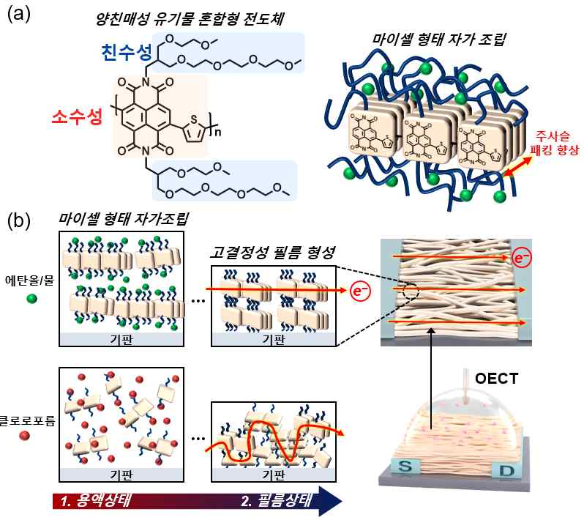
▲ (a) Schematic diagram of the molecule proposed in this study (b) Schematic diagram of the micelle-type self-assembly process of polymers through solvent change and the structure of the formed film

When this was applied to the active layer of the accumulation mode electrochemical transistor device, it was confirmed that the electron mobility and the figure of merit* increased by more than three times compared to the device prepared using the conventional organic solvent of chloroform.

* figure of merit (μC): a value to evaluate the characteristics of an electrochemical transistor and expressed as the product of charge mobility and volumetric capacitance (μC*)

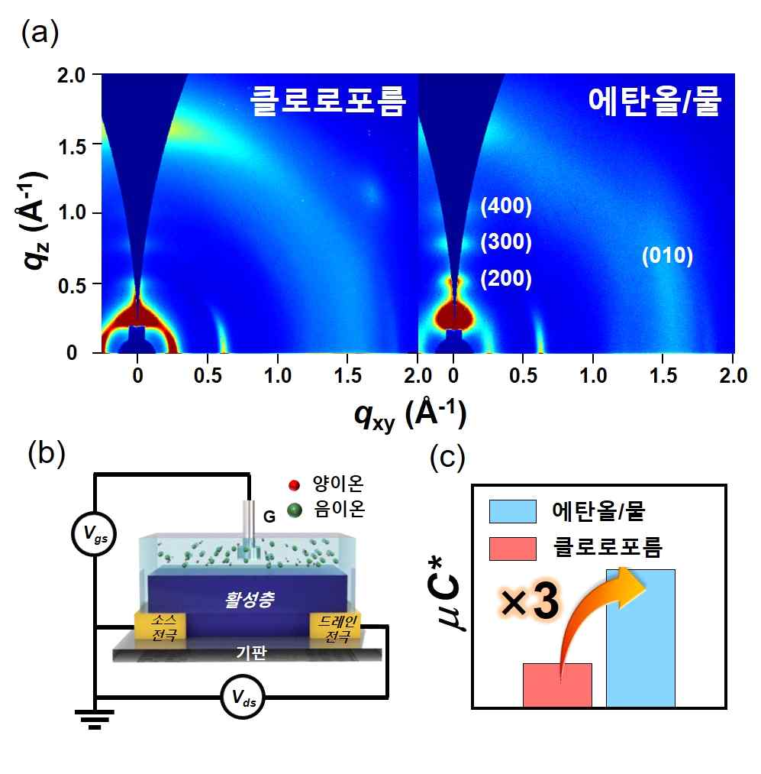
▲ (a) Crystallinity measurement results according to solvents proved by x-ray experiments (b) Device structure of organic electrochemical transistors (c) Transistor figure of merit graphs according to solvents

GIST Professor Myung-Han Yoon said, "This is expected to greatly contribute to the realization of next-generation composite circuit-type bioelectronic devices by simultaneously improving eco-friendliness and electron mobility characteristics of n-type electrochemical transistors."

KAIST Professor Beom-Jun Kim said, "This study is significant in that it suggests a strategy for synthesizing organic polymers suitable for the production of high-performance, human-implantable electrochemical devices that can be eco-friendly."

This research was led by GIST Professor Myung-Han Yoon and KAIST Professor Beom-Jun Kim and jointly conducted by GIST Ph.D. student Il-Young Jo, KAIST integrated M.S./Ph.D student Dahyun Jeong, and KAIST Ph.D. student Seungjin Lee with support from the Nano and Material Technology Development Project and was published online on January 5, 2022, in Advanced Functional Materials, an authoritative journal specializing in science and technology.



