Development of technology to quickly & easily diagnose battery deterioration after use

– Announcing a non-degradable diagnostic method to quickly and simply determine the status of cells using high-speed
charge/discharge data

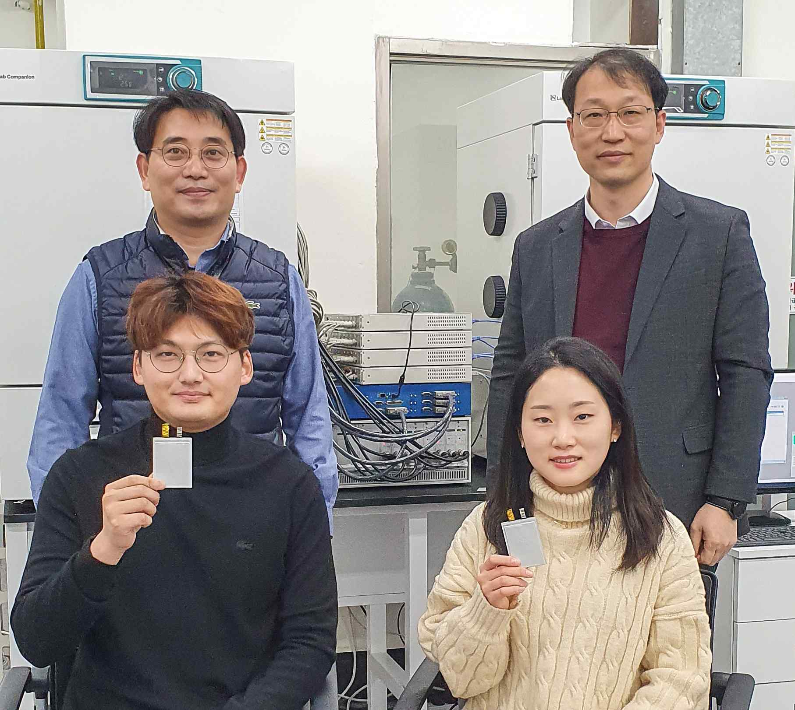
▲ Clockwise from top left: Inha University Professor Jinsub Choi, GIST Professor Jae-Young Lee,
Inha University Ph.D. student Jaeyun Ha, and GIST researcher Gyuwon Seo

A Korean research team has proposed a technology for rapidly diagnosing the deterioration of a battery, which is pointed out as the biggest cause of the abnormally fast rate of shorter battery life.

GIST (Gwangju Institute of Science and Technology, President Kiseon Kim) School of Earth Sciences and Environmental Engineering Professor Jae-Young Lee's research team collaborated with Inha University Department of Chemistry and Chemical Engineering Professor Jinsub Choi's research team laid the foundation for a method for rapidly diagnosing the deterioration state of lithium-ion batteries by using using IC-DV data of high-speed charge/discharge data.

Lithium-ion batteries are known to suffer from various deterioration factors that lower their capacity during repeated charge and discharge sessions. Although it is difficult to distinguish clearly because each factor influences the other in a complex way, it is mainly divided into three types: loss of lithium inventory (LLI), loss of active material (LAM), and conductivity loss (CL).

LLI is a degradation mode in which a solid electrolyte interface (SEI layer) is gradually formed on the surface of the anode due to the decomposition reaction of the electrolyte, and the lithium ion source is depleted due to the consumption of the electrolyte. On the other hand, if lithium is repeatedly inserted and de-inserted into the lattice of the negative electrode and positive electrode active material, the particle structure may deteriorate and the capacity may decrease, and this is classified as a LAM degradation. In addition, when the electrode is separated from the current collector or ion and electron mobility is reduced due to cracks between electrode materials, conductivity loss may occur and it is classified as CL.

Although various methods exist to analyze the deterioration mode of lithium-ion batteries, IC-DV (Incremental capacity-differential voltage analysis), the most widely used method of determining the deterioration state without disassembling the cell, is There is a problem that the measurement time is very long because the voltage curve must be obtained in a quasi-equilibrium state.

Although various methods exist to analyze the deterioration mode of lithium-ion batteries, IC-DV (incremental capacity-differential voltage analysis), the most widely used method of determining the deterioration state without disassembling the cell, is not optimal because the measurement time is very long as the voltage curve must be obtained in a quasi-equilibrium state.

The research team manufactured pouch-type cells of 0.25Ah and 1Ah with graphite anode and LiNi_{0.5}Mn_{0.3}Co_{0.2}O₂ cathode active material, and deteriorated them under high-speed charging and discharging conditions at 45°C at the rates of 4C and 6C. The voltage curve obtained as the cycle progressed was converted into dQ/dV and dV/dQ to confirm which side of the positive and negative capacity degradation occurred more predominantly. Thereafter, the LLI and LAM values were compared and analyzed from the voltage curves of the low-speed (0.1C) data and high-speed (4C, 6C) data, which are in a similar open circuit state.

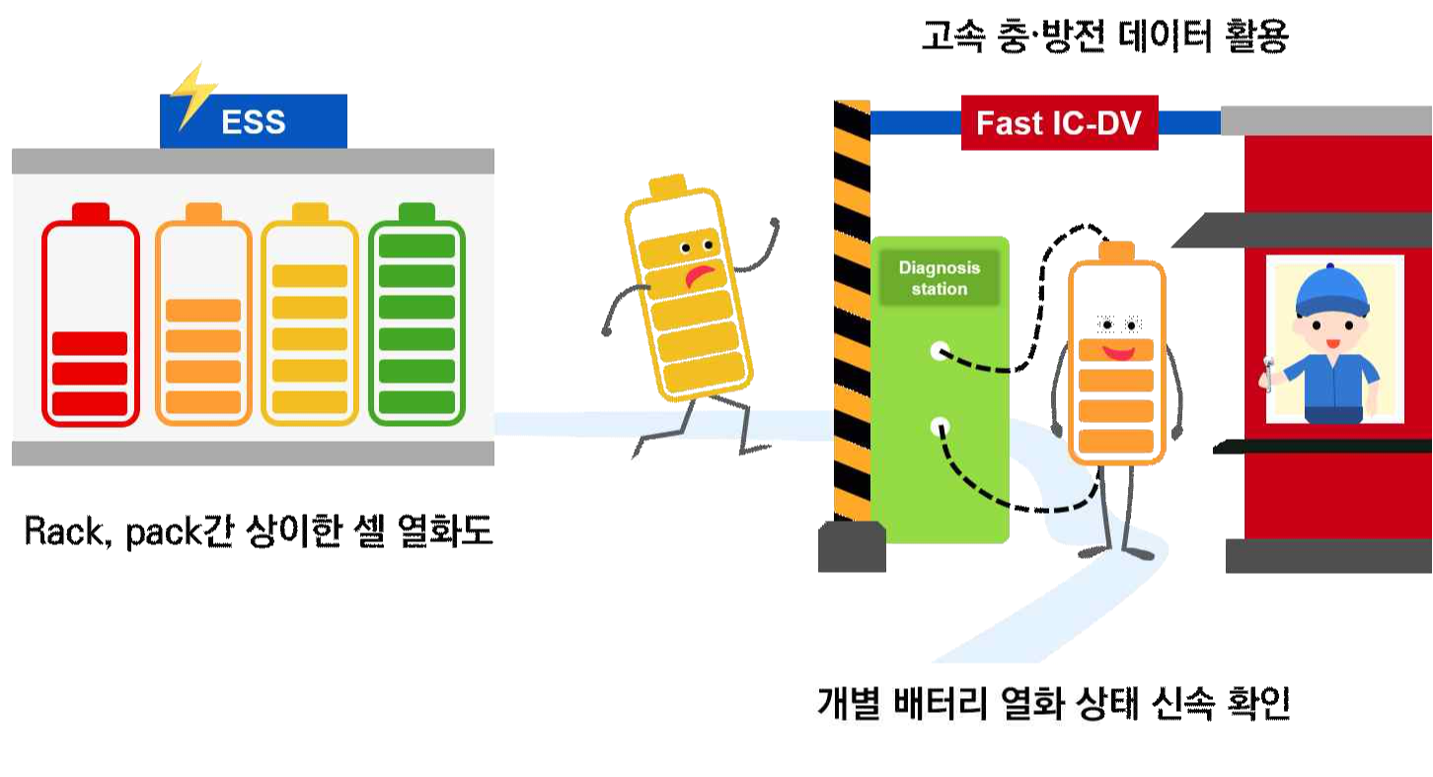
▲ Conceptual diagram of the meaning of estimating the degree of deterioration of battery
capacity quickly and simply by using high-speed charging and discharging data

The research team confirmed the nonlinearity between C-rate and LAM and linearity with LLI by comparing low-speed IC-DV and high-speed IC-DV. The capacity of the deteriorated cells was less affected by the change in C-rate. They confirmed that this was due to the accelerated diffusion characteristics due to the deterioration of the active material of the deteriorated cell.

In addition, it was confirmed that the LLI was proportional to the growth of the SEI layer of the cathode and could be extrapolated from the fast charge/discharge data. This research provides a simple process to analyze the complex degradation modes in high-current cycling within a limited time, which may be useful in on-board battery management systems.

GIST Professor Jae-Young Lee said, "This research can be used for important basic data to prepare the reuse standards for waste batteries, which are expected to be generated in large quantities in the next few years."

Inha University Professor Jinsub Choi said, "This research will be able to contribute economically and environmentally by simply checking the health status of the cell in a short time."

This research was led by GIST Professor Jae-Young Lee (co-corresponding author) and Inha University Professor Jinsub Choi (co-corresponding author) and conducted by Inha University Ph.D. student Jaeyun Ha (co-first author), and GIST researcher Gyuwon Seo (co-first author) and was supported by the Korea Electric Power Corporation and published online on November 17, 2021, in the Journal of Energy Chemistry, an international academic journal in the field of applied chemistry (impact factor for 2021: 9.676 / applied chemistry: 2/74 top 2.7%).



