Discovery of new dementia treatment
using ultrasound brain stimulation

– Non-invasive reduction of amyloid-β is one of the major
challenges in developing Alzheimer's disease treatment


▲ From left: Ph.D. student Mincheol Park, Professor Tae Kim,
Professor Jae Gwan Kim, and master's student Hoang Gia Minh

Alzheimer's disease is a disease in which plaque aggregation of amyloid-β protein and tau protein accumulate in the brain, causing neurodegeneration and cognitive decline, and is known to be the most common cause, accounting for 60-70% of dementia. A Korean research team has developed a new treatment that can help dementia with brain stimulation using ultrasound.

GIST (Gwangju Institute of Science and Technology, President Kiseon Kim) Department of Biomedical Science and Engineering Professor Tae Kim and Professor Jae Gwan Kim's joint research team reported that brain stimulation using ultrasound reduced amyloid-β* plaques and improved brain connectivity in 5xFAD, which is an Alzheimer's disease mouse model.

* amyloid-β: a polypeptide found in the brain of Alzheimer's patients and is known as one of the causative agents of Alzheimer's disease

The development of a drug for Alzheimer's disease based on the amyloid-β hypothesis has not made great progress despite many efforts. This research suggests the possibility of developing non-pharmacological treatments and is attracting attention as a method that can overcome the limitations of existing pharmacological treatments.

To develop a new treatment, the research team used ultrasound to stimulate the brain of an animal model of Alzheimer's disease with a gamma band of 40 Hz. An ultrasonic wave generating device was attached to the skull of the mice and ultrasonic stimulation was performed for 2 hours a day for 2 weeks in a state where they were able to move freely. As a result, it was confirmed that the level of amyloid-β in the brain decreased in the stimulation group.

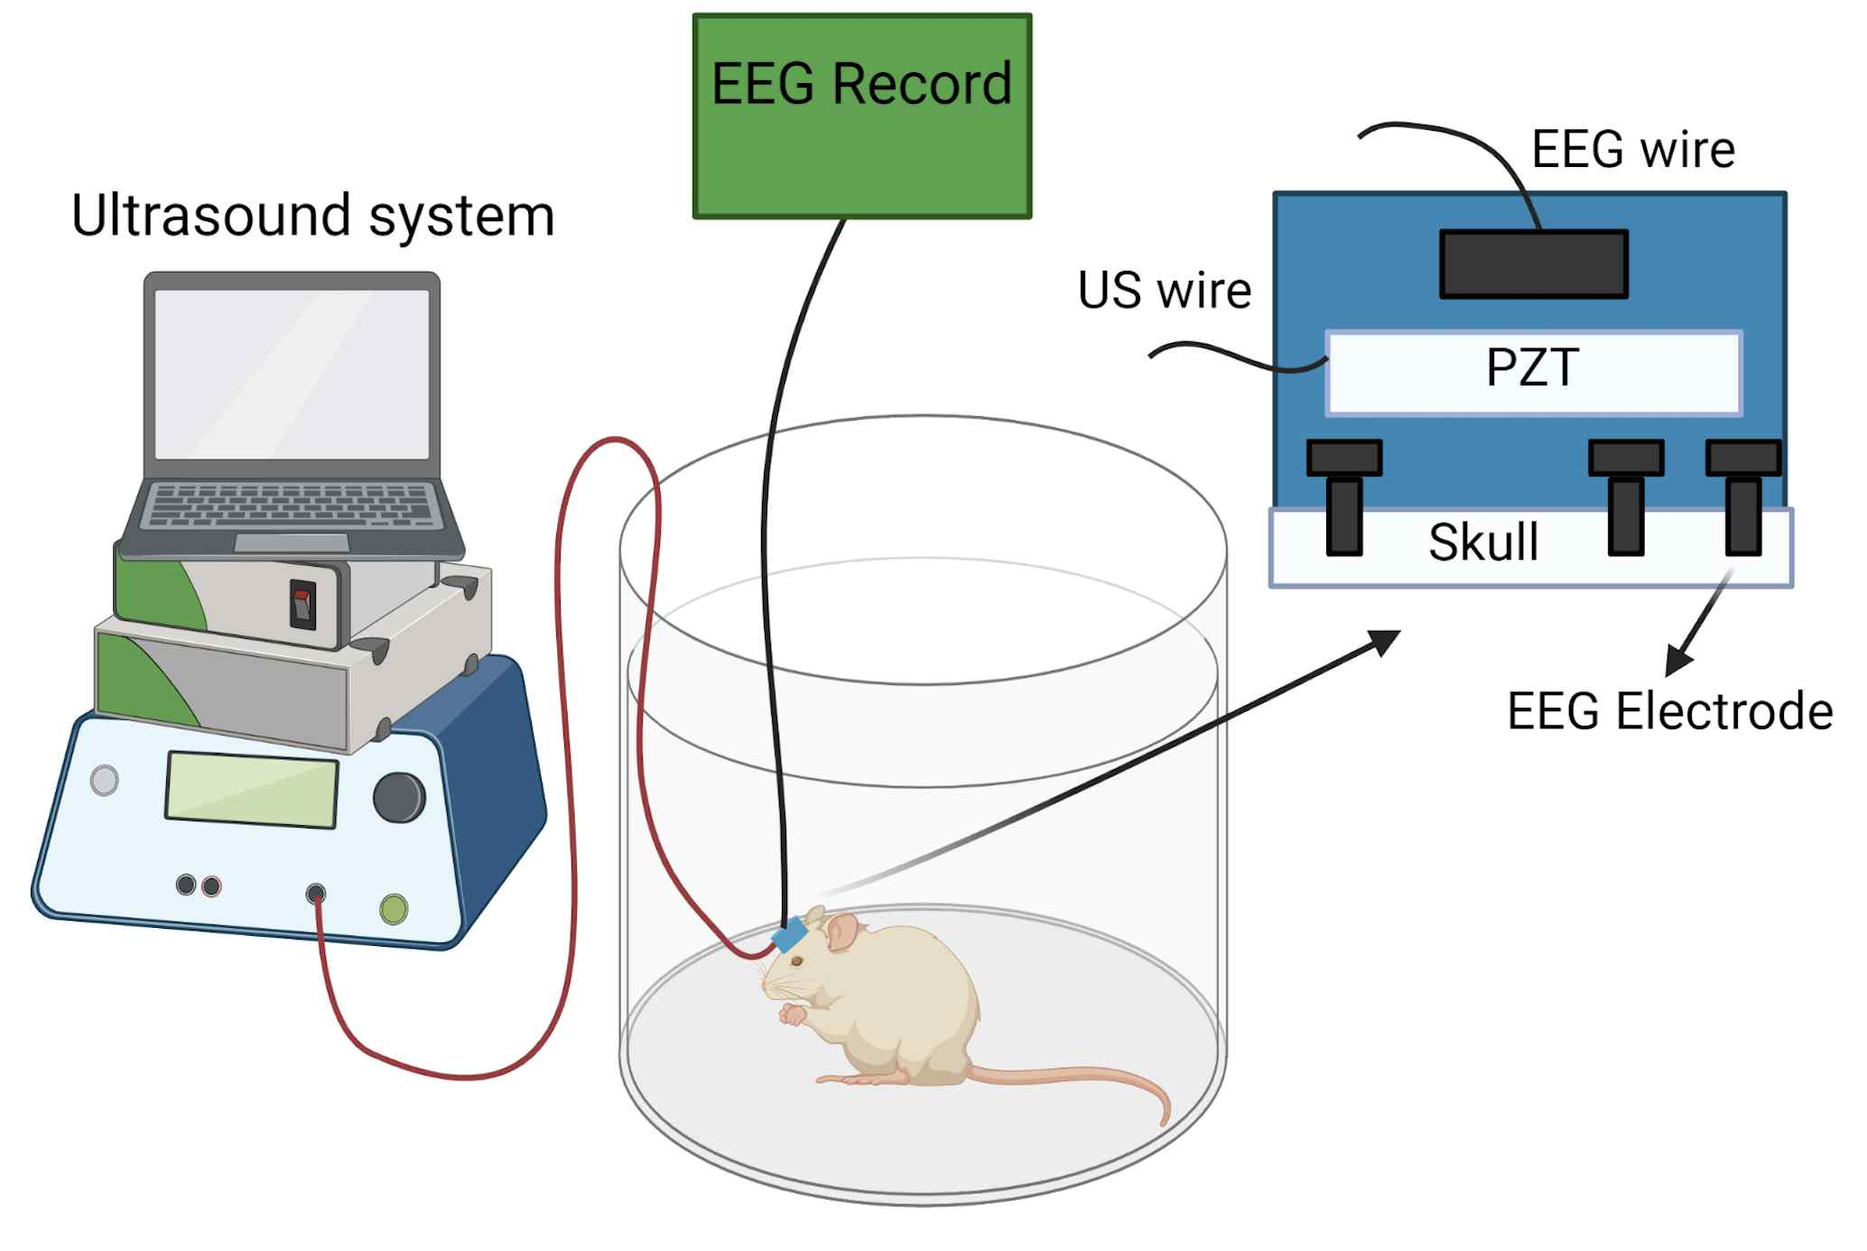
▲ Schematic diagram of transcranial ultrasound stimulation

In addition, the research team fixed EEG-measuring electrodes on the skull and analyzed EEG changes before and after ultrasound stimulation. An increase in EEG in the 40 Hz band and an increase in phase-frequency coupling were observed, and this improvement in brain activity means improved brain function.

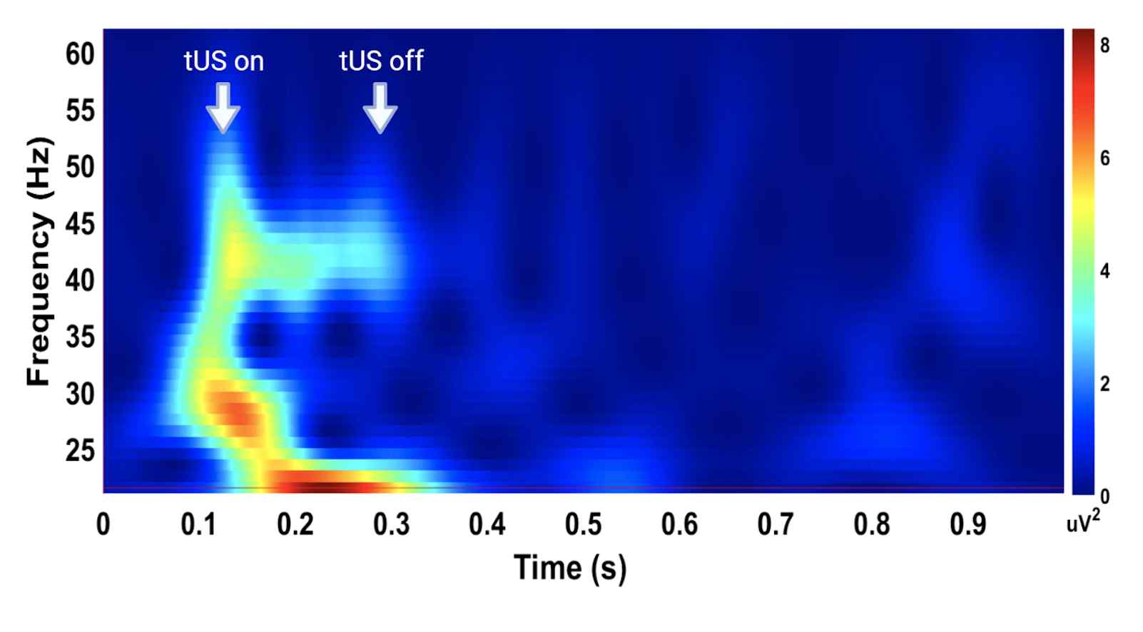
▲ EEG response to 40 Hz band ultrasonic stimulation

Professor Tae Kim and Professor Jae Gwan Kim said, "This research is the result of convergence research between two research teams from different fields of study. The non-pharmacological and non-invasive method of reducing amyloid-β using ultrasound is relatively safe and has few concerns about side effects. If efficacy is confirmed in Alzheimer's patients, it is expected to be used clinically in the near future."

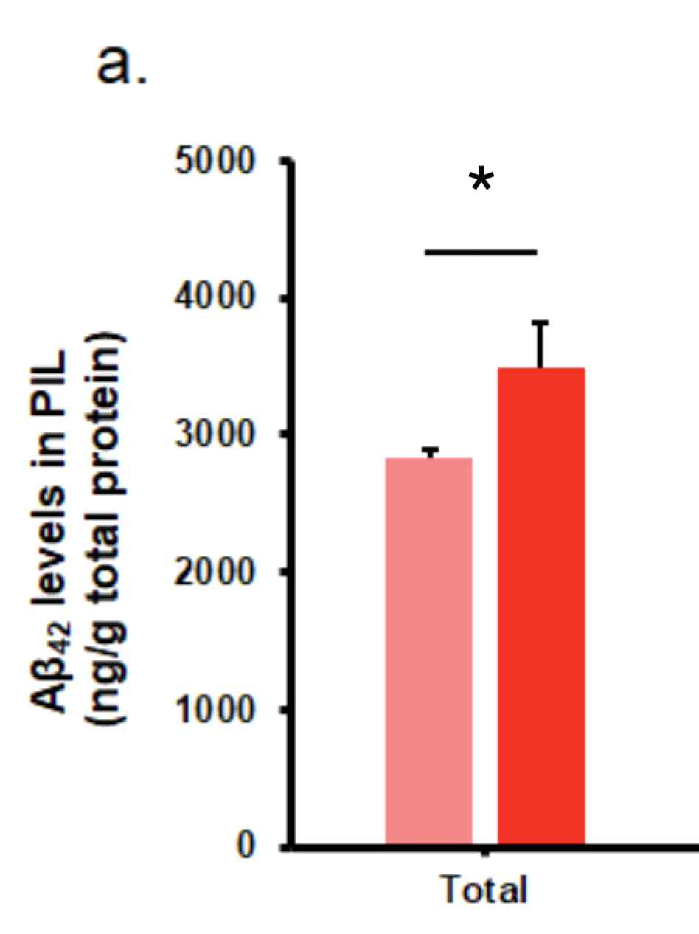
▲ Amyloid beta decrease in the stimulation group
(stimulation group: pink, non-stimulation group: red)

This research was led by GIST Professor Tae Kim and Professor Jae Gwan Kim and was conducted by Ph.D. student Mincheol Park and master's student Hoang Gia Minh as co-first authors with support from the National Research Foundation of Korea and the Korea Brain Research Institute funded by the Ministry of Science and ICT and was published online on December 7, 2021, in the prestigious neuroscience journal Translational Neurodegeneration (impact factor 8.014).



