Finding clues to overcome the limits
of application of gene scissors

- Newly identifies the core process of double helix DNA cutting of major genetic scissors

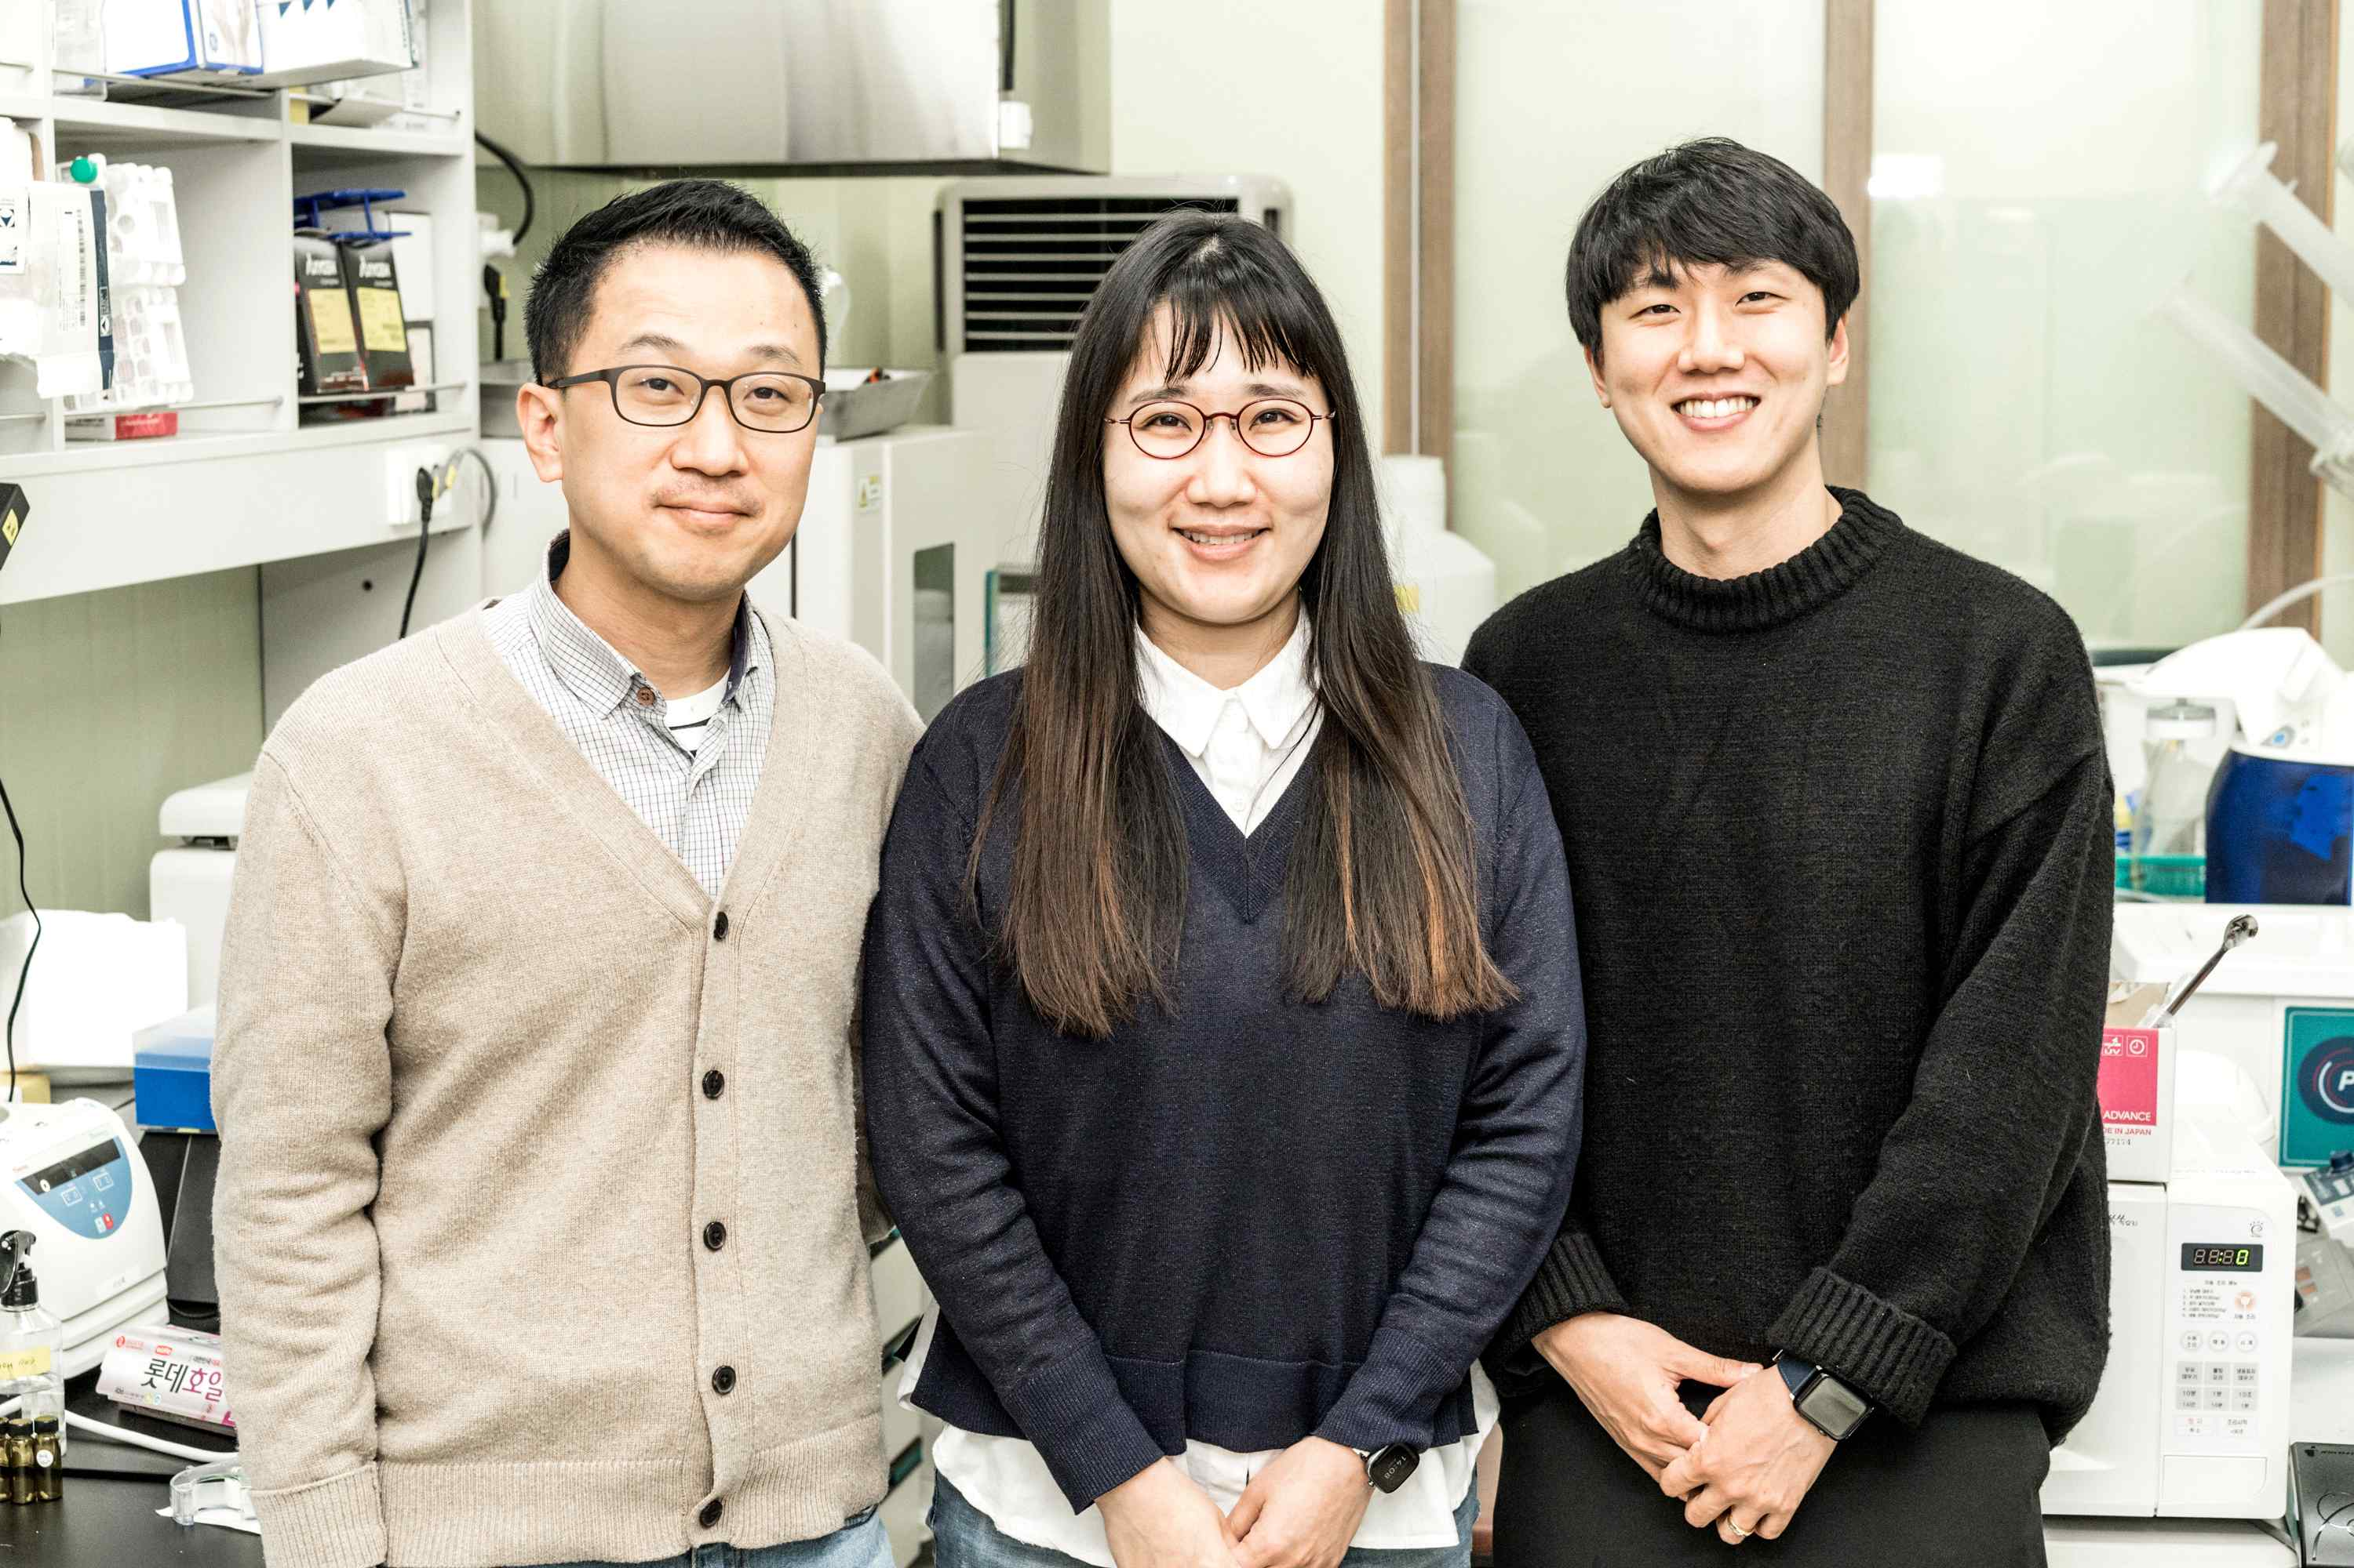
▲ From left: Principal researcher Sanghwa Lee, post-doctoral
researcher Heyjin Son, and researcher Jaeil Park

A Korean research team has found a clue to the development of a new gene scissors that can be used innovatively for next-generation gene editing and ultra-sensitive gene detection technology using single-molecule fluorescence imaging technology.

GIST (Gwangju Institute of Science and Technology, President Kiseon Kim) Advanced Photonics Research Institute (APRI) Principal researcher Sanghwa Lee's research team announced that the Cas12a CRISPR gene scissors had identified a molecular mechanism that completely cuts double-stranded DNA with only a single catalytically active site.

The Cas12a gene scissors is attracting attention as an attractive gene scissors that can replace Cas9, a representative gene scissors, due to its differentiated characteristics such as a relatively low off-target effect and indiscriminate single-stranded DNA cleavage activity.

In particular, the indiscriminate single-stranded DNA cleavage activity of Cas12a gene scissors has recently been utilized in a technology to detect trace amounts of nucleic acid of a specific nucleotide sequence, leading to the development of a COVID-19 diagnostic kit approved by the US FDA.

However, despite these advantages, the Cas12a gene scissors, unlike Cas9, lacks the technology to precisely control the DNA cleavage activity, so it is not properly utilized for the cutting-edge gene editing technologies such as base and prime editing.

In a previous study published in Nature Communications three years ago, the research team found that the Cas9 gene scissors independently cut double-stranded DNA into two catalytically active sites, but the Cas12a gene scissors cut through a single catalytically active site. It has been found that the double-stranded DNA of the target is cut sequentially.

Therefore, unlike Cas9, which can control DNA cleavage activity relatively easily through mutation of each of the two catalytically active sites, in the case of Cas12a gene scissors, where a single catalytically active site sequentially cuts the double-stranded strand of the target DNA, it is difficult to precisely control the DNA cutting activity.

In this regard, to secure a technology to precisely control the DNA cleavage activity to increase the versatility of the Cas12a gene scissors, it was necessary to elucidate the key process and regulatory mechanism of the complete double-stranded DNA cleavage reaction by the single catalytically active site of the Cas12a gene scissors.

To observe in real time the structural change of the Cas12a gene scissors-DNA complex that occurs in the process of completely cutting double-stranded DNA after the Cas12a gene scissors cut the first DNA strand with a single catalytically active site, the research team conducted single-molecule fluorescence imaging in real time using a single molecule fluorescence imaging technology (single molecule fluorescence frets).

Through this, it was observed for the first time that the Cas12a gene scissors-DNA complex undergoes two consecutive structural rearrangements to complete double-stranded DNA cleavage with a single catalytically active site. In particular, it was found that the essential step for target DNA cleavage is local unwinding of the cleavage site, and magnesium ions play a decisive role in stabilizing this structure.

These results extend the existing understanding that magnesium ions contribute to the cleavage activity of the catalytic site and are the first to suggest that magnesium ions also affect structural changes essential for CRISPR operation.

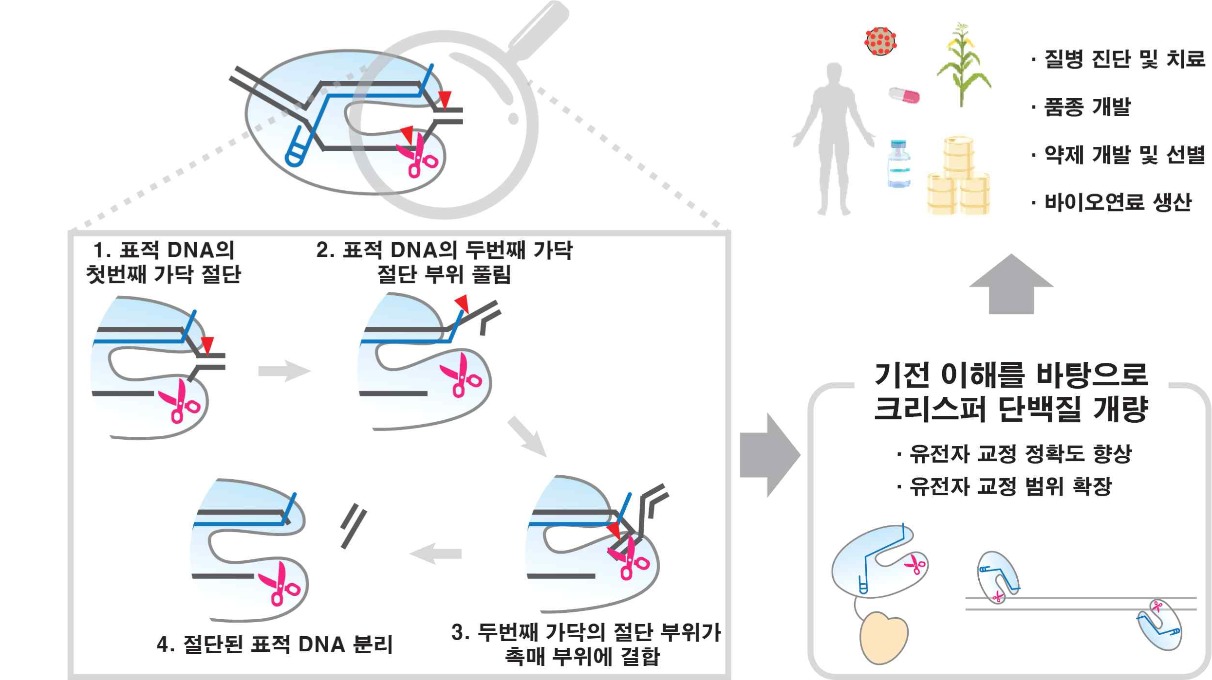
▲ The key process and expected effects of CRISPR/Cas12a gene scissors cutting the target DNA.

Based on the mechanism identified in this study, the research team plans to promote the discovery of various gene scissors with precisely regulated DNA cleavage activity.

This research was supported by the National Research Foundation of Korea grants funded by the Ministry of Science and ICT and by a GIST Research Institute grant and were published online on December 1, 2021, in the Proceedings of the National Academy of Sciences (PNAS), a world-renowned academic journal from the United States.



