Quantum gyroscope theory presented

- At least 4 times higher resolution than existing fiber optic gyroscopes
- Applied wave quantum sensing based on coherence de Broglie waves (CBW)
to Sagnac interferometers


▲ Professor Byoung S. Ham

GIST (Gwangju Institute of Science and Technology, President Kiseon Kim) School of Electrical Engineering and Computer Science Professor Byoung S. Ham (GIST Center for Photon Information Processing, director) published a quantum gyroscope theory that applied coherence de Broglie waves (CBW), a result of quantum wave optics, to Sagnac interferometers.

Professor Byoung S. Ham proposed a new principle that can implement a quantum gyroscope that exceeds the resolution of the existing Sagnac gyroscope at least 4 times under the same conditions, securing a method to dramatically improve the resolution of the gyroscope in geodesy, which is essential for earth science as well as inertial navigation, which is essential for unmanned flights, guided weapons, submarines, and spacecraft.

A gyroscope is an experimental instrument for observing the mechanical motion of a rotating body, and an optical fiber gyroscope is a representative example. Recently, micro-electromechanical system (MEMS) technology is applied to produce ultra-small electronic components. It is widely used in electronic devices such as tablets and smartphones and plays an important role in various fields such as information and communication technology (ICT), internet of things (IoT), and automobiles.

The best existing gyro sensor is based on Sagnac and consists of a ring laser interferometer with a size of several hundred square meters and can measure the Earth rotation error limit with a resolution of more than one hundred millionths. Usually, high resolution is obtained using a fiber optic gyroscope, which is a core technology for inertial navigation, which is essential for drones, guided weapons, and submarines.

The quantum gyroscope proposed in this study has the same structure as the existing gyroscope but uses the CBW quantum sensor technique based on the superimposed Mach-Zehnder interferometer to measure the amount of angular acceleration change by using a quantum technique.

Unlike conventional quantum sensing technology based on a single pair of photons, it relates to a macro-quantum gyro sensor that exceeds the resolution of the existing gyroscope by applying laser light as it is.

Macro-quantum sensing, which is the basis of this study, is a conventional method based on the particle nature of light unlike quantum sensing. The CBW quantum sensor* is a new quantum sensing principle that is applied regardless of the intensity of light using the wave nature of light.

* CBW quantum sensor: Unlike the existing quantum sensing principle based on a single photon pair, this was first proposed by Professor Byoung S. Ham as a wave quantum sensor that secures quantum sensing regardless of photon intensity based on the phase overlap of the interferometer.

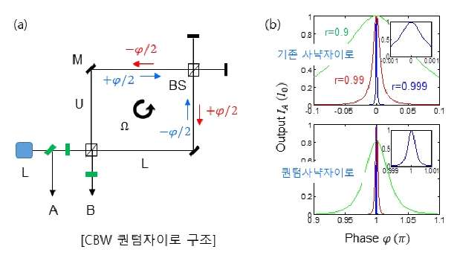
▲ (a) Quantum Sagnac gyro structure. (b) Comparison of resolution calculations

Professor Byoung S. Ham said, "For existing quantum sensing, securing a multiphoton entangled pair remained unresolved, making it difficult to apply a quantum sensor. For the CBW quantum sensor, it was difficult to apply a unidirectional application based on light reflection like Lidar due to the adoption of a reciprocating path of an interferometer. In the rotation-based gyroscope, the reciprocating path interferometer was automatically configured, so it could be easily applied."

This research was supported by GIST via GRI 2021 and ICT R&D program of MSIT/IITP and was published online on November 3, 2021, in Advanced Devices & Instrumentation, a sister journal of Science.



