Identification of new RNA degradation
mechanism of RNase H

- Discovery of multi-asymmetric function of nuclease RNase H

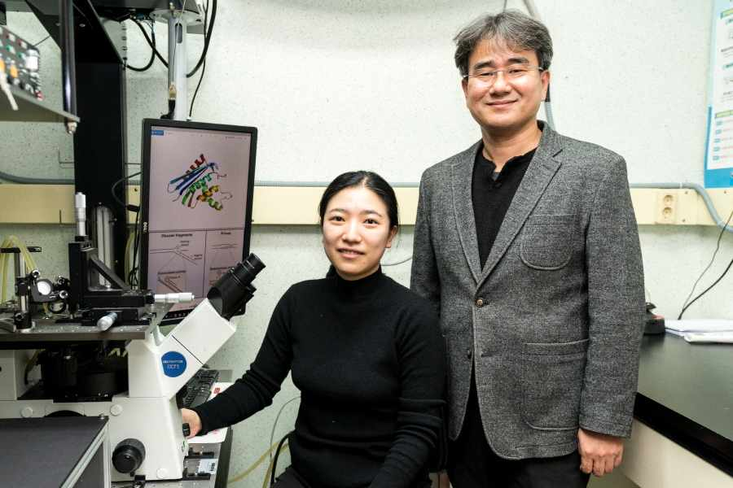
▲ From left: Ph.D. student Hyunjee Lee and Professor Gwangrog Lee

Research results have shown that RNase H, known as a random RNA (genetic information transmitter) degrading enzyme, changes the decomposition direction of the enzyme according to the characteristics of the substrate.

GIST (Gwangju Institute of Science and Technology, President Kiseon Kim) School of Life Sciences Professor Gwangrog Lee's research team identified a mechanism of a new asymmetric degradation mode in which RNase H continuously or dispersively degrades RNA depending on the direction of DNA overhang during RNA degradation.

This study revealed the multi-function of RNase H, which was previously unknown. This was evaluated as a significant discovery that would have a great impact and insight in understanding gene cloning and maintenance, and it was selected as a 'Breakthrough Article' in the top 1-2% of the academic journal Nucleic Acids Research.

RNase H is an enzyme that plays an important role in DNA replication and transcription, the most basic of life phenomena, and is essential for maintaining the life of all living things. Mutations in RNase H are known to cause Aicardi-Goutières syndrome*, a developmental brain disease.

* Aicardi-Goutières syndrome: Subacute encephalopathy associated with basal ganglia calcification, leukodystrophy, and cerebrospinal fluid lymphocytosis is a rare genetic disease with about 120 cases reported in the literature.

The research team observed the interaction of RNase H with various RNA:DNA structures in real time using single-molecule fluorescence FRET observation technology*. It was found that it is regulated according to the direction.

* fluorescence resonance energy transfer (FRET): A fluorescence technique that can observe the movement of molecules one by a method using a physical phenomenon. The internal structure of RNA is a key technology that allows us to know how the transcription process changes.

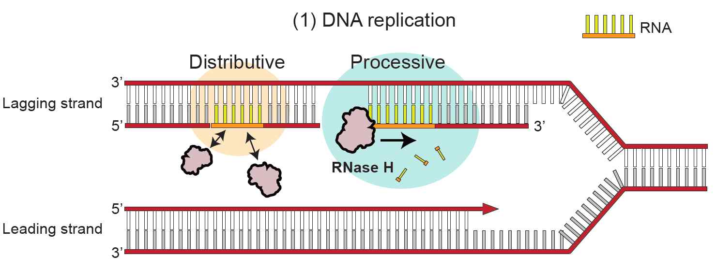
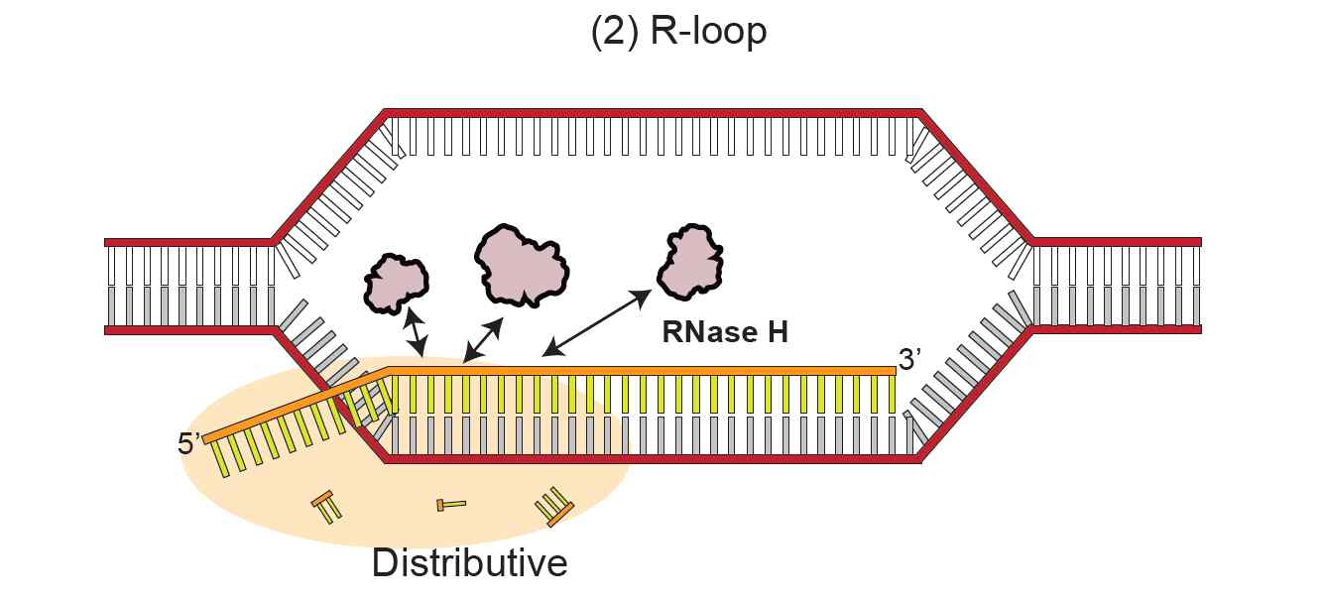
▲ Schematic diagram of the asymmetric RNA degradation mechanism of RNase H
(1) DNA replication: RNA primers that are continuously generated by the synthesis of lagging strands are degraded by RNase H. If DNA is not synthesized until the next RNA primer, RNase H binds specifically to the 3' overhang junction and continuously degrades the RNA primer (Processive). On the other hand, when DNA is synthesized up to the 5' end of the RNA primer, RNase H repeats association and dissociation and randomly degrades RNA (Distributive).
(2) R-loop processing: During transcription, R-loop that threatens the stability of the genome is resolved by RNase H. In the R-loop structure, RNase H repeats association and dissociation, and randomly degrades RNA (Distributive).

The research team found that when the direction of the DNA overhang is 3', RNase H continuously degrades RNA without falling out of the RNA:DNA hybrid. It was confirmed that when there was no DNA overhang and the direction of the overhang was 5', RNase H dispersedly degraded RNA by repeating binding and dissociation to the RNA:DNA hybrid.

The R-loop formed during the transcription process is removed by RNase H for the stability of the genome. The research team reproduced the structure of the actual R-loop and found that RNase H removes the R-loop by degrading RNA using two degradation modes.

Professor Gwangrog Lee said, "This study revealed a novel RNA recognition mode and molecular mechanism of degradation of RNase H. It is expected to contribute to the understanding of gene cloning and maintenance in the future and to the development of new drugs for Aicardi-Goutières syndrome, a developmental brain disease."

The research was conducted by GIST Professor Gwangrog Lee's team with support from the National Research Foundation's Mid-Range Researcher Support Program, Korean Health Technology R&D Project, and GIST's Research Institute and was published online on November 12, 2021 in Nucleic Acids Research, a global academic journal that ranks in the top 2.6% of papers in the field of biochemistry and genetics.



