Development of catalysts that
control chemical reactions with light

- Repeatedly switching metathesis (replacement exchange) reactions using light

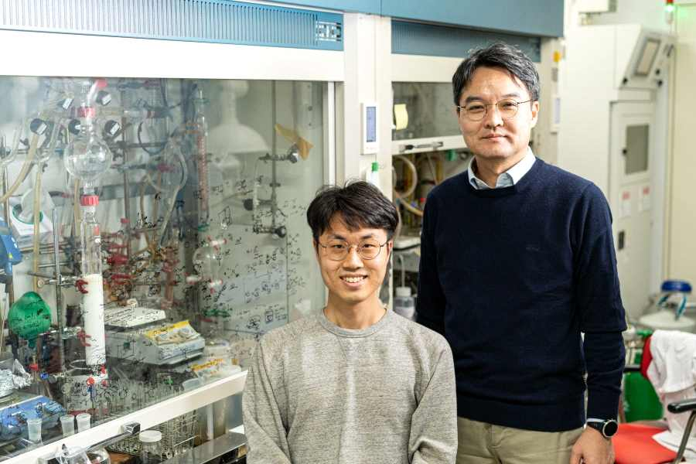
▲ From left: Integrated student Seongwook Park (first author) and Professor Sukwon Hong

A catalyst that can stop chemical reactions with light has been developed. Existing photoswitching catalysts start their reaction when they receive light, but this study is the first case where the reaction stops when it receives light.

GIST (Gwangju Institute of Science and Technology, President Kiseon Kim) Department of Chemistry Professor Sukwon Hong's research team developed a ruthenium* olefin metathesis** catalyst that can control the reactivity in real time using light.

* ruthenium: One of the platinum group elements, it is a hard and brittle metal. Like other platinum group catalysts, it becomes a catalyst for hydrogenation and oxidation.

** olefin metathesis: It refers to a reaction in which a carbon-carbon double or triple bond of a starting material is decomposed using a metal catalyst to form a new carbon-carbon double or triple bond compound, respectively. It is used in the synthesis of cyclic, acyclic alkenes, and polymers with various functional groups.

Enzymes, the best catalysts created by nature, can be organically switched between active and inactive states by external stimuli. Accordingly, chemists are trying to make a functional catalyst that can be converted to an external stimulus beyond a simple catalyst.

Metathesis catalysis has been widely applied to the synthesis of biologically active organic compounds such as polymers, fuel additives, and pharmaceuticals by forming new bonds in organic compounds or by introducing various functional groups. Recently, the development of a catalyst capable of switching this metathesis reaction through an external stimulus is in progress.

Existing on-off switching catalysts have insignificant reactivity control by external stimuli, or use stimulus sources that are inconvenient to use in practice, such as acid bases or redox reactions.

Light is a good stimulus that can be easily controlled during a chemical reaction. Existing photo-switching catalysts have only metathesis catalysts that start the reaction when they receive light. The switching catalyst developed by the research team, contrary to existing ones, is the first case in which the reaction stops when it receives light.

The research team was able to secure a catalyst whose structure changes according to light by introducing this structure to the existing metathesis catalyst, paying attention to the change in structure of the light-sensitive azobenzene* functional group when exposed to light.

* azobenzene: a molecule in which two phenyl groups are connected by an N=N double bond and has the property of showing photoisomerization properties.

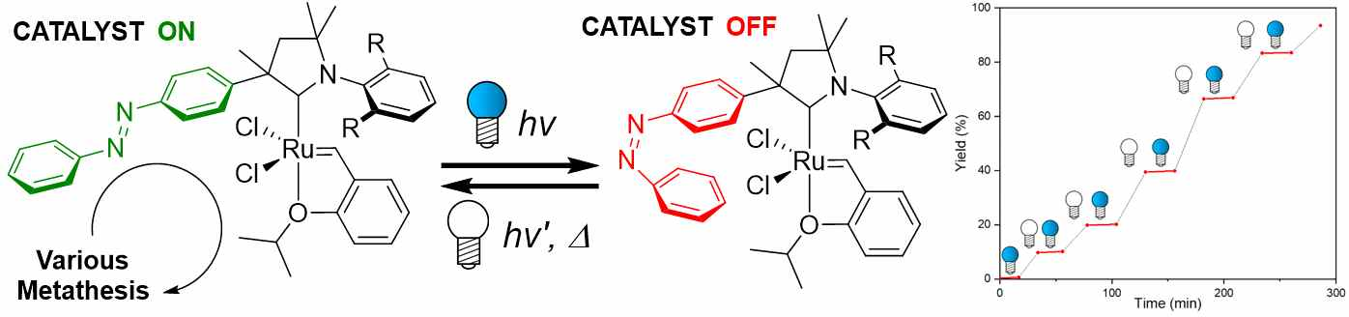
▲ A ruthenium metathesis catalyst that reversibly responds to light

The developed catalyst shows a dramatic difference in reactivity (60 to 300 times) depending on light in various metathesis reactions, which is larger than the difference in reactivity (1.5 to 2.5 times) of existing catalysts using the same strategy. In addition, the newly developed catalyst showed that the reactivity can be repeatedly switched on-off if the light irradiation condition is changed during the reaction.

Professor Sukwon Hong said, "This research result is significant in that it is the first case of a catalyst that can stop a reaction with light. It is expected that patterning technology using light such as photolithography* will be applied using the developed on-off switching catalyst."

* photolithography: a technology to create an integrated circuit by drawing extremely fine and complex electronic circuits on a semiconductor substrate using light

This research was led by Professor Sukwon Hong (corresponding author) and conducted by integrated student Seongwook Park (first author) with support from the National R&D Program through the National Research Foundation of Korea and by the "Nobel Research Project" grant of the Grubbs Center for Polymers and Catalysis and was published online on November 1, 2021, in ACS Catalysis, a world-renowned academic journal in the field of catalysts published by the American Chemical Society.



