Researching the principle of how anthelmintic
agents act on cancer cell membranes

- Professor Jeong-Seok Nam's research team developed a treatment
strategy that interferes with the survival of cancer cells


▲ From left: Professor Jeong-Seok Nam, Dr. So-Yeon Park,
and Ph.D. student Jee-Heun Kim

Despite advances in cancer treatment, cancer cells still do not die easily even with chemotherapy but survive and constantly threaten the health of patients. A Korean research team has uncovered the mystery of the cancer cell membrane, which helps cancer cells to proliferate despite external stress.

GIST (Gwangju Institute of Science and Technology, President Kiseon Kim) School of Life Sciences Professor Jeong-Seok Nam's research team found that lipid raft* exists more specifically in cancer cells than in normal cells, and it helps cancer cells to survive without dying by continuously activating survival signaling pathways in cancer cells.

* lipid raft: an ordered region separated by cholesterol and saturated lipids present in the cell membrane that plays an important role as a hub for various signal transduction

The research team found that cancer cells acquire the characteristics of cancer stem cells* as the number of lipid rafts increases in the cancer cell membrane, and the team found a new therapeutic strategy to overcome intractable cancer through targeted lipid raft therapy.

* cancer stem cells: A specific cell group in cancer tissue that has indefinite self-renewal and the ability to differentiate into cells with various traits, which causes cancer recurrence, metastasis, and resistance to chemotherapy.

The research team found that the US Food and Drug Administration (FDA) approved anthelmintic drug Miltefosine destroys lipid rafts in cancer cell membranes.

The research team demonstrated that lipid raft-targeted treatment using miltefosin could interfere with cancer cell survival signals and lower the ability of cancer recurrence. This is significant in that it provided an experimental basis for the treatment of intractable cancer.

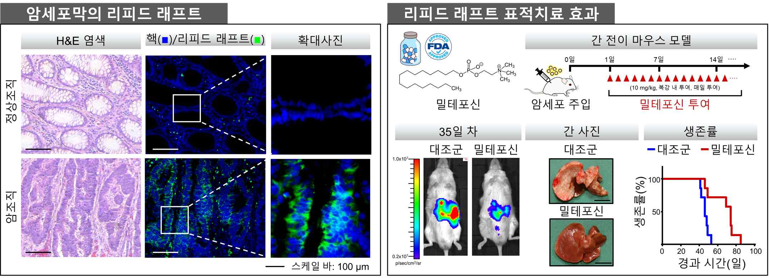
▲ Anticancer treatment strategy through lipid raft-targeted therapy
(Left) Lipid raft of cancer cell membrane: As a result of observation in normal and cancer tissues, it was confirmed that cancer cells had more lipid rafts compared to normal cells.
(Right) Effect of lipid raft targeted therapy: As a result of administering miltefosin by injecting cancer cells into a mouse model, it was confirmed that miltefosin reduced liver metastases and increased the survival period of mice.

Professor Jeong-Seok Nam said, "This study revealed a new role for lipid rafts in regulating the survival signals of cancer cells, and the greatest significance is that it opens the possibility of a new treatment strategy that can overcome intractable cancer."

This research was led by GIST Professor Jeong-Seok Nam and conducted by Dr. So-Yeon Park and Ph.D. student Jee-Heun Kim as the first authors with support from National Research Foundation of Korea, the Cell Logistics Research Center of the National Research Foundation of Korea, and by the GIST Research Institute and was published online on November 4, 2021, in Clinical and Translational Medicine, an authoritative journal in the top 6.79% of the medical field.



