Capturing the moment of melting metal

- Success in real-time observation of changes in electron structure at the moment of melting metal using X-ray laser... contributing to future energy research such as nuclear fusion

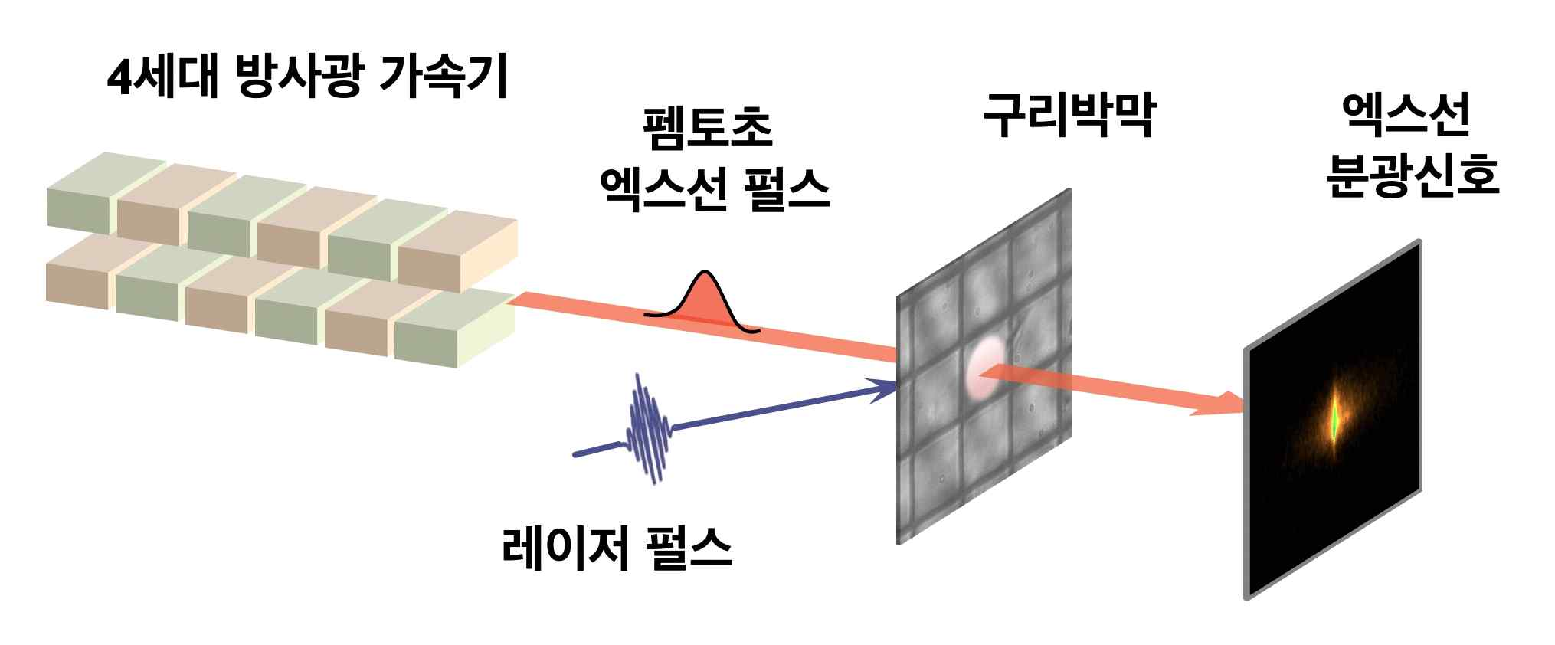
▲ Femtosecond laser spectroscopy experiment: The copper thin film begins to melt by the powerful laser pulse, and, after a certain period of time, an ultrafast spectral signal is obtained using the femtosecond X-ray pulse emitted from the 4th generation radiation accelerator.

GIST (Gwangju Institute of Science and Technology, President Kiseon Kim) Department of Physics and Photon Science Professor Byoung Ick Cho's research team in the Department of Physical and Optical Sciences succeeded in observing the moment when a metal melts and changes from a solid to a liquid in real time. This is expected to help discover new physical properties of materials in the extreme space-time domain and contribute to future energy research such as nuclear fusion.

The research team used femtosecond (one trillionth of a second) X-ray pulses emitted from an X-ray free electron laser to observe the moment when the interatomic bond is changed by a powerful laser and the metal is melted, and spectroscopic signals for changes in electronic structure at the moment of melting were captured using X-ray pulses.

Overseas researchers reported a theoretical prediction about ten years ago that when noble metals are heated to very high temperatures by powerful lasers and change into a liquid, especially gold, silver, and copper, interatomic bonds are momentarily strengthened and the phase transitions to liquid through a more rigid state, but such a phenomenon has never been directly observed.

This is because the time resolution of the conventional X-ray measurement method is limited to about 10 picoseconds (one hundred billionths of a second), so there is a limit to measuring the time domain of less than 1 picosecond in which changes in atomic bonds occur.

The research team used ultrafast X-ray spectroscopy using femtosecond (one trillionth of a second) X-ray pulses emitted from an X-ray free electron laser to overcome the existing time limit.

The researchers used a powerful laser to heat copper to an ultra-high temperature of 10,000 degrees or higher. At this time, about 10% of the electrons involved in the interatomic binding entered an excited state, but the remaining electrons were exposed to more powerful attraction of the atomic nucleus, resulting in stronger binding, and observed for the first time using ultra-fast X-ray spectroscopy.

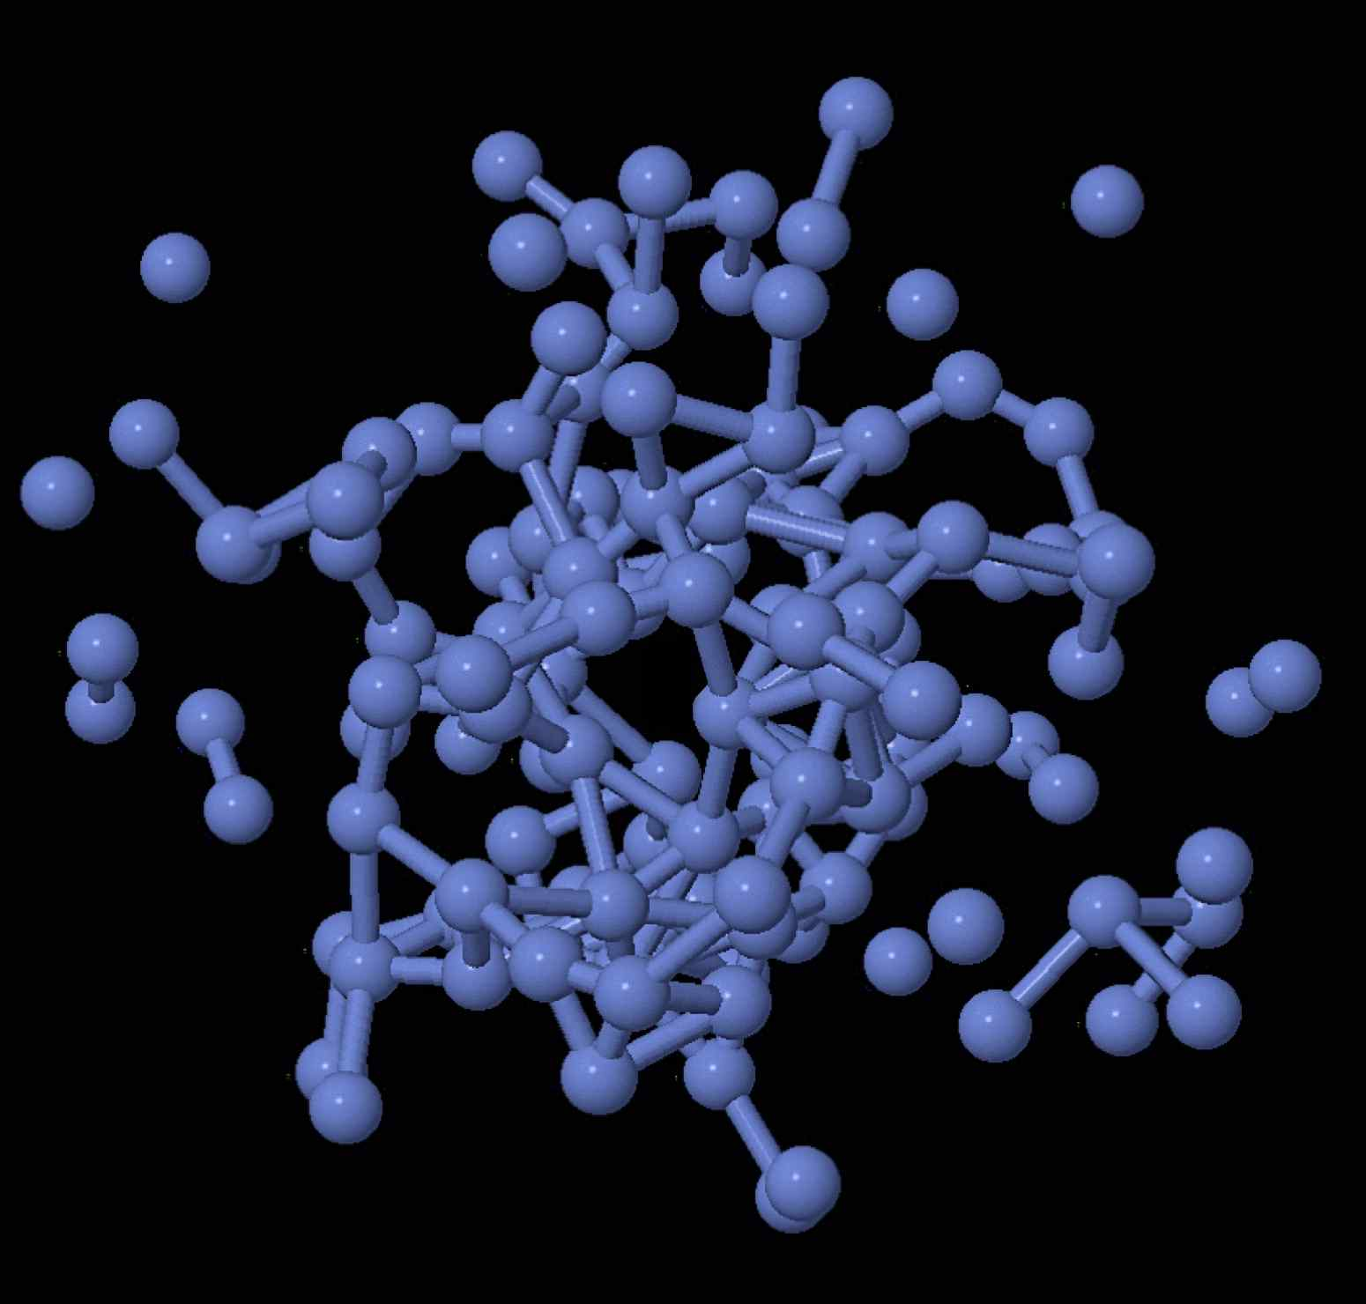
▲ Interatomic bonding of ultra-high temperature substances heated by lasers

The ultra-hot, hard copper with stronger bonding persists for hundreds of femtoseconds and then slowly weakens. This is a result contrary to the conventional wisdom that when a heated substance melts, the bonds between atoms are immediately weakened and change into a liquid.

In fact, in extreme temperature and pressure environments such as laser nuclear fusion and the Earth's interior, there are many unique properties that are different from those previously known. The fact that it can be hardened provides the key to understanding extreme specific properties.

Professor Byoung Ick Cho said, "By using femtosecond X-ray spectroscopy, it is possible to observe various singularities in the extreme space-time domain in addition to observing atomic bonding in the ultrafast region. Based on the accumulated knowledge and experience, we hope to play a leading role in the global scientific community, including nuclear fusion energy research."

This research, conducted by Professor Byoung Ick Cho's team at GIST, was carried out with support from the Institute for Basic Science, the National Research Foundation of Korea, and a GRI grant funded by the GIST in 2021 and was published online on October 22, 2021, in Physical Review Letters, the most prestigious academic journal in the field.



