Development of accurate sugar chain
analysis method to predict disease and aging

- Accurately measure the relative quantitative ratio of intracellular sugar chains at the molecular level... systematically understand disease-related physiological changes

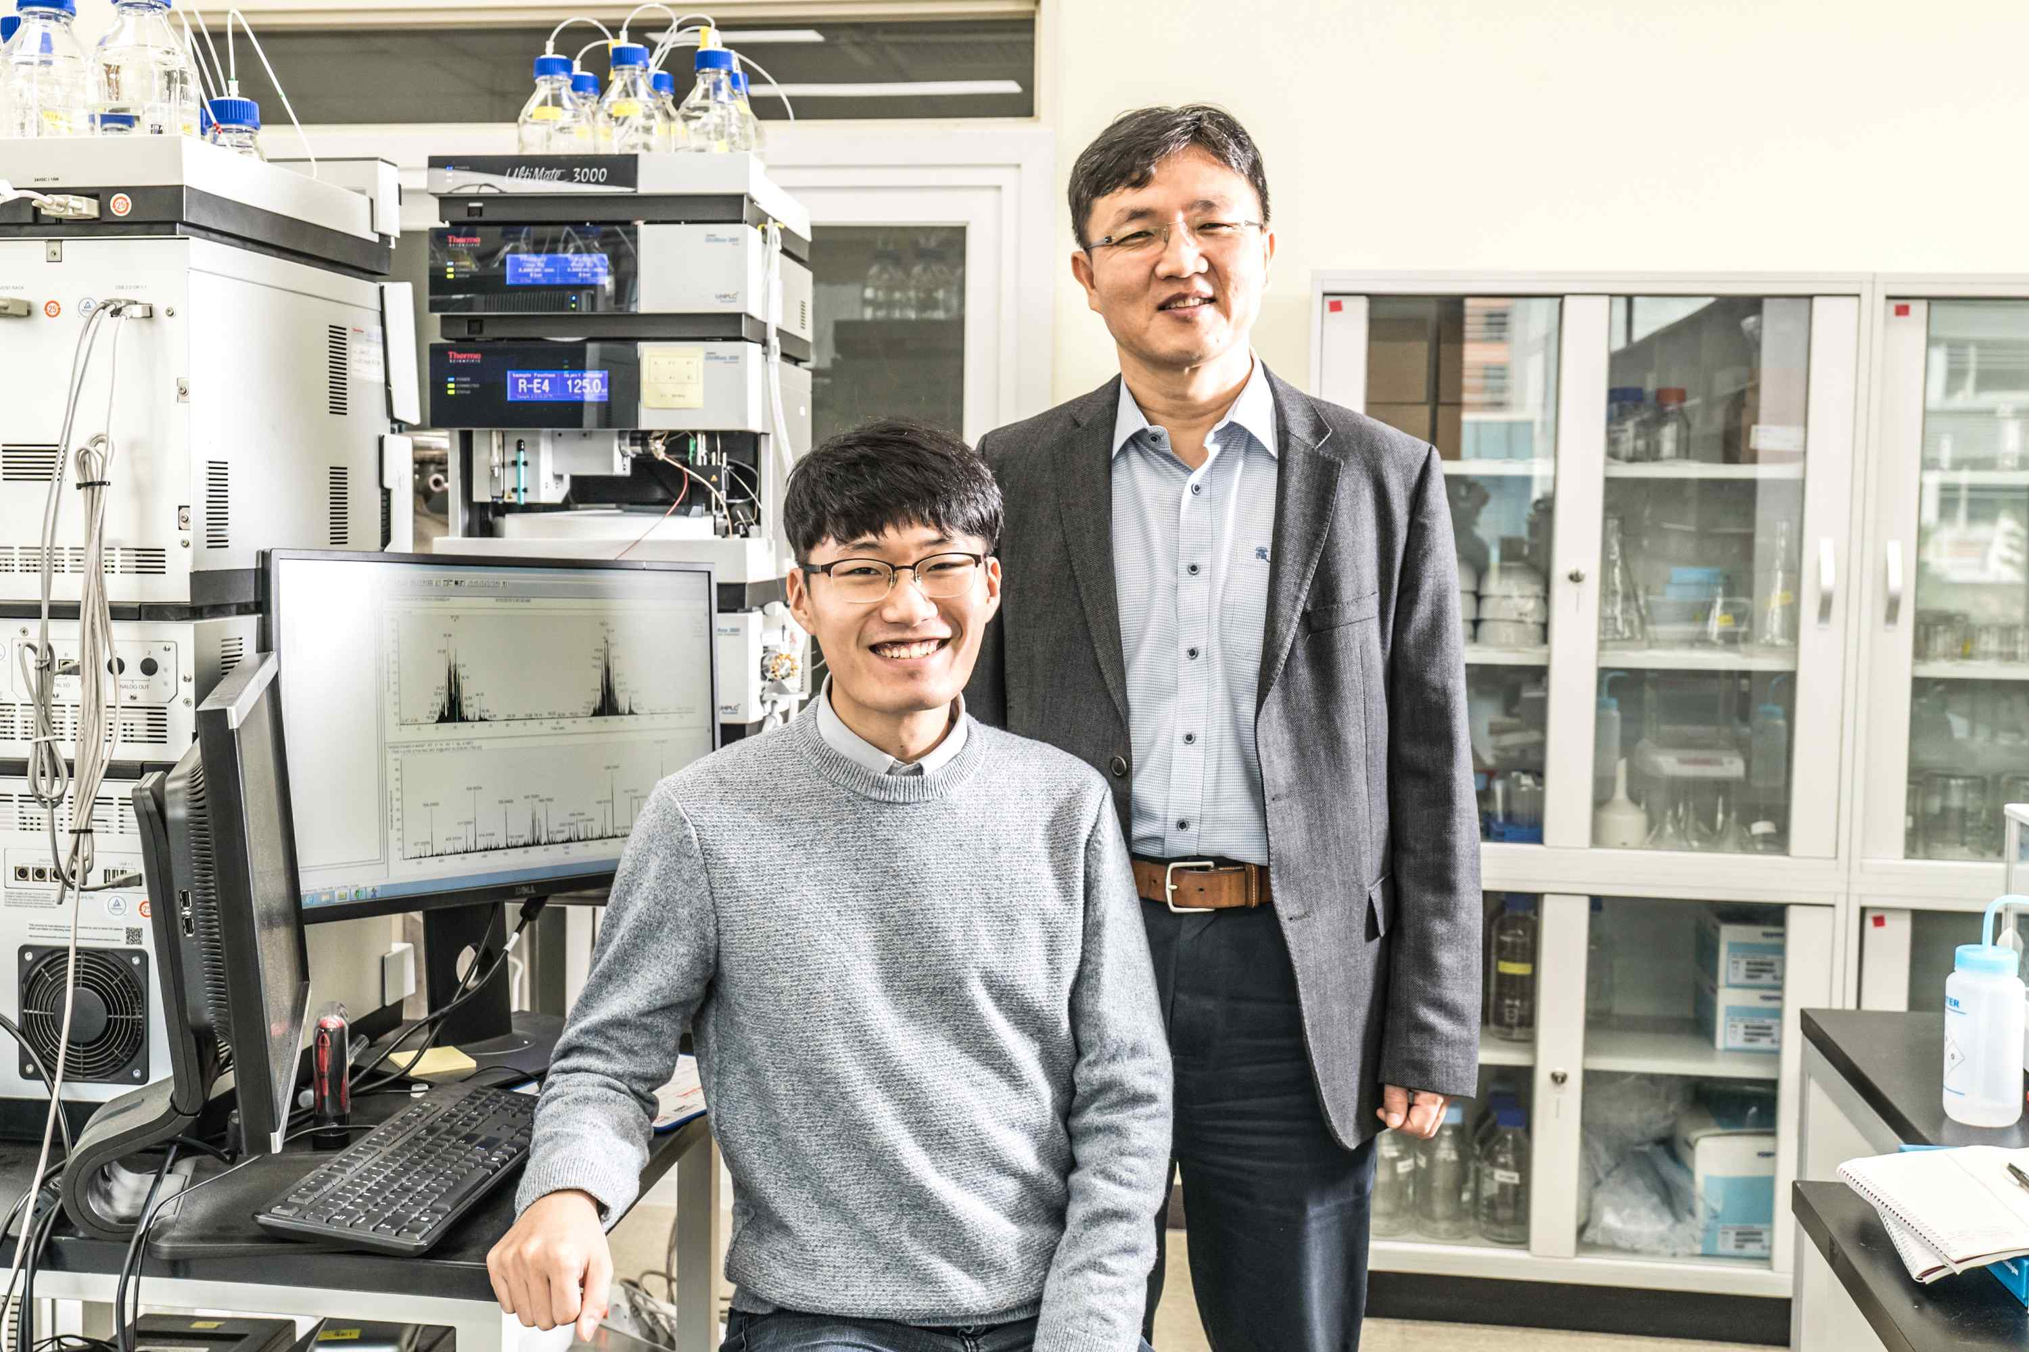
▲ From left: Ph.D. student Jonghyun Kim and Professor Tae-Young Kim

A Korean research team has developed an analysis technology that accurately measures the concentration of sugar chains that help immunity by recognizing various nutrients in blood or body fluids and by distinguishing viruses and bacteria.

GIST (Gwangju Institute of Science and Technology, President Kiseon Kim) School of Earth Sciences and Environmental Engineering Professor Tae-Young Kim's joint research team with Chungnam National University Graduate School of Analytical & Science Technology (GRAST) Professor Hyun Joo An developed an assay that can measure the relative ratio of sugar chains in cells with high efficiency at the molecular level using metabolic heavy water labeling*.

* metabolic heavy water labeling: a stable isotope labeling technique that introduces deuterium into biomolecules involved in metabolic processes using water substituted with deuterium instead of hydrogen

A glycan refers to a carbohydrate bound to a protein, and various functions of the protein are regulated through changes in the type and number of sugar chains. In addition, sugar chains are known to be closely related to aging and the expression of diseases such as cancer, immune diseases, and neurological diseases because they perform a key function in the process of molecular recognition or signal transduction between cells.

Therefore, the technology for measuring changes in the amount of sugar chains in vivo plays a very important role in the diagnosis and treatment of diseases related to the function of sugar chains.

The research team developed their own quantitative analysis method that can calculate the relative amount between sugar chains obtained in the steady state and disease state using a mass spectrometer after labeling all kinds of sugar chains with heavy water using the heavy water labeling method.

The research team also confirmed the quantification accuracy and quantification range of sugar chains after labeling HeLa cells, a representative model cancer cell, with heavy water. Through this experiment, the relative quantitative difference between a total of about 100 sugar chains could be measured, including high-mannose type N-glycan and complex/hybrid type N-glycan up to 100 times.

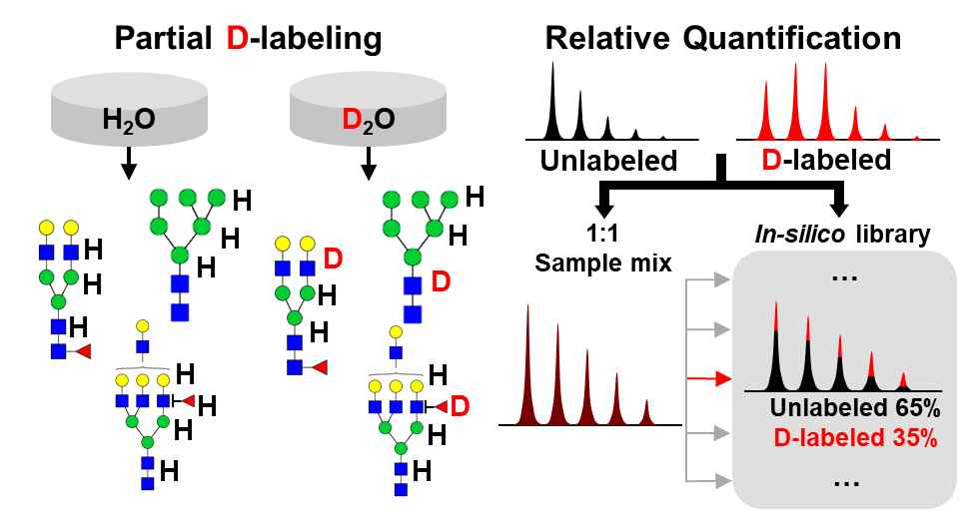
[Figure] Schematic diagram of measuring the isotope distribution using the heavy water labeling method and obtaining the relative quantitative ratio of sugar chains
The sugar chains extracted from cells grown in normal culture media and sugar chains extracted from cells grown in heavy water-labeled culture media show different isotope distributions in the mass spectrum. Using these two isotope distributions, the isotope distribution created when each sample is mixed in different ratios is calculated by computer to make a library (in-silico library). Finding the isotope distribution most similar to the isotope distribution of the mass spectrum was obtained by mixing the same amounts of the sugar chains labeled with heavy water and the unlabeled sugar chains in the in silico library and by calculating the relative ratio between the mixed sugar chains.

Professor Tae-Young Kim said, "In this study, the heavy water labeling-based relative quantification method developed for lipidomes in our laboratory was applied to glycomes. The possibility of simultaneous relative quantitation of biomolecules such as proteins, lipids, and metabolites, including sugar chains, was presented with a single stable isotope* label. Unlike existing analytical methods that can measure only quantitative changes occurring in one type of biomolecules, the relative quantitative method based on heavy water labeling is expected to be a basic technology for systematically understanding physiological changes caused by various diseases."

* stable isotope: a stable, non-radioactive element with the same atomic number but a different mass number due to a difference in the number of neutrons

This research was led by GIST School of Earth Sciences and Environmental Engineering Professor Tae-Young Kim with Chungnam National University Graduate School of Analytical & Science Technology (GRAST) Professor Hyun Joo An and conducted by Ph.D. student Jonghyun Kim with support from the National Research Foundation's mid-sized research support project and was published online on October 21, 2021, in Analytical Chemistry, the most prestigious journal in the field of analytical chemistry.



