Development of next-generation semiconductor materials that can dramatically improve power consumption
and information density

- Identification of dielectric constant that can be adjusted in stages according to
lattice deformation using selective oxygen annealing in perovskite materials


▲ From left: Professor Sanghan Lee and Dr. Hyunji An

A Korean research team has developed technology that can dramatically improve the power consumption and information density of existing semiconductor devices. It is expected to contribute to the development of mem capacitors and mem computing systems, which are next-generation electronic devices.

GIST (Gwangju Institute of Science and Technology) School of Materials Science and Engineering Professor Sanghan Lee's research team succeeded in adjusting the dielectric constant* step by step by using the lattice** transformation of the perovskite material*** which is used as a basic material for semiconductors.

* dielectric constant: It is a measure of how much charge a material can store when given an electric field. Accordingly, the dielectric material may be generally used in a memory device that stores electronic information.

** lattice: The smallest structural unit constituting a crystalline material in which atoms, molecules, and ions are arranged in a regular pattern in all directions.

*** perovskite material: A material in which the molecular structure of ABO₃ is regularly arranged. Most of it is a material with dielectric properties and is used as an important material for semiconductors such as general capacitors and memory.

Although the dielectric constant is an intrinsic property of a material, if the dielectric constant is controlled in the dielectric material, the storage step of the memory device can be adjusted, so power consumption and information density of the existing semiconductor device can be dramatically improved.

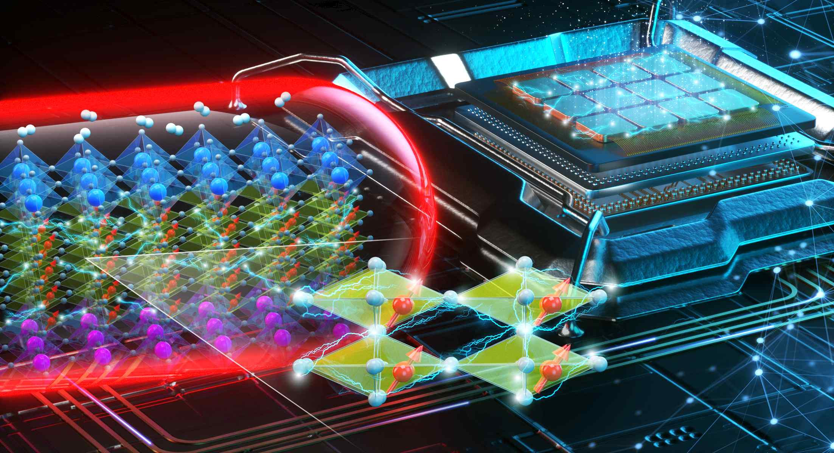
▲ Schematic diagram when ferroelectricity controlled by lattice tension and perovskite material with controlled dielectric properties are used as a next-generation memory device

* Enlarged lower figure in the middle: A process in which ferroelectricity occurs due to bias in one direction of manganese cations (red) due to lattice tension of strontium manganese oxide in a perovskite structure.

Recently, it has been reported through theoretical calculation papers that the phase change from paraelectricity to ferroelectricity can occur according to lattice deformation in some dielectric materials of the perovskite (ABO₃) structure. Among them, SrMnO3 (SMO) is a material that can undergo multiple phase transformation to ferromagnetic as well as ferroelectric according to lattice deformation. The strong combination of these two stiffnesses has been spotlighted as a material with high potential for use as a next-generation multi-memory device.

However, when these materials were experimentally implemented in previous studies, it was difficult to directly determine the ferroelectricity and dielectric constant due to the large leakage current and the occurrence of structural defects due to the lattice deformation.

This research team devised and applied a selective oxygen annealing method to overcome this limitation. For the first time in an SMO thin film, it was experimentally confirmed that a phase change from paraelectricity to ferroelectricity according to lattice tension and stepwise control of the dielectric constant were possible.
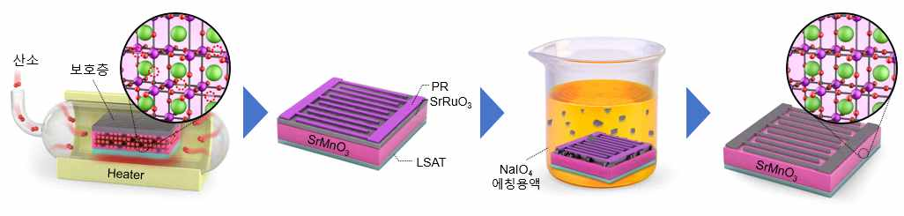
▲ Schematic diagram of the selective oxygen annealing method that can effectively reduce the leakage current and structural defects of the lattice-tensioned SrMnO3 thin film proposed by this research team

The lattice tension of SMO was induced by forming a crystalline thin film using a pulsed laser deposition method based on a strontium tantalum aluminum (LSAT) substrate having a larger lattice constant than the SMO thin film. In addition, by controlling the thickness of the thin film, the lattice tension was adjusted stepwise up to 2%.

Furthermore, the researchers devised a selective oxygen annealing method to prepare a SrRuO3 protective layer on the SMO thin film and to remove the protective layer after annealing in a high-temperature oxygen atmosphere. Thus, a structurally stable thin film was realized.

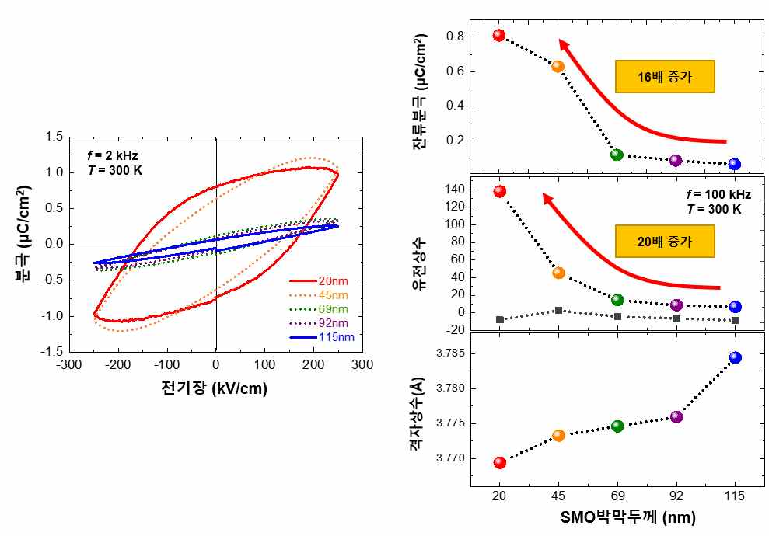
▲ Results of ferroelectric curves and dielectric constants adjusted in stages according to lattice tension in SrMnO3 thin films fabricated by selective oxygen annealing. As the lattice increases by up to 2% based on the existing SrMnO3 thin film, the residual polarization increases by 16 times and the dielectric constant by 20 times.

Professor Sanghan Lee said, "This research result is meaningful in that it can provide a starting point for the development of mem capacitors, which are in the spotlight as a next-generation electronic device but are still in the material development stage. The development of dielectric materials that can be adjusted step by step according to lattice tension is expected to lead the development of next-generation semiconductor devices in the future."

This research was led by GIST Professor Sanghan Lee and conducted by Dr. Hyunji An (first author) with support from the Creative Materials Discovery Program supported by the National Research Foundation of Korea and was selected as the highlight paper in NPG Asia Materials (IF=10.481), a renowned academic journal in the field of materials, and was published online on October 29, 2021.



