Development of technology to convert environmentally-impactful substances into highly utilized organic compounds

- Implementation of a system that saves up to 34.04% of energy consumption
in existing processes... Expected to quickly enter a carbon-neutral society

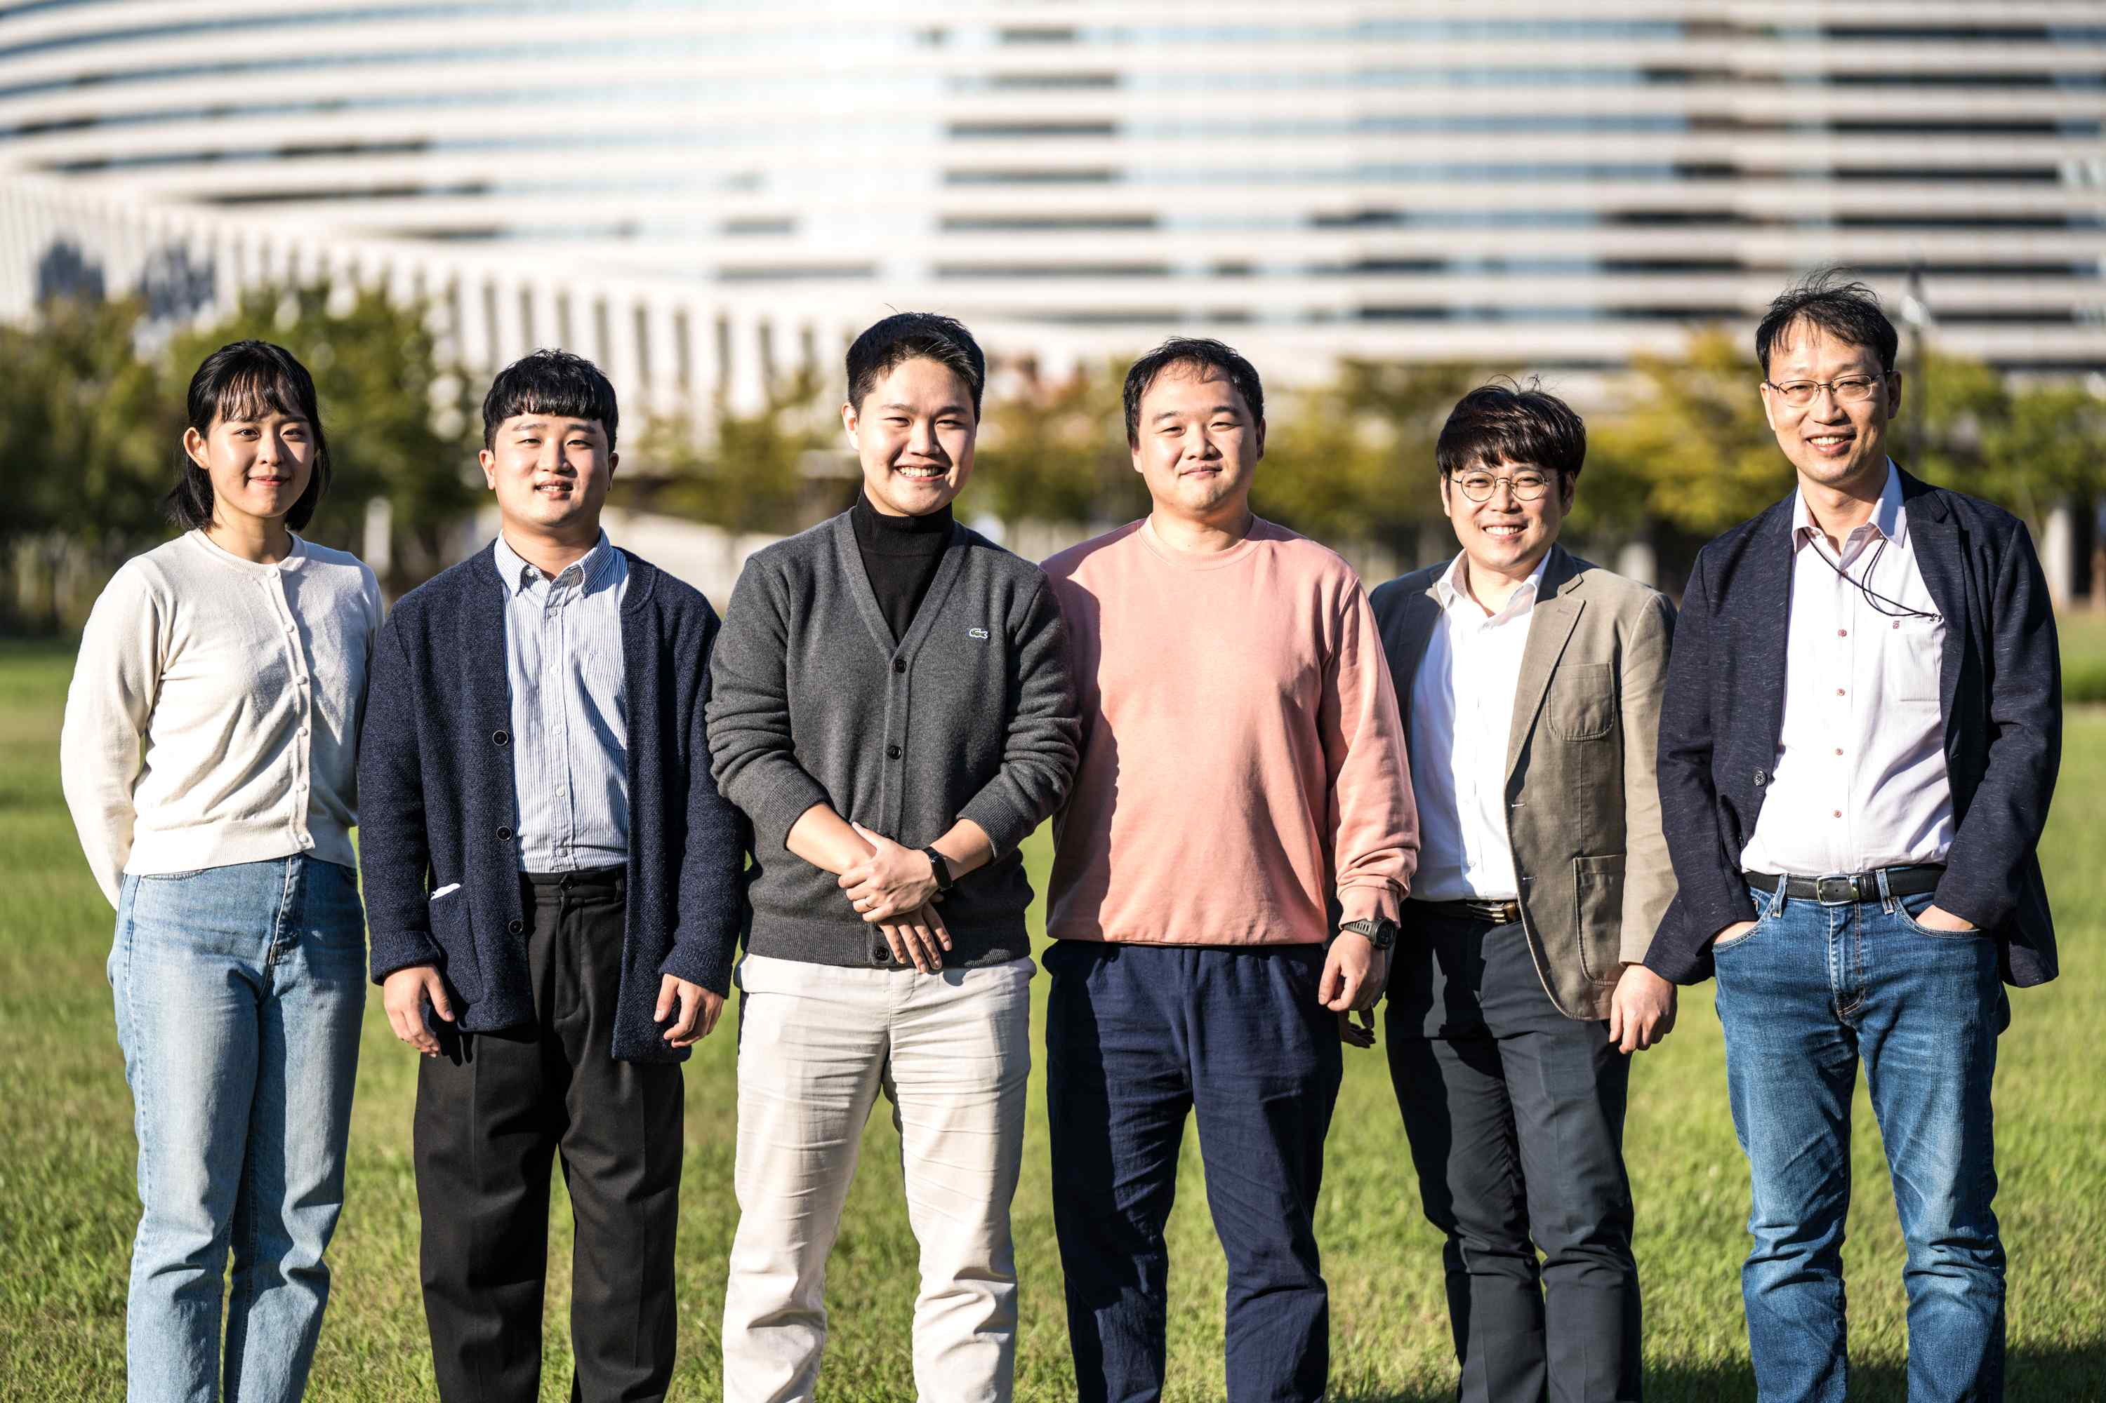
▲ (From left): Master’s student Youjin Lee, Dr. Sunki Chung, Ph.D. student Minjun Choi (first author), Dr. Jin Won Kim (co-first author), Dr. Sungyool Bong, Professor Jaeyoung Lee (corresponding author)

Carbon dioxide and ammonia are emerging as social problems, causing environmental pollution as the main culprits of greenhouse gas and fine dust, respectively. Researchers in Korea have succeeded in developing a technology that removes carbon dioxide and ammonia while converting them into high-value organic compounds.

GIST (Gwangju Institute of Science and Technology, President Kiseon Kim) School of Earth Sciences and Environmental Engineering Professor Jaeyoung Lee's research team developed an electrolytic conversion* process that can simultaneously remove and convert ammonia and carbon dioxide, and announced a technology to efficiently produce syngas** that can be used as a raw material for chemical products or as an energy source for electricity generation.

* simultaneous electrolytic conversion of ammonia and carbon dioxide: It is a technology to electrochemically convert ammonia and carbon dioxide to produce high-value organic compounds.

** syngas: A mixed gas containing carbon monoxide and hydrogen as main components and is a raw material for various chemical products and has high utility as an energy source such as producing electricity.

Electrochemical conversion of carbon dioxide is very popular because it can reduce greenhouse gases in the atmosphere and convert it to hydrocarbon-based compounds with high added value under normal temperature and pressure conditions.

However, because the theoretical driving voltage required for carbon dioxide electrochemical conversion is very high, it is necessary to reduce excessive power consumption and link it with renewable energy to realize a truly carbon-neutral society.

Existing carbon dioxide electrolysis process has the disadvantage that the total power consumption required for the carbon dioxide electrolysis process is very large because the carbon dioxide reduction process has a structure that pairs with water electrolysis (1.23 V vs. RHE) with a high theoretical potential, which is the biggest obstacle to commercialization.

The research team conducted an electrochemical oxidation reaction (0.06 V vs. RHE) of ammonia with relatively low power consumption instead of water electrolysis, which consumes more power. Through a new attempt consisting of a pair reaction, it succeeded in converting harmful ammonia and carbon dioxide into high value-added substances while lowering the total power consumption.

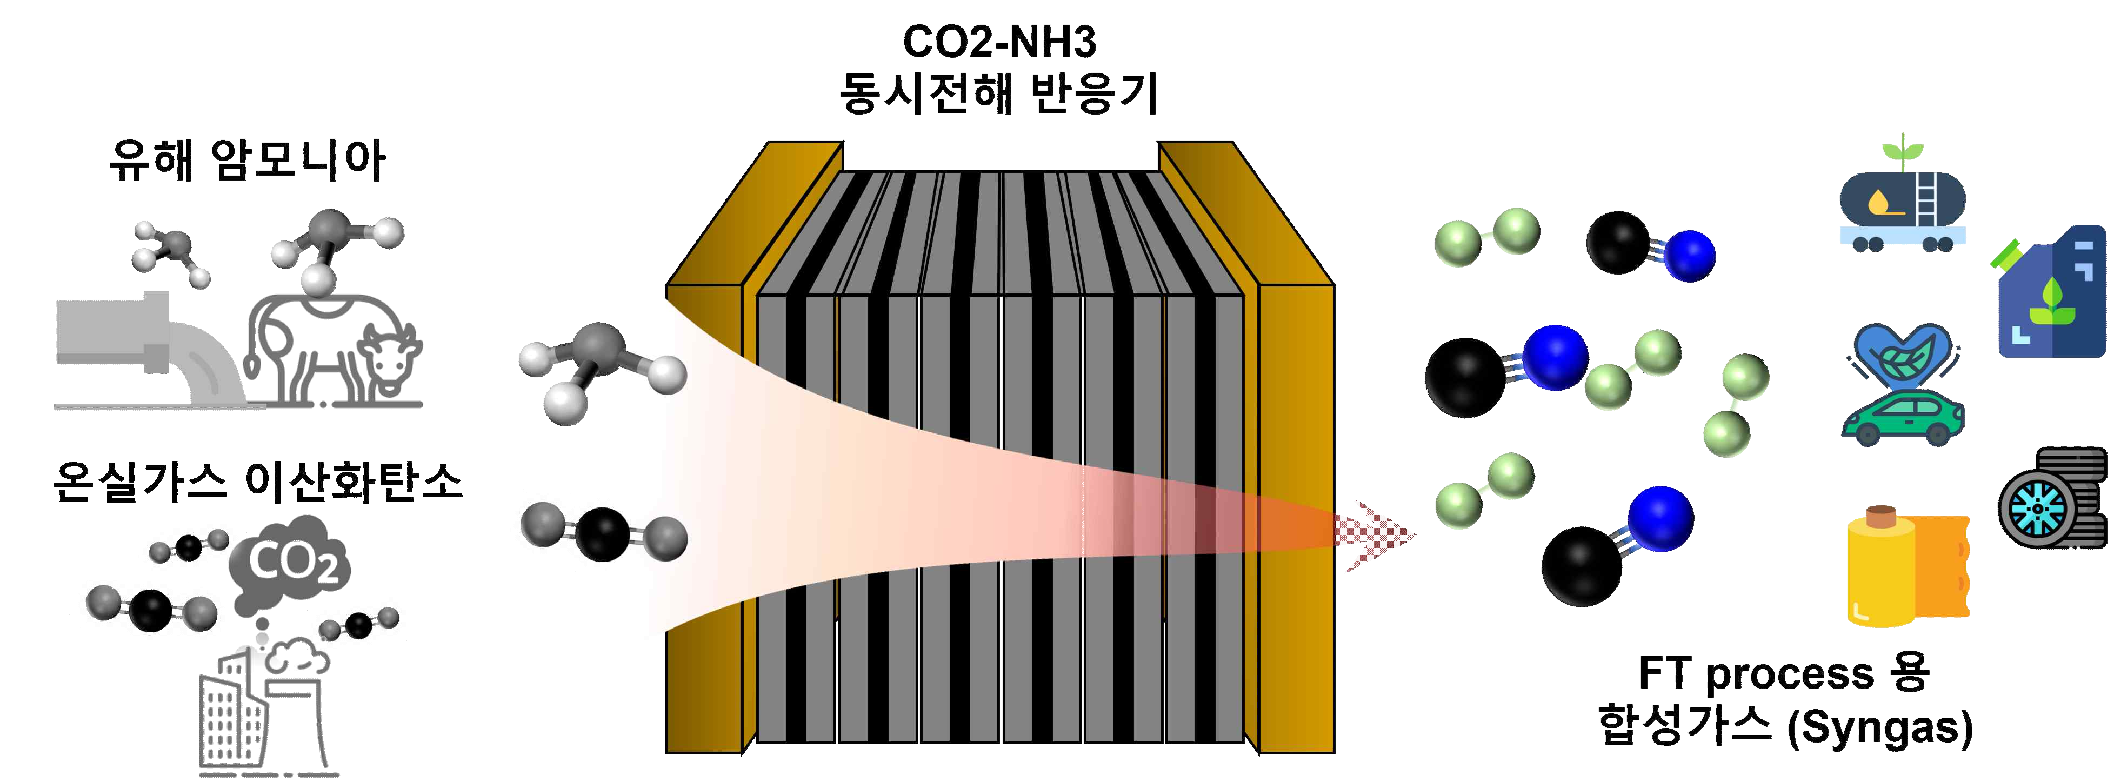
▲ Schematic diagram of eco-friendly and high-efficiency fuel production process through ammonia and carbon dioxide simultaneous electrolysis system

The cell driving voltage was reduced by up to 34.04% through the simultaneous ammonia-carbon dioxide electrolysis process using the self-made near-zero-gap, and an energy-saving carbon fuel production process capable of producing syngas containing carbon monoxide (CO) and hydrogen (H2) was newly proposed.

In addition, it was demonstrated that the ratio of CO:H2 can be selectively adjusted according to the concentration of ammonia input from the produced synthesis gas (syngas, a mixed gas of CO and H2) and the applied current density.

Professor Jaeyoung Lee said, "The results of this research are significant in that they suggest a new carbon fuel production process that is economical and more environmentally friendly than existing processes with the possibility of customized synthesis gas production in various fields. In the future, it is expected that the high-efficiency fuel production process will be expanded by mass-producing eco-friendly fuels through the expansion and large-area of the electrode catalyst."

This research was led by GIST Professor Jaeyoung Lee and conducted by Ph.D. student Minjun Choi and research Assistant Professor Jin Won Kim with support from the Engineering Research Center (ERC Ecosystem Research Center) funded by the National Research Foundation of Korea and was published online on October 7, 2021, in the Chemical Engineering Journal (IF=13.273), which is in the top 3% of academic journals in the field of chemical engineering technology.



