Controlling characteristics of next-generation
electronic devices at the atomic level

- Pioneering the possibility of controlling the properties of functional
oxide materials by controlling the electronic structure of the substrate

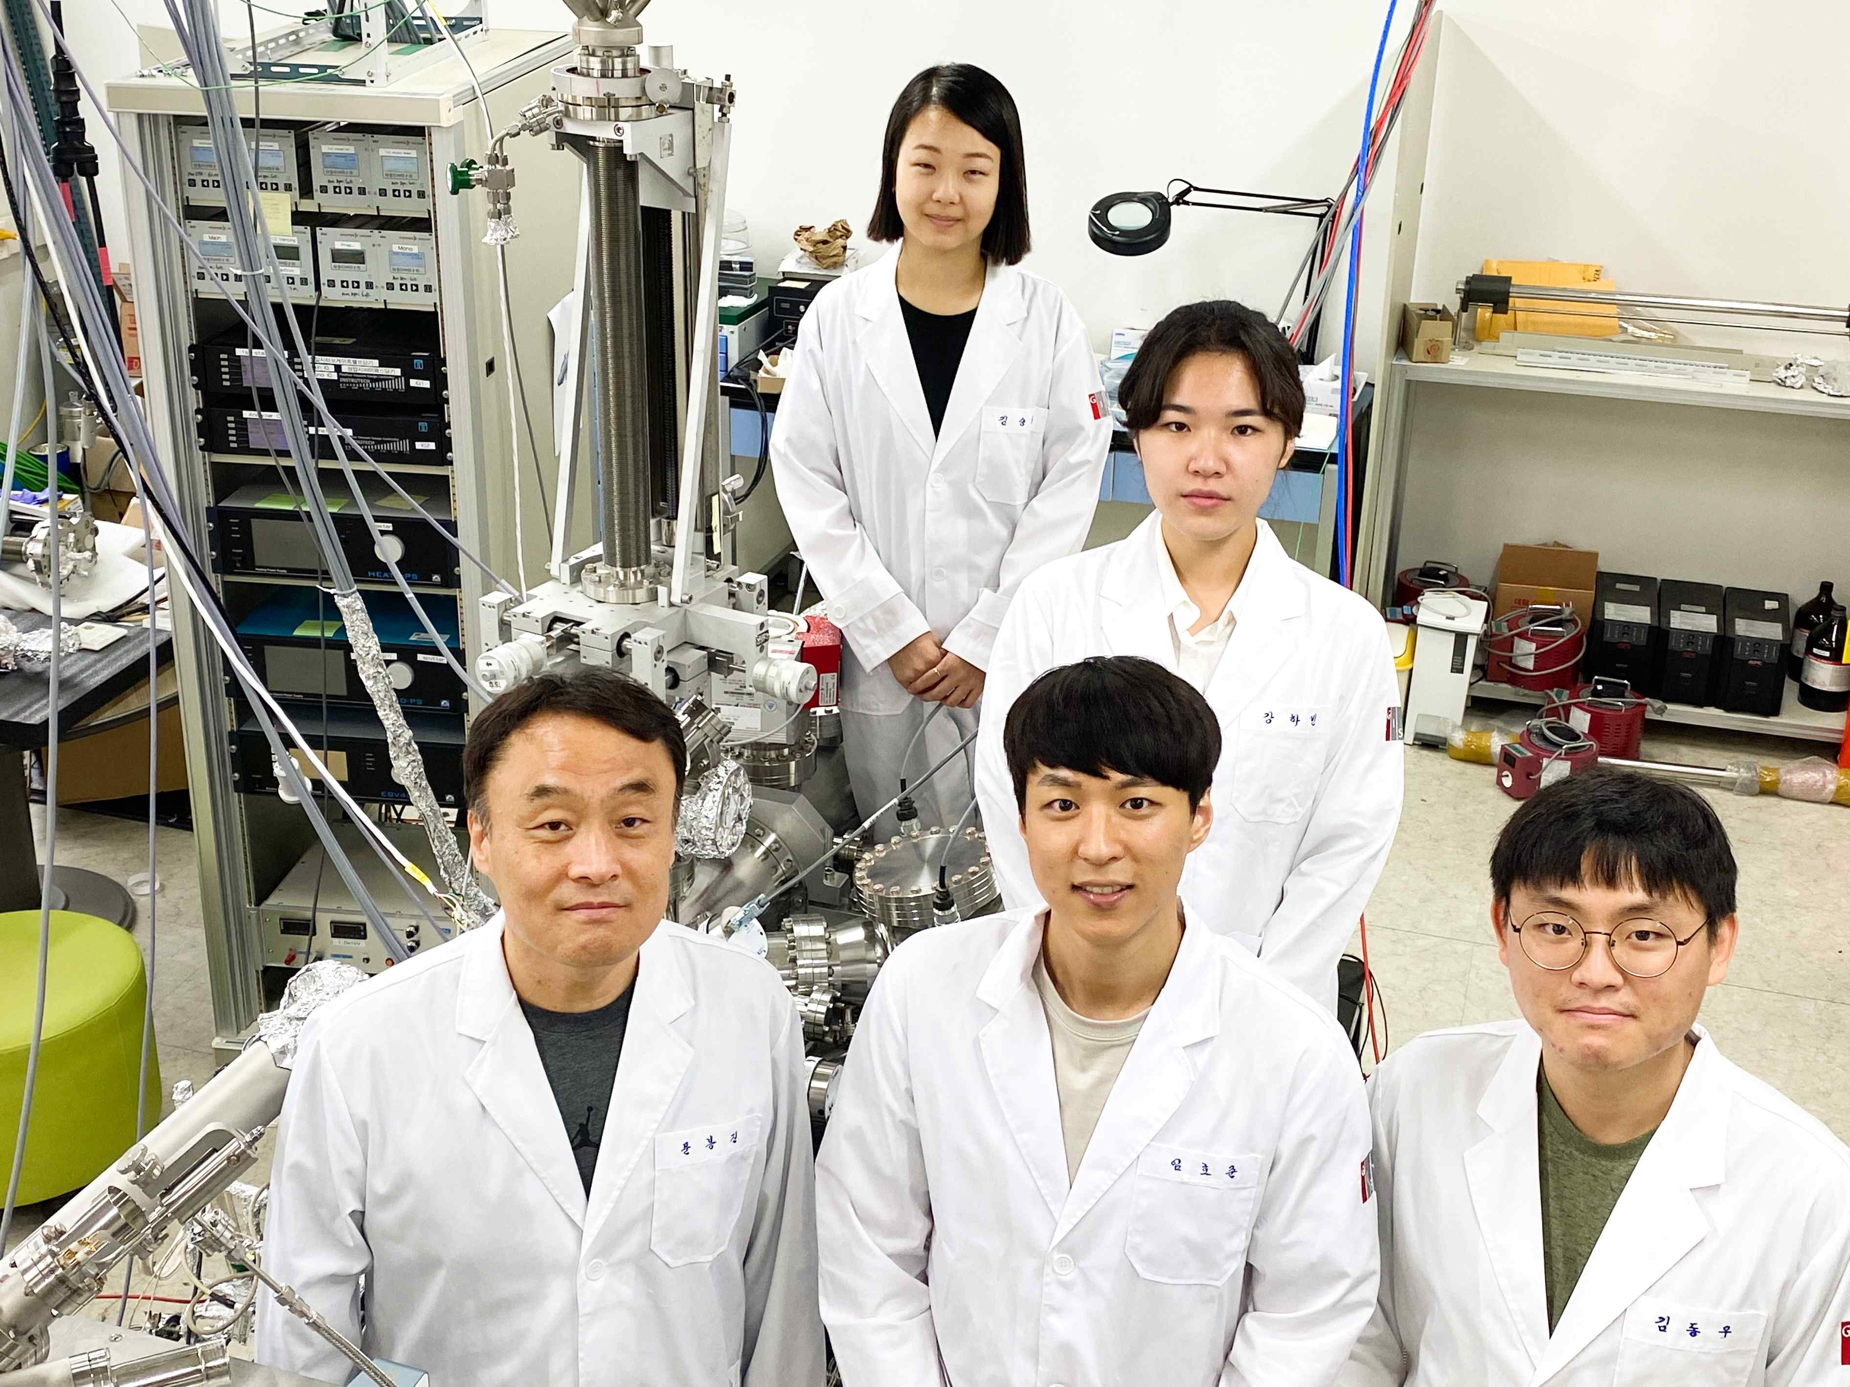
▲ Counter-clockwise from bottom left: Professor Bongjin Mun,
first author Hojoon Lim, Minsik Seo, Habin Kang, and Moonjung Jung

GIST (Gwangju Institue of Science and Technology) Department of Physics and Photon Science, Ultra-fine Ultra-fast X-ray Science Research Center (SRC), and the Center for Advanced X-ray Science (C-AXS) Professor Bongjin Mun's research team succeeded in observing the changes in the electronic/chemical/structural state of the heterojunction composite oxide substrate in real time.

The research team investigated the chemical composition change and the formation of a space charge layer* on the surface of a strontium titanate (SrTiO₃) substrate exposed to a high-temperature oxygen environment and found the resulting energy band bending using an ambient pressure x-ray photoelectron spectrometer**.

* space charge layer: It is a region where electric charges are distributed in a thin layer according to the movement of electrons or ions, and the electrical properties of materials are determined by controlling charge transport and rectification characteristics.

** ambient pressure x-ray photoelectron spectrometer: It is an atmospheric pressure photoelectron spectrometer specially designed to operate the existing photoelectron spectrometer operating in a high vacuum state in an atmospheric pressure environment and is capable of measuring the chemical/physical properties of surfaces under real reaction/operational conditions.

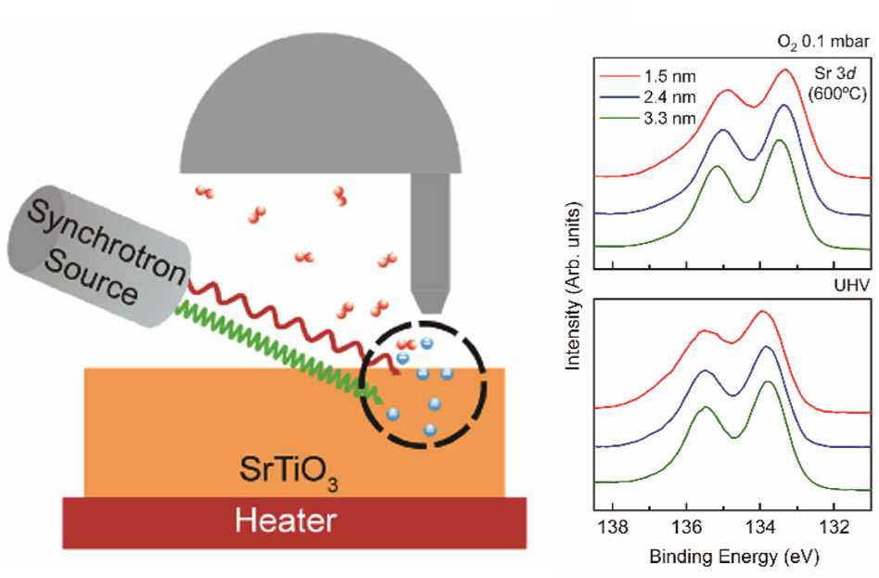
[Figure 1] Observation of surface information change according to the depth of a material using a radiation accelerator.
By controlling the energy (wavelength) of X-rays to determine the penetration depth of X-rays into the material and the penetration depth of the photoelectrons that are generated, chemical/electronic structure information of a material can be differentiated and measured according to the depth from the surface. In this study, X-ray energy was controlled in the range of 100 to 1000 eV, and surface information at depths of 1.5, 2.4, and 3.3 nm was compared and analyzed (depth profile).

A complex oxide heterostructure is a material manufactured by stacking oxides with different properties in layers, and the constituent materials interact through the interface to realize excellent electrical, magnetic, thermal, and mechanical functionality.

Large magnetic resistance, metal-insulator transition, high-temperature superconductors, and two-dimensional electron gas, which are major topics in the development of next-generation electronic devices, are all characteristics implemented in a heterojunction composite oxide structure. However, the principles and mechanisms of these operations have not yet been clearly identified.

Changes in the chemical/electrical/structural properties of the substrate material surface (interface where the functional oxide and the substrate material interaction occurs) under the temperature and pressure conditions for growing the functional oxide significantly contribute to the performance determination of the functional oxide grown thereon. Therefore, it is essential to closely understand the surface dynamics of the substrate to design the optimal growth conditions for performance improvement.

The research team performed in situ analysis of the chemical and electronic structure of a strontium titanate substrate whose outermost surface was terminated with a titanium dioxide (TiO₂) layer in an atmospheric pressure photoelectron spectroscopy chamber.

The gas environment inside the chamber is controlled from ultra-high vacuum to oxygen gas pressure of 0.1 mbar (about ten thousandths of atmospheric pressure), and the temperature environment is controlled from room temperature to 600°C. The role of the oxygen environment and the formation of the space charge layer by atomic movement and chemical structural change on the surface of the strontium titanate* substrate was confirmed in real time.

* strontium titanate: It has excellent lattice compatibility with other functional oxides and is thermally/chemically stable, so it is one of the most used materials as a substrate for growing functional oxides when manufacturing a heterojunction composite oxide.

Professor Bongjin Mun said, "In this study, the surface space charge characteristics of pure strontium titanate substrates were revealed by excluding the effects of doping that may affect the electronic/chemical/structural state of the substrate. Through this research, the possibility of controlling the properties of substrates and functional materials and their application as next-generation electronic materials has been greatly improved."

The paper "Nature of the surface space charge layer on undoped SrTiO₃ (001)," which was published on October 14, 2021, as the cover paper (Issue 38) for the Journal of Materials Chemistry C, a prestigious academic journal from The Royal Society of Chemistry, was conducted by GIST Professor Bongjin Mun's research team with support from the National Research Foundation of Korea and the GIST Research Institute.



