Identification of drug mechanism for the treatment of liver cirrhosis and intestinal invasion of oral microorganisms

- Pioneering new horizons in microbiome-based liver disease treatment

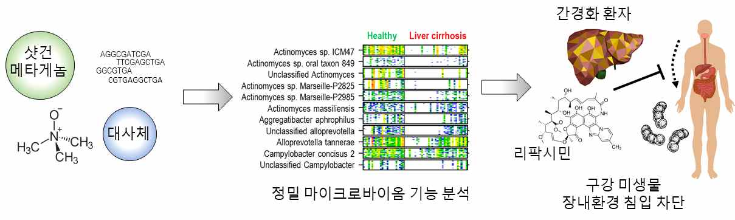
▲ Identification of oral microbiome-intestinal environment
penetration mechanism through precise microbiome analysis

Studies have shown that antibiotics that treat the occurrence of cirrhosis and intestinal invasion of oral microorganisms are effective in preventing oral microorganisms from invading the intestinal environment.

GIST (Gwangju Institute of Science and Technology, President Kiseon Kim) Professor Sunjae Lee's research team discovered the mechanism of liver cirrhosis and rifaximin* drugs through shotgun metagenome**-based precision microbiome*** analysis technology in a joint study with a research team at King's College London, UK.

* rifaximin: an antibiotic to treat intestinal invasion
** shotgun metagenome: microbiome genomic DNA data
*** microbiome: A community of microorganisms that are symbiotic with humans.

Rifaximin, an antibiotic, has been used to treat hepatic encephalopathy in patients with liver cirrhosis, but the mechanism has not been clearly elucidated.

Hepatic encephalopathy is a disease in which the function of the liver is reduced due to cirrhosis, etc., and toxic substances are accumulated in the body that affect the brain, causing consciousness disorders or behavior to change.

This joint research team conducted a precision microbiome analysis study to determine the case of liver cirrhosis and investigated the mechanism by which oral microbes penetrate into the intestinal environment, causing systemic inflammation in patients, and in particular, the mechanism by which the drug rifaximin effectively prevents oral microbes from entering the gut.

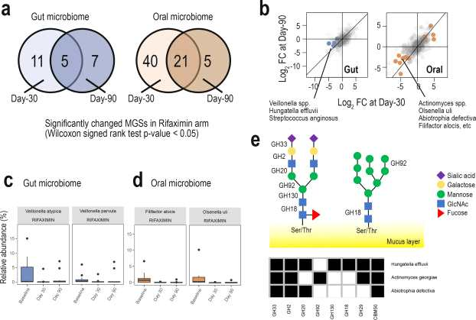
▲ Simultaneous intestinal/oral microbiome analysis revealed the invasion of oral microorganisms with high intestinal mucin resolution and blockade by rifaximin.

In particular, through multiomics analysis of shotgun metagenomes and metabolites that have not been attempted in previous studies along with composition of oral microbiome full-genome reference, the cut-oral axis was systematically analyzed. It was found that blocking the intestinal invasion of oral microorganisms such as Veillonella and Streptococcus played a major role in preventing hepatic encephalopathy caused by cirrhosis.

Professor Sunjae Lee said, "The results of this research will open a new horizon in the development of microbiome-based new drugs for the treatment of liver disease and hepatic encephalopathy using bioinformatics and data mining techniques. In addition, it is expected that the microbiome can be applied to early diagnosis and monitoring of diseases."

This research was conducted by GIST Professor Sunjae Lee's research team with support from support from the Ministry of Science and ICT's Bio-Synergy Research Project, Biomedical Technology Development Project, and Excellent New Research Project from the National Research Foundation of Korea, and was published online on September 24, 2021, in the Journal of Hepatology, a top journal in liver disease research.



