Proven effectiveness of rehabilitative horseback riding for the treatment of cerebral palsy

- Identification of the effectiveness and mechanism of equestrian
rehabilitation for patients with cerebral palsy

- Emphasis on the importance of interaction and communication
between patients and animals (horses)

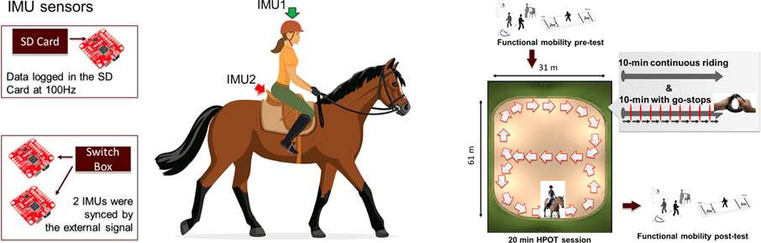
[Figure 1] (Left) A patient with cerebral palsy riding a horse with an inertial sensor measuring the movement of the patient and the horse, respectively. (Right) Experimental protocol for each horseback riding rehabilitation treatment.

The prevalence of cerebral palsy (CP) in children in Korea is high, with an incidence of 3 out of every 1,000 children. Although complete recovery is almost impossible, physical functions can be improved through rehabilitation and social interactions.

GIST (Gwangju Institute of Science and Technology, President Kiseon Kim) School of Mechanical Engineering Professor Pil-won Huh's research team along with Dr. Priscilla Lightsey's research team from Texas A&M University, revealed the effectiveness of horseback riding and its gait rehabilitation mechanism for cerebral palsy patients.

Most infants with cerebral palsy are spastic, and their posture is unnatural due to abnormal muscle tension, and basic activities such as walking and balance are difficult. Recently, the effectiveness of rehabilitation treatment riding horses has been gradually recognized, but the specific mechanism has not been understood.

The purpose of this study was to find out what causes equestrian rehabilitation to improve the walking and balance abilities of cerebral palsy patients.

For this purpose, 'equestrian rehabilitation improves the walking and balance ability of patients with cerebral palsy', 'equestrian rehabilitation improves the interaction between the patient and the animal (horse)', 'the relationship between the patient and the animal (horse) due to equestrian rehabilitation interaction correlates with gait and balance ability' is correlated with walking and balance ability.

Each of the cerebral palsy patients participating in the experiment received 8 horseback riding rehabilitation treatments, and, as a result, it was confirmed that the walking and balance abilities of the cerebral palsy patients improved. In addition, as the rehabilitation treatment was repeated, improved synchronization could be observed due to the interaction between the cerebral palsy patient and the animal (horse).

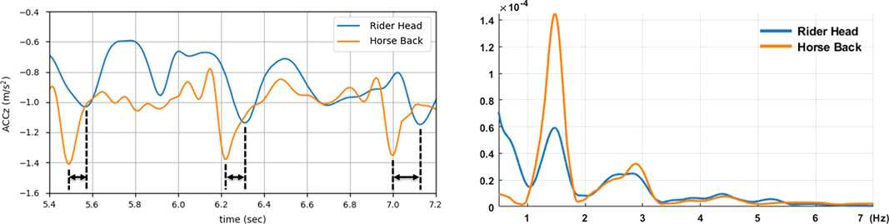
[Figure 2] (Left) It can be seen that the movement of the horse affects the movement of the patient. (Right) The frequency characteristics of speech and movement of the patient can be checked. It can be confirmed that the movements of the patient and the horse are synchronized with each other as they receive equestrian rehabilitation treatment.

Compared to previous studies that only reported the utility of horseback riding rehabilitation, the results of this study investigated the cause of why horseback riding rehabilitation is effective. In particular, it is significant in the physical interaction data between the patient and the animal (horse).

Professor Pilwon Hur said, "The results of this study are meaningful in that they have confirmed the possibility of developing cerebral palsy horseback riding rehabilitation programs and related technologies that can actively utilize physical interactions and emotional empathy between humans and animals (horse). It is expected that it will contribute to improving the quality of life of patients with cerebral palsy by maximizing the efficiency of rehabilitation of cerebral palsy in the future."

This research was conducted by GIST Professor Pilwon Hur the research team of Dr. Priscilla Lightsey of Texas A&M University with support from the Horses and Humans Research Foundation project in the United States and was published on September 6, 2021, in the Journal of NeuroEngineering and Rehabilitation, which is the top 5.15% paper in the field of rehabilitation.



