Development of high-efficiency eco-friendly
solar hydrogen production technology


▲ From left: Professor Kwanghee Lee, Professor Sanghan Lee,
Dr. Sehun Seo, and Ph.D. student Hojoong Choi

A high-performance photoelectrode is required for efficient solar hydrogen production. A Korean research team has developed a photoelectrode with the highest efficiency and stability among the perovskite-based photoelectrodes reported so far.

GIST (Gwangju Institute of Science and Technology) Professors Kwanghee Lee and Sanghan Lee's research team combined an organometallic halide perovskite* (perovskite) solar cell with a nanostructured molybdenum disulfide** catalyst to efficiently produce hydrogen without expensive platinum This technology has been demonstrated.

* organometallic halide perovskite: It can absorb light in a wide area and has high charge mobility, so it is attracting attention as a photoactive layer for next-generation solar cells.

** molybdenum disulfide (MoS₂): As a semiconductor material with a two-dimensional structure, it is stable and has high activity for hydrogen production, so it is one of the cheaper hydrogen production catalyst candidates to replace platinum.

Photoelectrochemical water decomposition using perovskite does not guarantee high stability because the perovskite material itself is vulnerable to moisture. To date, all high-efficiency perovskite photoelectrodes are a combination of an expensive platinum catalyst, a protective layer, and perovskite. The high cost is an obstacle to commercialization.

Therefore, it is necessary to develop a low-cost, high-efficiency, high-stability catalyst for hydrogen production and a catalyst for perovskite photoelectrodes that is inexpensive, stable, and can replace the high efficiency of platinum.

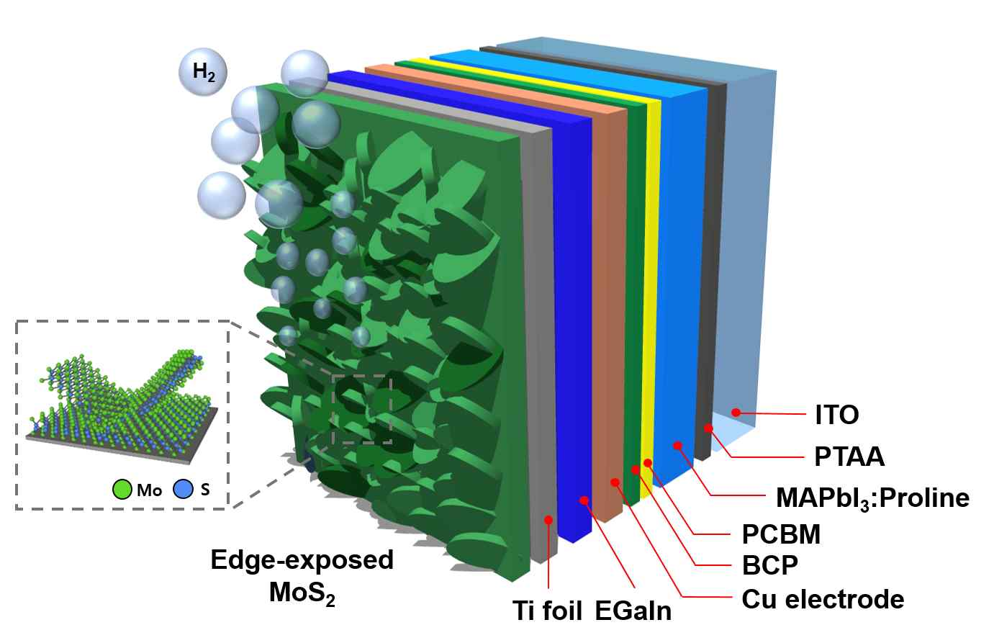
[Figure 1] Schematic diagram of a perovskite photocathode bonded with MoS₂ deposited on titanium foil as a protective layer using pulsed laser deposition.

To this end, the research team produced molybdenum disulfide (MoS₂), one of the representative catalysts for platinum-substituted hydrogen production, on a perovskite protective layer (titanium foil) using pulsed laser deposition, a representative physical vapor deposition method.

When fabricating MoS₂ on titanium foil, the nanostructure of MoS₂ was successfully controlled by controlling the number of pulses, one of the deposition conditions. Nanostructured MoS₂ showed a higher efficiency of hydrogen production than planar MoS₂. Then, the MoS₂-deposited titanium foil was sealed using an indium-gallium alloy, a liquid metal, to successfully prevent moisture from penetrating into the perovskite material, ensuring high stability.

The perovskite photoelectrode developed by the research team successfully prevented the rapid initial performance degradation of the photoelectrode due to the easy exfoliation of the existing platinum catalyst thanks to the high stability and efficiency of MoS₂. Among the photoelectrodes, the longest stability of 120 hours and half-cell efficiency of 11.07%, the highest efficiency, were achieved.

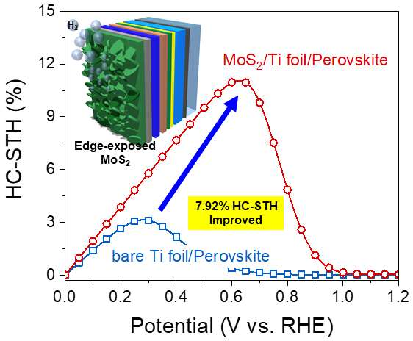
[Figure 2] Molybdenum disulfide-bonded perovskite photocathode produced by this research team achieved 11.07% half-cell efficiency, which is 7.92% higher than that of non-catalyst perovskite photocathode.

Professor Sanghan Lee said, "The result of this study is most meaningful in that it suggests that it is possible to fabricate a high-efficiency and high-stability perovskite-based photoelectrode without an expensive platinum catalyst. It is expected to contribute to advancing the practical use of eco-friendly hydrogen production technology in the future."

This research was led by GIST Professors Sanghan Lee and Kwanghee Lee and conducted by Ph.D. student Hojoong Choi and Dr. Sehun Seo with support from the Future Hydrogen Original Technology Development program of the National Research Foundation of Korea and the Global Research Laboratory of the National Research Foundation of Korea and was selected as the cover paper in the Journal of Materials Chemistry A (IF=12.732), which is the top 7% paper in the energy field, and published online on October 12, 2021.



