Real-time tracking of high-speed charge
movement on semiconductor surfaces


▲ From left: Professor Jong Seok Lee and Ph.D. student In Hyeok Choi

As semiconductor devices become thinner, it is necessary to in-depth understanding of the physical phenomena that occur on the surface of semiconductors in order to improve the performance of nano devices. In particular, the movement of charges formed by light irradiation is expected to provide a fundamental clue in the development of solar cells and photocatalytic technologies.

GIST Department of Physics and Photon Science Professor Jong Seok Lee's research team traced the ultrafast behavior of photo-excited* electrons on a semiconductor surface and revealed the formation process of a surface electric field.

* photoexcitation: realizing an inversion distribution in which the number of particles having a high energy level is greater than the number of particles having a low energy level by irradiating the laser medium with light

Understanding the ultrafast dynamics of electrons on the surface of polar semiconductors is a great help in improving the performance related to energy generation, transmission, and storage in solar cells, which can contribute to establishing strategies for improving the efficiency of photocatalyst-related devices.

In previous research, a method was used to increase the surface effect by reducing the size of a semiconductor sample to the level of nanometers (10⁻⁹ meters) in order to track the movement of electrons on the surface of the semiconductor. It has been an obstacle to understanding the intrinsic surface properties.

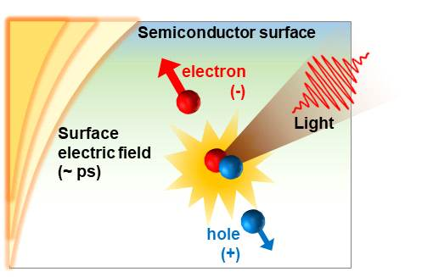
▲ Schematic diagram of the movement of photo-excited electrons and holes in polar semiconductors and the formation of ultrafast surface electric fields

This study succeeded in tracking the ultrafast electron motion on the surface in real time without reducing the size of the sample using time-resolved nonlinear spectroscopy.

The research team observed in real time the surface electric field formed by photo-excited electrons in gallium arsenide (GaAs) and indium arsenide (InAs), which are representative polar semiconductors, in real time through femtosecond-time-resolved second harmonic generation technology.

When a photon (light) enters the material, hot electrons and holes with high kinetic energy are created, and these recombine due to surface defects such as dangling bonds on the semiconductor surface. At this time, because the electrons move at a speed more than a thousand times faster than that of holes, the spatial distribution of electrons and holes changes, and thus a surface electric field is formed.

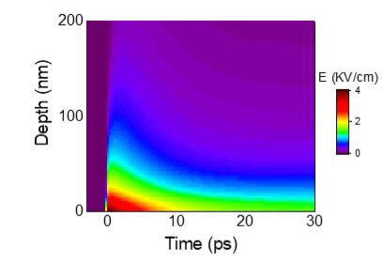
▲ Computational simulation results for ultrafast surface electric field formation in polar semiconductors

The research team measured this surface electric field, which was formed at a thickness of several nanometers near the surface, through the formation of second harmonics. In particular, through time-resolving technology using a femtosecond laser, an electric field is formed over several hundred femtoseconds (10⁻¹⁵ seconds) according to the movement of these photocharges. They also found that it disappears over tens of picoseconds (10⁻¹² seconds).

GIST Professor Jong Seok Lee said, "The result of this study is a meaningful result of real-time tracking of the ultra-high-speed movement of photo-excited charges on the semiconductor surface, and it is expected to greatly contribute to the development and performance improvement of solar cells or photocatalyst-related devices in the future."

This research was supported by the Ministry of Science, ICT and Future Planning and by the GIST Research Institute and was published online on September 17, 2021, in Applied Surface Science, a world-class academic journal in materials science and coatings, with support from the National Research Foundation's Senior Researcher Project and Leading Research Center Project.



