Successful quantum bar alignment and orientation control with polymer crystallization

- Development of a hybrid semiconductor wire of less than 10 nanometers (nm) with a uniform quantum bar arrangement, and structural analysis through a three-dimensional transmission electron microscope

- Various applications are expected in the field of next-generation
displays and optoelectronic devices


▲ From left: Ph.D. student Jun Ho Hwang, Professor Eunji Lee, and Dr. Seon-Mi Jin

GIST (Gwangju Institute of Science and Technology) School of Materials Science and Engineering Professor Eunji Lee's research team succeeds in controlling the crystallization rate of conductive polymer to determine the position of quantum rods* and developed a hybrid nanowire manufacturing technology that can uniformly control alignment and orientation (particles are arranged in a certain direction).

The ultra-fine structure of semiconductor wires of less than 10 nanometers was successfully confirmed by three-dimensional transmission electron microscopy analysis**.

* quantum rod: Semiconductor nanoparticles with a diameter of several nanometers and a length of several tens of nanometers

** three-dimensional transmission electron microscopy analysis: A technique that extracts three-dimensional morphological information by reconstructing a series of images acquired from various angles using a transmission electron microscope, also called transmission electron microscopy tomography.

Quantum rods are semiconductor crystals with an aspect ratio that have a structure and shape. Although the alignment direction between particles has a great influence on the electrical and optical properties, it tends to agglomerate randomly with a low aspect ratio. Sophisticated positioning and orientation control are very important factors to consider for performance characterization.

The research team introduced a block capable of binding to a quantum rod in a conductive polymer, applied a solution process, adjusted the crystallization rate of the polymer by considering the diffusion coefficient of a heterogeneous solvent, and successfully fabricated a hybrid wire in which quantum rods are uniformly arranged.

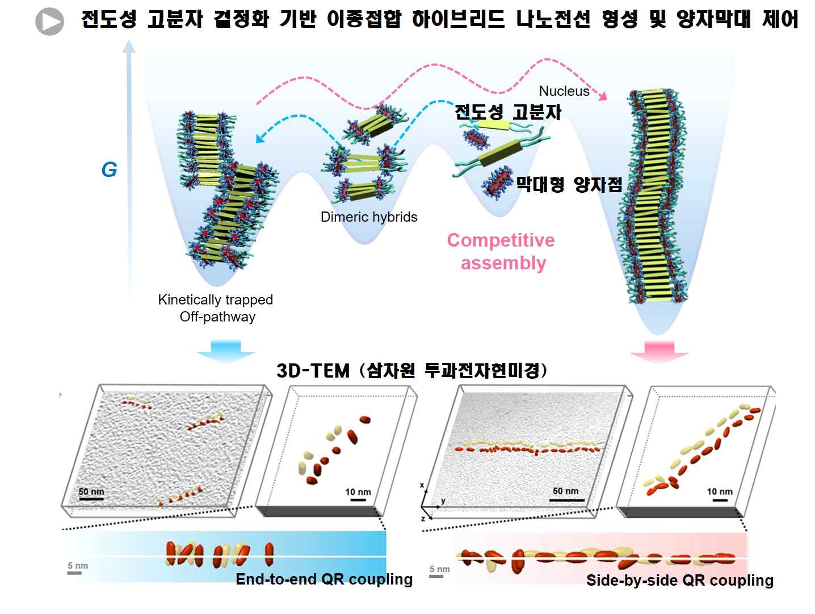
[Figure] Controlling the position, alignment and orientation of quantum rods by the crystallization constraint effect of self-assembled polymers

It is a hybrid semiconductor wire with a width of 10 nanometers and a length of several micrometers, in which a conductive polymer as an electron donor and a quantum rod as an electron acceptor have an alternating arrangement. In particular, the generation of nanowires, crystallization of conductive polymers, crystallinity, position and uniform arrangement of quantum rods could be identified through the development of a three-dimensional transmission electron microscopy method.

It was confirmed that the crystallization rate of the polymer had a very large effect on the length of the nanowire and the alignment mode of the quantum rod as well as the degree of polarization and the charge transfer path, leading to specific electrical and optical properties.

Professor Eunji Lee said, "This study is meaningful in that it suggests a strategy that can freely control the alignment and orientation of quantum bars in ultra-fine semiconductor nanostructures. It is expected that many applications will be possible in the field of next-generation electro-optical devices such as optical communication, quantum computing, 3D display, and solar cells as well as a new concept for a light emitting switch device by using the combined mode of the quantum rod with polarization characteristics."

This research was led by GIST Professor Eunji Lee (corresponding author) and conducted by Ph.D. student Jun Ho Hwang and Dr. Seon-Mi Jin as co-first authors with support from the from the Technology Development Program to Solve Climate Changes of the National Research Foundation of Korea, the Samsung Research Funding & Incubation Center of Samsung Electronics, and the GIST Research Institute and was published online on September 27, 2021, in the international journal Chemistry of Materials (IF: 9.811) and will be published afterwards as the cover paper in recognition of the study's importance.



