Development of technology to detect and extract energy consumption patterns of households
using artificial intelligence

- Contributes to the policy of utilizing household electricity
demand to cope with the climate crisis


▲ From left: Professor Jinho Kim and Ph.D. student Keon Baek

Efficient management and stable supply of electricity are very important to cope with global climate environment problems and realize carbon neutrality*. In particular, the demand response** (DR) system as a means of stabilizing electricity supply and demand and converting clean energy is attracting worldwide attention.

* carbon neutrality: A concept and policy that minimizes greenhouse gas emissions caused by human activities and achieve zero net emissions by absorbing and removing the remaining greenhouse gases.

** demand response (DR): In the event of a power system problem, consumer resources, such as companies participating in the power DR market, increase or decrease demand as requested by the system, especially in peak time, wind power, and solar power changes.

GIST (Gwangju Institute of Science and Technology) School of Energy Convergence Professor Jinho Kim's research team has developed a new artificial intelligence (AI)-based analysis technology that detects and extracts the consumption patterns of home energy users living in houses or apartments.

The research team extracted the usage patterns of household appliances and people's occupancy through a new probabilistic approach methodology using the measurement data of power consumption in seconds of household appliances.

To estimate the actual participation potential of DR resources, it is necessary to analyze energy load characteristics including user behavior based on information data. In the simulation algorithm for estimating the potential demand response, the user's discomfort level related to the dynamics of home appliances was quantified and reflected.

For example, the degree of comfort felt by humans in the temperature change according to the operation of the air conditioner and the thermal inertia of the room is constrained according to the ISO scale and was measured and controlled based on the International Renewable Energy Agency (IRENA) standard so that the change in illuminance of lighting did not cause eye fatigue. Accordingly, it is possible to estimate the resource potential within the range that satisfies the energy use satisfaction of the living users.

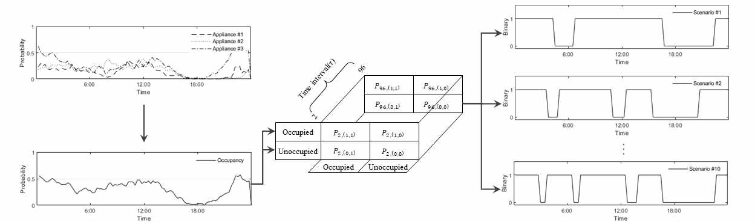
[Figure 1] Simulation of resident behavior pattern extraction process
Analyze load data in multiple dimensions (day, weather, season) to learn patterned results to derive features, and use them to construct probabilistic scenarios for forecasted days

This technology was applied to the demand response market for carbon reduction and intuitively presented the market incentives to improve macro-environmental responsiveness. Through this study, the research team confirmed that when a household participates for 250 days as a demand response resource, about 10 MWh of energy can be contributed to the power grid, which is equivalent to reducing 7.7 tons of carbon dioxide.

It also suggested that if a portion of the generator output using fossil fuels is replaced with a DR resource, a new market incentive can be created that can return the environmental benefits from carbon reduction to consumers.

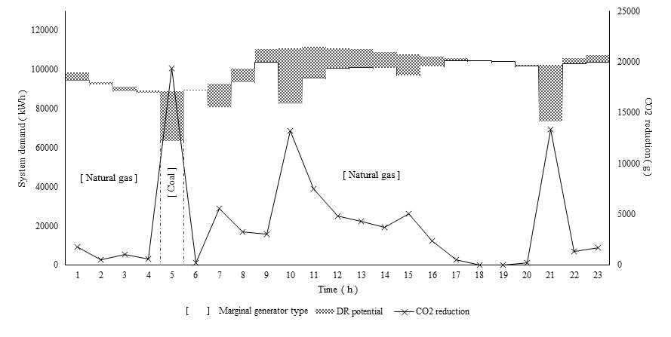
[Figure 2] Substitution effect of demand response resources for carbon reduction
Schematic of the environmental benefits that can be expected when the developed technology is applied to accumulate demand response resources for customers living in houses/apartments, quantifying carbon reduction when large-scale household demand response resources replace fossil fuels by calculating carbon dioxide emissions from marginal generators for each time period on a daily basis

Professor Jinho Kim said, "Through the results of this research, big data-based analysis that can convert household energy demand into large-scale integrated resources is possible. In the future, by expanding the sector to which this technology is applied, it can contribute to improving the effectiveness of sector coupling* in various fields such as water, heat, gas, and electric vehicles and preparing policies for this."

* sector coupling: A technology and system that combines energy sectors (water, heat, gas, transport) in the form of using and storing variable renewable energy power into other energy forms.

The study was conducted by GIST Professor Jinho Kim's research team with the support of the Ministry of Trade, Industry and Energy and the Korea Energy Agency and was was published in the September 2021 issue of IEEE Transactions on Smart Grid, a journal within the top 10% in the field of electrical and electronic engineering.



