The mystery in the difficult poem of genius poet
Lee Sang was solved after 90 years

- A physicist explains the mystery of the title of a series of poems that has not been solved for 90 years since its presentation based on four-dimensional geometry

- Exploring the expansion of dimensions shown in 'Triangular Design Diagram' and 'Infinite Architectural Hexagon'


▲ From left: Professor Soo Jeong Lee and
GIST College graduate Sang-hyun 'Maverick' Oh

A mystery about the title and some of the contents of 'Triangular Design Diagram' (1931) and 'Infinite Architectural Hexagon' (1932), two of the most difficult poems by the genius poet Lee Sang (1910.9.23-1937.4.17), who celebrated their 111th birthday this year, was was explained by a physicist 90 years after their publication.

University of California at Merced Ph.D. student Sang-hyun Oh (GIST College physics major, 2020) and GIST (Gwangju Institute of Science and Technology) Division of Liberal Arts and Sciences Professor Soo Jeong Lee recently published a paper based on four-dimensional geometry to analyze the the poems' difficult titles and coined the terms 'tertiary angle,' 'hexagonal angle,' and 'infinite hexagonal body.'

'Tertiary angle' refers to three angles used when expressing directions in four-dimensional space as hyperspherical coordinates. As a result of the study, it was found that this is a term devised based on the idea that three angles are one 'three-dimensional angle.'

'Hexagonal angle' refers to the angle of an angled four-dimensional figure, which is a term devised based on the fact that six faces meet at one point in a four-dimensional figure. The research team confirmed that 'hexagonal' means an angled four-dimensional figure, and 'infinite hexagon' means a four-dimensional figure made up of infinitely many points.

In addition, the research team revealed that the 'spectrum' of the 'Triangular Design Diagram - Memorandum 1 on Lines' is a device that expands the space from 2D to 3D by taking the spectrum of light expressed in dots (see Figure 1). In 'Infinite Architectural Hexagon - AU MAGASIN DE NOUVEAUTES,' the line "pseudo-angle in the middle of the square in the middle of the square" sequentially expands the dimension of space and finally means a square existing in four-dimensional space (see Figure 2).

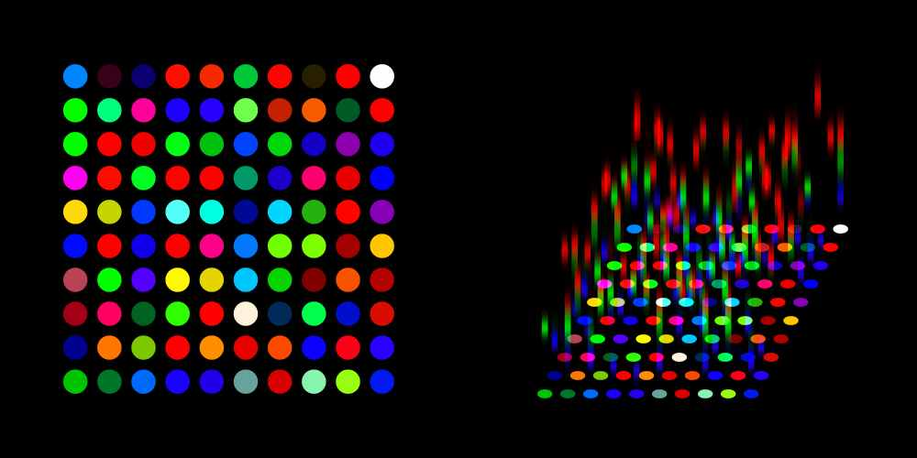
Figure 1: Dimensional expansion by 'spectrum' of 'Triangular Design Diagram - Memorandum 1 on Lines'

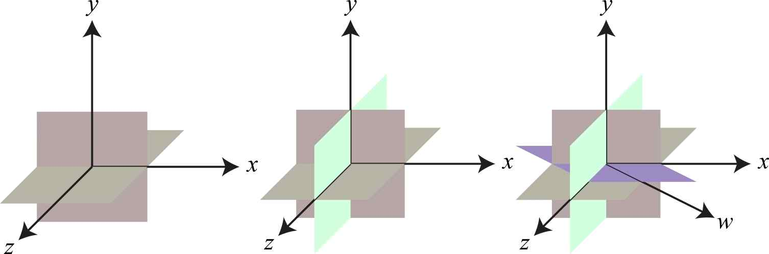
Figure 2: Dimensional expansion of 'Infinite Architectural Hexagon - AU MAGASIN DE NOUVEAUTES' of 'pseudo-angle in the middle of the square in the middle of the square'

Left: "In the middle of the square." Two squares are orthogonal as they pass through each other's center lines in three-dimensional space.

Middle: "Middle, middle, middle, middle, middle." The three squares are orthogonal as they pass through each other's center lines in three-dimensional space.

Right: "The middle of the square, the middle of the square." The four squares are orthogonal as they pass through each other's center lines in four-dimensional space.

Professor Soo Jeong Lee and Sang-hyun Oh said, "With this paper, we found that the poems were an initial literary attempt to implement and design architecture in four-dimensional space-time. This study highlighted the path through which thoughts and original imagination using the above four-dimensional geometry were embodied in the works. It is meaningful in that it has prepared a stepping stone for follow-up research to deconstruct these difficult poems."

Professor Soo Jeong Lee realized the importance of trigonometric-related ideas presented by Sang-hyun Oh in his final report for the 'Ideal Literature and Science' course during the first semester of 2020. The paper was completed after continuous collaboration and meetings.

This study was published on August 31, 2021, in the Journal of Korean Culture, issue No. 54, published by the International Academic Forum on Korean Language and Literature.



