Development of an artificial intelligence algorithm to recognize the perspective of a disaster rescue robot

- Proposal of a large-scale data set that simulates a disaster site and an algorithm for estimating the location of victims... Expected to be used in disaster relief work


▲ From left: GIST Professor Hae-Gon Jeon, DGIST Professor Sunghoon Im,
and KAIST Professor In So Kweon

As large-scale disasters such as earthquakes, fires, and typhoons are rapidly increasing around the world, prompt and safe lifesaving methods at dangerous disaster sites is very important. Research on an algorithm that can build a large-scale data set that simulates a disaster site and estimate the location of victims at the scene has just been published.

A joint research team consisting of GIST (Gwangju Institute of Science and Technology) AI Graduate School Professor Hae-Gon Jeon, DGIST Professor Sunghoon Im, KAIST Professor In So Kweon, and researchers from Carnegie Mellon University in the US developed an artificial intelligence algorithm to recognize the perspective of disaster rescue robots.

Despite social demands for large-scale disaster response, studies related to disaster rescue are not actively being studied because industrial demand is not supported. In particular, the development of artificial intelligence technology is expected to present a breakthrough paradigm for disaster relief work, but related research is sluggish due to lack of datasets for related research and lack of protocols to verify the developed algorithms.

In addition, disaster site data sets are difficult to acquire, and some of the acquired data sets are insufficient to annotate for artificial intelligence algorithm learning.

The research team proposed a large-scale data set that simulated a disaster scene in a virtual reality space. Earthquake and fire scenes were created in indoor and outdoor virtual environments. Images were acquired so that pre- and post-disaster situations could be accurately compared in the same space and point of view, and 3D information, camera location information, and semantic image segmentation information were annotated.

In addition, an algorithm for estimating the location of the victim at the disaster site was proposed. Based on the spatial information learned from the pre-disaster situation, the researchers proposed an artificial intelligence algorithm that can infer the location of the victim in a disaster situation using only a single image.

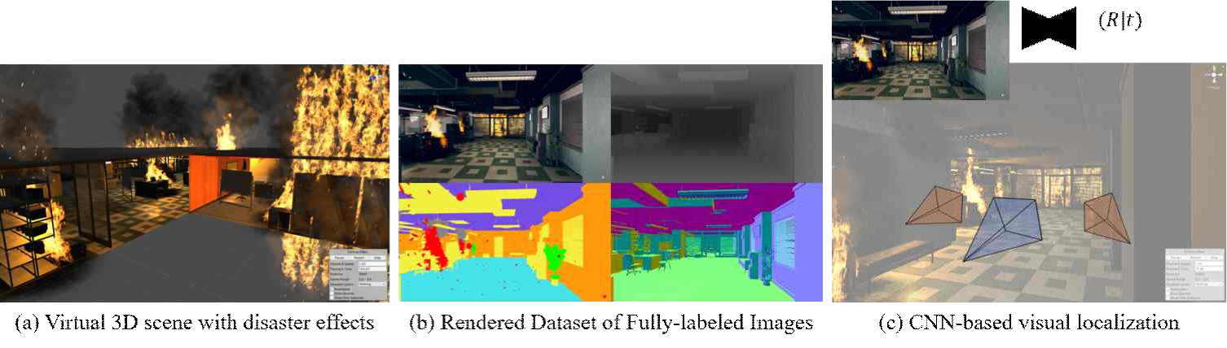
[Figure] (a) Produce a disaster situation in a virtual environment. (b) 3D depth information, semantic segmentation information, and 3D normal vector information provided in a disaster environment. (c) Research on victim location estimation based on artificial intelligence using a single image.

Professor Hae-Gon Jeon said, "In this study, we proposed an artificial intelligence algorithm for recognizing the perspective of a disaster rescue robot that can quickly respond to a disaster situation in a virtual reality space through simulation using artificial intelligence. It is expected that this study will be used to trigger various disaster rescue studies in the future."

This research was conducted by GIST Professor Hae-Gon Jeon and a joint research team from DGIST, KAIST, and Carnegie Mellon University in the United States with support from the Ministry of Trade, Industry and Energy and the Korea Institute of Information & commu- nications Technology Planning & Evaluation (IITP) and was published online on July 7, 2021, in IEEE Transactions on Pattern Analysis and Machine Intelligence, which is the top 0.3% journal in computer science-artificial intelligence.

