Development of multi-spectral display
that prevents forgery

- Implementation of visible light-infrared light control structure through multi-spectral photonics structure - Expected to be used in security applications for next-generation forgery prevention


▲ Counterclockwise from right in the back row: Professor Young Min Song, Dr. Young Jin Yoo, Ph.D. students Sehui Chang and Joo Hwan Ko, and Dr. Gil Ju Lee

As counterfeit items from banknotes and gift certificates to high-end luxury goods are diversifying and the amount of counterfeit items is rapidly increasing, a new next-generation security anti-counterfeiting technology is needed to solve this problem. A Korean research team has developed a next-generation security-forgery prevention technology that can store a variety of information in one place.

GIST (Gwangju Institute of Science and Technology) School of Electrical Engineering and Computer Science Professor Young Min Song's research team succeeded in developing a colorful next-generation multi-spectrum* forgery-resistant display for security that contains infrared information that cannot be seen with the naked eye.

* multi-spectrum: Refers to multiple regions of the spectrum, which are the wavelength ranges of light classified according to characteristics.

The display developed by the research team looks like general color prints because it can realize various colors of the entire wavelength band of visible light seen with the naked eye, but hidden information can be confirmed when observed with a thermal imaging camera that detects the infrared region. Unlike the existing holographic or fluorescent material-based security devices, this display has a high security level because it can contain various information without revealing itself as a security device.

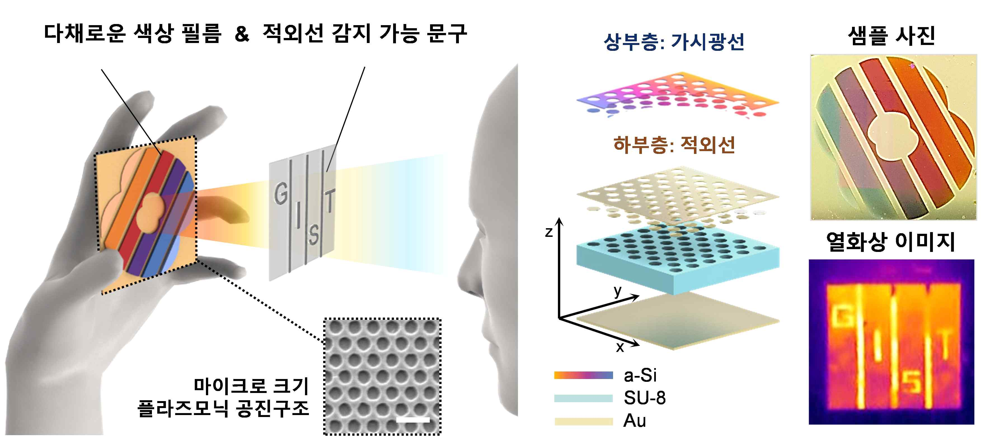
[Figure 1] Infrared display capable of realizing various colors
Infrared display designed to be detectable only with thermal imaging cameras to verify the wording. It is characterized by colorful color implementation through thin film thickness and thermal image recording through cycle control of microstructures.

Traditionally, multispectral photonics technologies have been difficult to develop in terms of independent control of wavelength-specific optical characteristics, but the team succeeded in implementing two spectra in a single structure by applying different optical resonance structures to control visible light and infrared bands individually.

In the visible light region, an ultra-thin color development structure composed of a metal-high absorption medium capable of developing colors in an ultra-thin film structure of several tens of nanometers was applied. In the infrared region, multi-spectral characteristics were realized at a very thin thickness (~3 μm) by selectively implementing strong absorption through a plasmonic structure* using a micro-hole pattern.

* plasmonic structure: It is a phenomenon of collective vibration of electrons caused by the interaction of light and electrons, and the electric field increases on the surface of the structure, and it refers to a structure that causes strong absorption at a specific wavelength.

This technology can be implemented on a very thin flexible device substrate, beyond the limitations that have been possible only on very limited substrates so far for realizing visible light colors and writing information in the infrared region. In addition, since no separate energy is required for operation, it can be used in various fields requiring security, such as the financial sector, government offices, and the military.

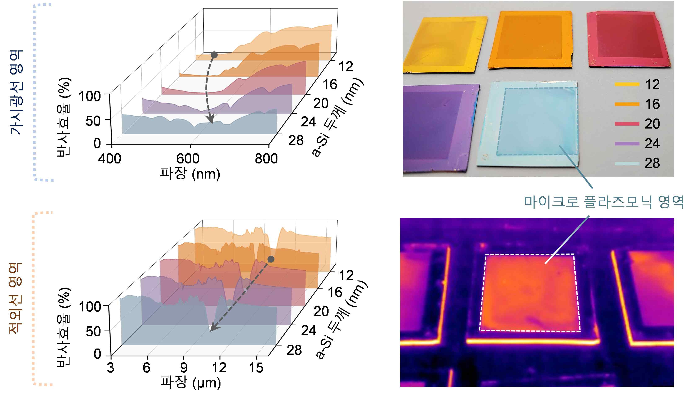
[Figure 2] Implementation of colorful colors through ultra-thin control
Reflection efficiency and sample photo in the visible region due to nanometer thickness control of amorphous silicon (a-Si) (top of figure). Infrared region reflection efficiency and thermal image according to the thickness change of a-Si (bottom of the figure).

GIST Professor Young Min Song said, "By inducing multi-spectral light control, the technology to prevent forgery has been further strengthened. In the future, it will be possible to develop a next-generation ultra-small security display that changes the image in real time by applying a material capable of active modulation."

This research was supported by the National Research Foundation of Korea, the Korean Institute of Energy Technology Evaluation and Planning, the Ministry of Trade, Industry & Energy (MOTIE), and by the GIST Research Institute and was published in the international journal Advanced Optical Materials (IF: 9.926).



