Serendipity of cancer treatment, development of a new treatment strategy that maximizes the efficacy of chemotherapy

- Professor Jeong-Seok Nam's team discovered CD45-expressing
cancer cells that induce chemotherapy resistance


▲ From left: Professor Jeong-Seok Nam and Dr. So-Yeon Park

Despite advances in cancer treatment, many patients still suffer from cancer metastasis or recurrence after chemotherapy. When chemotherapy is administered, cancer tissue becomes smaller and appears to respond well to chemotherapy, but a small number of cancer stem cells* resist the attack of chemotherapy and survive and cause a recurrence.

* cancer stem cells: A specific cell group in cancer tissue that has indefinite self-renewal ability and the ability to differentiate into cells with various traits. Tumors are formed by these few cells, and cancer recurrence and metastasis occur.

GIST (Gwangju Institute of Science and Technology) Professor Jeong-Seok Nam's research team discovered the chemotherapy-resistant biomarker CD45 through genomic profiling of cancer tissues of colorectal cancer patients.

Serendipity* on the novel function of CD45 is expected to help the understanding of intractable cancer and to develop new treatment strategies.

* serendipity: a major discovery made by chance

CD45 has been known as an immune cell marker, and little is known about its expression and function in cancer cells. The research team accidentally discovered that CD45 expression was high in colorectal cancer chemotherapy-resistant cancer tissues. The presence of CD45-expressing cancer cells was investigated using a new analysis technique called single-cell genome profiling and a dual labeling technique using an epithelial cell binding molecule (EpCAM).

Furthermore, the research team confirmed that the CD45-expressing cancer cells present in the patient's cancer tissues survived chemotherapy and radiation treatment to induce cancer cell proliferation and recurrence.

Through clinical studies, the research team proved that the higher the CD45 expression of cancer cells, the poorer the treatment prognosis for chemotherapy.

If the size of the cancer is reduced with chemotherapy or radiation therapy and then surgery is performed, the possibility of a complete cure increases, but it is not effective for all patients, so the importance of developing a biomarker is growing. Therefore, the discovery of the biomarker CD45, which can predict the treatment response to chemotherapy before surgery, is significant.

The research team found that cancer cells expressing CD45 have the ability to self-renew and have the characteristics of cancer stem cells that continuously regenerate cancerous tissues and found a therapeutic strategy that can overcome intractable cancer through the CD45 target.

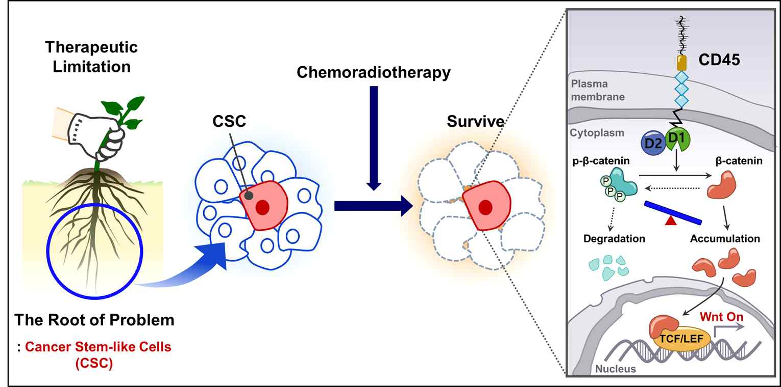
▲ Mechanism of chemotherapy resistance in CD45-expressing cancer cells

Using a CD45 inhibitor developed as an immune drug, it was found that CD45-targeted therapy could suppress the resistance of cancer stem cells to anticancer treatment and lower the ability of cancer recurrence after chemotherapy. This is significant in that it provided an experimental basis for the treatment of intractable cancer.

Professor Jeong-Seok Nam said, "The significance of this study is that it revealed a new role of CD45 in inducing chemotherapy resistance and opened the possibility of a new therapeutic strategy to overcome intractable cancer."

This research was led by GIST Professor Jeong-Seok Nam and conducted by Dr. So-Yeon Park as the first-author with support from the National Research Foundation of Korea and the GIST Research Institute and was published online on August 11, 2021, in Theranostics, an authoritative journal that specializes in the top 6.071% in the medical field.



