Development of non-invasive diabetes self-diagnosis system using smart contact lenses

- Diabetes diagnosis by glucose concentration in tears... Quantitative analysis using a camera to detect the color change of nanoparticles that are
harmless to the human body

▲ Schematic diagram of color change to smart
contact lenses due to glucose in tears

A technology that can manage blood sugar in a non-invasive way using tears has been developed by a Korean research team. It is expected to significantly reduce the burden of pain that may occur during blood collection by replacing the existing invasive method.

GIST (Gwangju Institute of Science and Technology) Department of Biomedical Science and Engineering Professor Euiheon Chung's team developed a smart contact lens that is harmless to the human body and does not require electrodes through joint research with Hanyang University Department of Bioengineering Professor Dong Yun Lee (Elixir Pharmatech*).

* Elixir Pharmatech, Inc.: Professor Dong Yun Lee of Hanyang University founded a laboratory company to commercialize immune and anti-inflammatory technologies developed in laboratories.

The typical diagnosis of diabetes is an invasive method that measures the concentration of glucose in the blood collected by pricking the tip of a finger with a needle. Pricking a finger each time to measure blood sugar causes great psychological stress for patients, and there is a possibility of side effects, such as infections.

The research team confirmed the possibility of diagnosing diabetes through the glucose concentration in tears, which are highly correlated with the disease state, among the main body fluids that will replace blood, and proceeded to develop smart contact lenses.

Among the body's major body fluids to replace blood, the research team confirmed the possibility of diabetes diagnosis through glucose concentration in tears using tears that are highly correlated with disease conditions and developed smart contact lenses.

In the case of diabetic patients, when the blood glucose level rises, the glucose level in other body fluids also increases. Therefore, the contact lenses developed by the research team change color according to the glucose level in tears, and the blood glucose level can be measured by linking it with a smartphone.

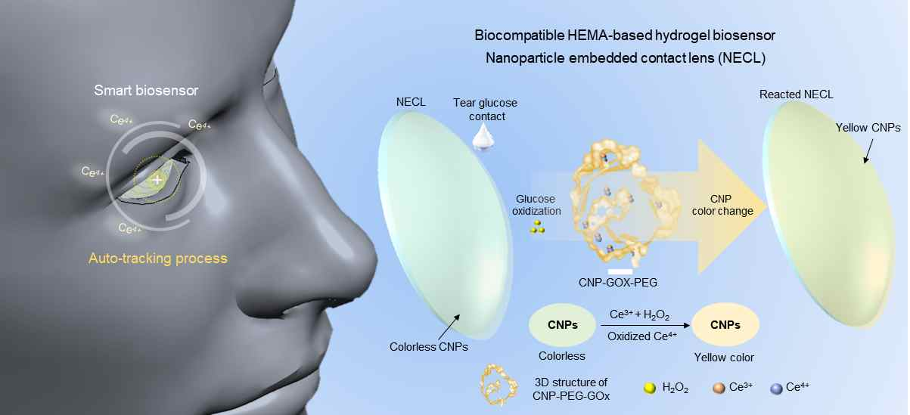
▲ The overall diagram of the glucose concentration measurement system in tears through the changing color of smart contact lenses and a schematic diagram of the chemical reaction of the lens color change process.

According to the research team, the nanoparticles in the lens changes color depending on the glucose concentration in the tears, and they developed a system that can accurately capture the degree of color change and an eye tracking algorithm that can minimize measurement errors due to eye movement. The eye tracking algorithm is designed to give more precise measurements and enable self-diagnosis of diabetes.

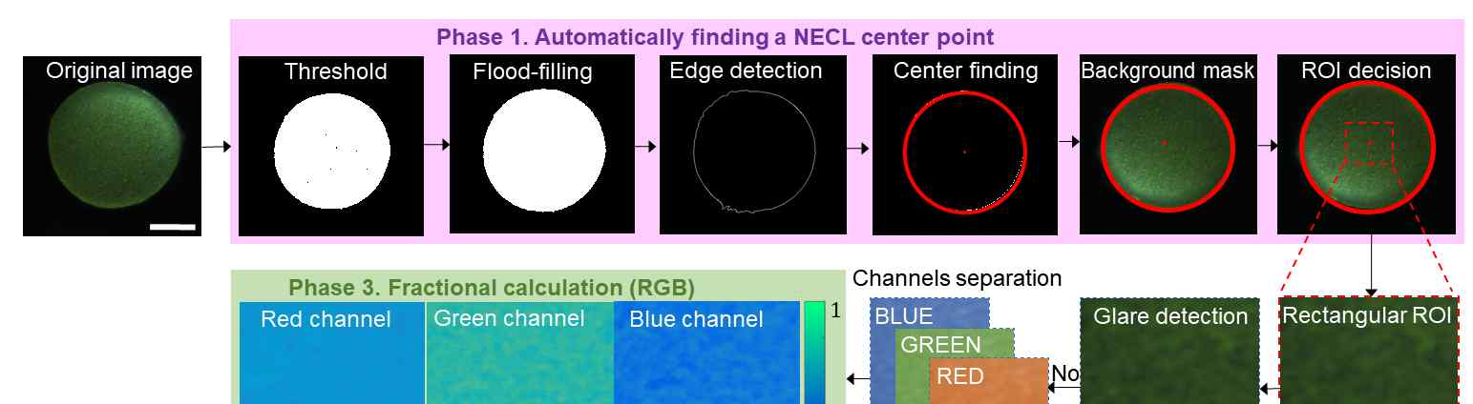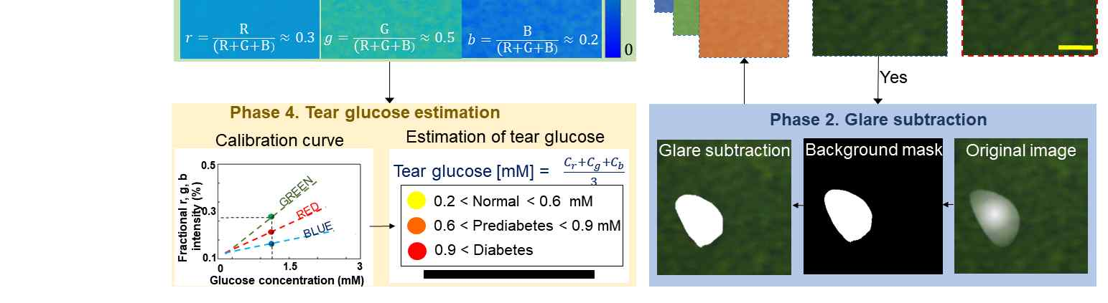
▲ Algorithm configuration diagram that can quantitatively analyze the automatic tracking and color change of smart contact lenses.

In addition, the smart contact lens developed in this study does not require electrodes and minimizes the burden on the body by quantitatively analyzing the color change of nanoparticles that are harmless to the human body by using a camera.

GIST Professor Euiheon Chung said, "This technological achievement can reduce invasive measurements, which is the biggest disadvantage of the existing diabetes diagnosis method. If deep learning technology and big-bio data are used in the future, it can become a more precise non-invasive method for use in everyday life."

Hanyang University Professor Dong Yun Lee said, "If safety evaluation through clinical trials is conducted in the future, it is expected that the burden on the patient will be minimized, and self-diagnosis of diabetes will be made easier than with the conventional diagnosis method."

This research was led by Professor Euiheon Chung (corresponding author) and Hanyang University Professor Dong Yun Lee (corresponding author) and conducted by Dr. Hee-Jae Jeon with support from the GIST Research Institute and the National Research Foundation of Korea and was was published online on August 20, 2021, in Nano Letters, a renowned international journal in the field of nanotechnology. It will also be published as a supplementary cover in a printed version in the future.



