GIST develops high-capacity silicon anode
materials for lithium secondary batteries

- Securing superior electrochemical performance and durability compared to existing silicon anode materials... Development of high capacity and high efficiency silicon anode materials

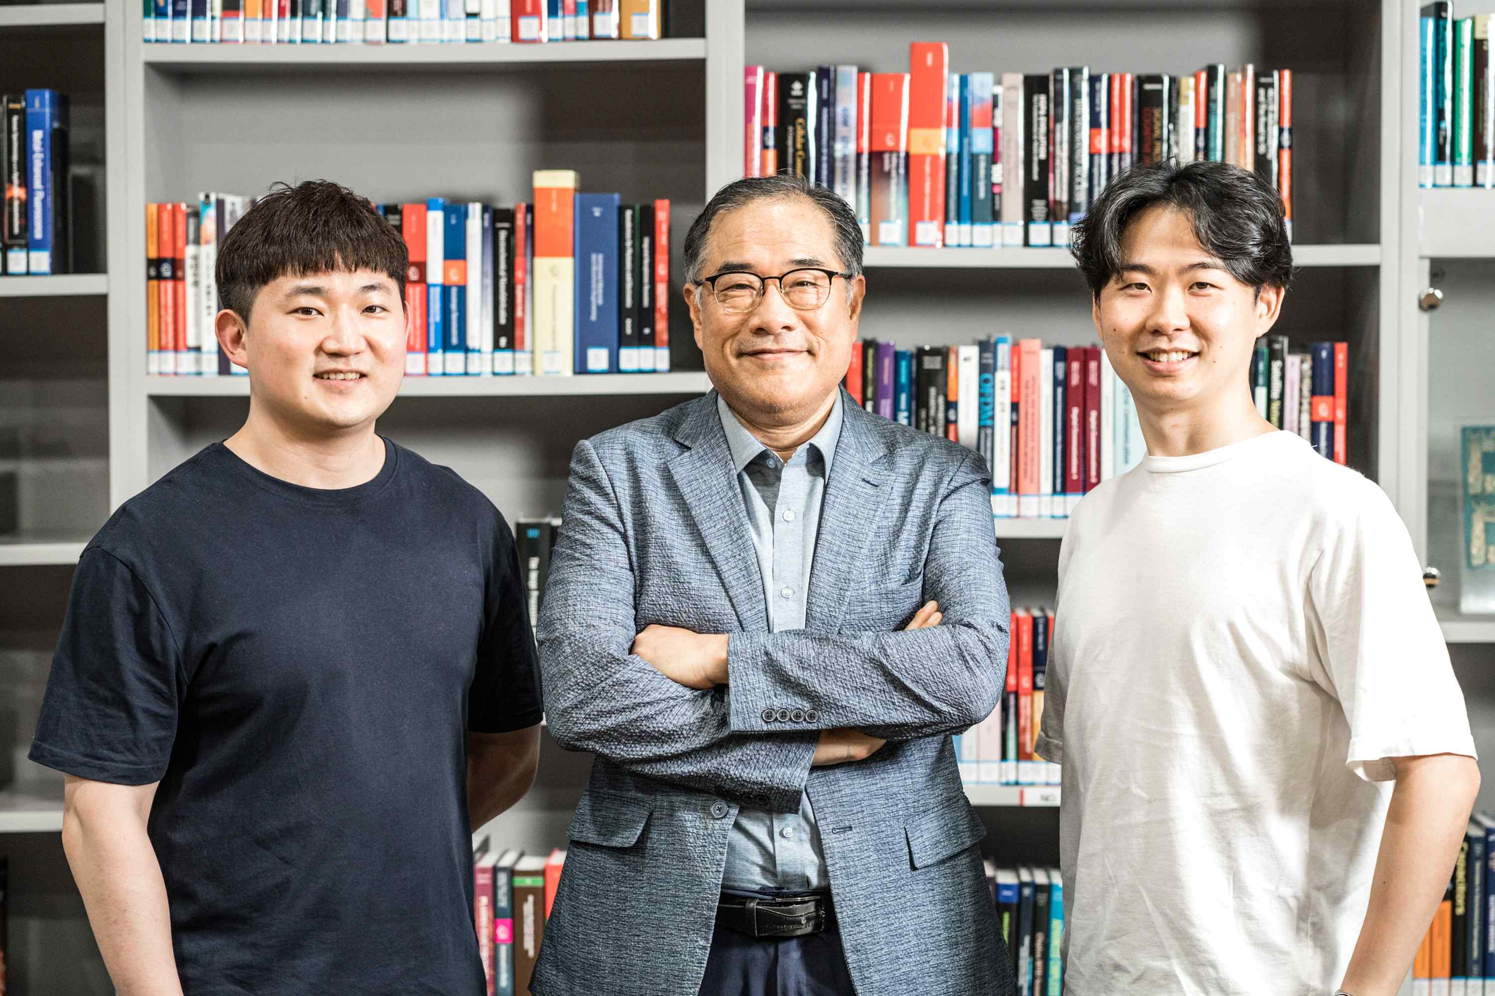
[Photo] From left: Ph.D. student Seokho Suh, Professor Hyeong-Jin Kim,
and master's student Hocheol Yoon

Unlike primary batteries, secondary batteries can be reused after charging, so their application areas are gradually expanding, such as electric vehicles, drones, and robots. A Korean research team has developed a silicon-copper-carbon composite anode material with superior electrochemical performance and a simpler synthesis process compared to the existing silicon anode material for lithium secondary batteries, which is expected to dramatically improve the energy density of secondary batteries in the future.

GIST (Gwangju Institute of Science and Technology) Institute of Integrated Technology Professor Hyeong-Jin Kim improved the performance and durability of silicon anodes*, which are attracting attention as anodes for next-generation lithium secondary batteries.

* silicon anode: Silicon anode is the closest technology to commercialization among existing next-generation anodes. It has a theoretical capacity of up to 4,200 mAh/g per unit weight, making it an ultra-high-capacity next-generation anode with a theoretical capacity 10 times greater than that of conventional graphite anodes.

Silicon anode has a theoretical energy density 10 times higher than that of conventional graphite anodes and is attracting attention as an economical and eco-friendly material as a next-generation anode.

In particular, it can be used as a medium-to-large energy storage device that requires high energy density and power density, such as large-capacity energy storage systems (ESS) and electric vehicles, so competition for development is fierce in countries around the world. However, the non-conductive properties of silicon and the low lifespan due to the volume expansion of silicon during the charging and discharging process are acting as obstacles to commercialization.

Recently, research on materials for improving the performance of silicon anodes is being conducted, but for more practical performance improvement, it is necessary to study a technology that has a low production cost and can be mass-produced. There is a lack of research on technologies considering practical and mass production possibilities for the commercialization of silicon anodes.

The research team succeeded in improving the electrical conductivity of the silicon electrode and relieving the mechanical stress in the electrode generated during charging and discharging by applying a simple electrode heating process to carbonize the silicon-copper alloy reaction and electrode binder*.

* binder: The binder mechanically stabilizes the electrode by preventing the bond between the active material or the conductive material from loosening when charging and discharging are repeated.

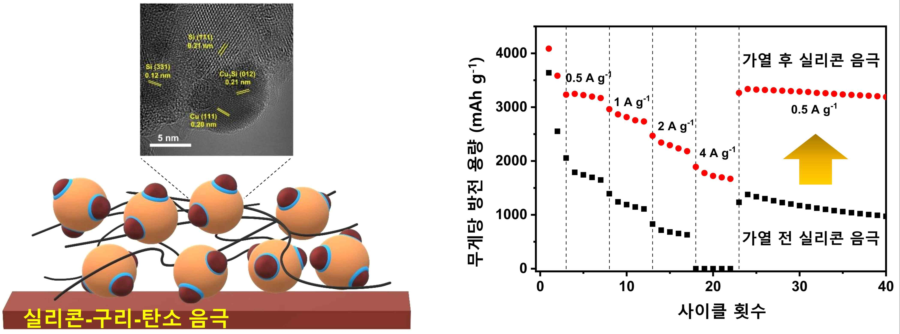
[Figure] Comparison of electrochemical performance before/after heating silicon electrodes

As a result, the silicon-copper-carbon composite anode showed significantly improved electrochemical properties. In particular, at a high current density of 4 A/g, conventional silicon anodes do not charge and discharge properly and confirmed that the silicon-copper-carbon composite anode maintained a high capacity of 1,776 mAh/g.

The silicon-copper-carbon synthesis technology has the advantage that the synthesis process is simple and the possibility of mass production is high because a simple heating process is applied compared to the existing silicon anode material synthesis technology.

Professor Hyeong-Jin Kim said, "In particular, the convergence of various applications and electrode processing technologies between silicon and dissimilar metals is key, and we hope to contribute to improving the performance of lithium secondary batteries in the future as a result of complex research with dissimilar metals beyond the limited use of silicon materials."

The research was led by GIST Professor Hyeong-Jin Kim and conducted by Ph.D. student Seokho Suh and master's student Hocheol Yoon with support from supported by the GIST Research Institute and the Korea Institute of Energy Technology Evaluation and Planning and was published online on August 10, 2021, in Applied Surface Science, a world-class academic journal in the field of coatings.



