Professor Euiheon Chung's research team develops optical imaging technology that can quantitatively measure cerebral blood flow

- Development of optical tools based on laser speckle
for clinical research on vascular diseases

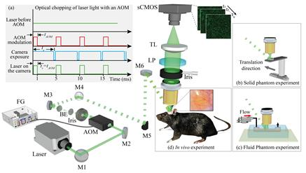
▲ [Figure 1] The overall schematic diagram of the quantitative laser speckle-based quantitative cerebral blood field measurement system developed in this study and examples of various experimental methods (proof of concept experiment, in vitro experiment, in vivo experiment)

An optical imaging technology that can quantitatively measure the change and speed of cerebral blood flow has been developed by a Korean research team. It is expected to present a new treatment for vascular diseases such as stroke.

GIST (Gwangju Institute of Science and Technology) Department of Biomedical Science and Engineering Professor Euiheon Chung's team succeeded in developing a system that can quantitatively measure the change and speed of cerebral blood flow when a cerebral infarction occurs on the cerebral surface by analyzing laser speckle*, an interference pattern created by irradiating a laser beam to the brain.

* laser speckle: When irradiating laser light at objects such as biological tissue, it is a speckled-spotted interference pattern caused by the interaction of particles and laser light. In the case of biological tissue as an interference pattern, information such as the movement of blood cells in biological tissue is reflected in continuous speckle images.

Although the human brain accounts for only 2% of the body mass, it consumes 20% of the body's oxygen and nutrients. Therefore, measuring the change and rate of cerebral blood flow is very important for understanding cerebral metabolism and cerebrovascular pathology.

Although changes before and after the movement of blood flow can be seen in existing research methods, there is a limitation in measuring the speed of blood flow. This research team has developed a method to quantitatively measure the rate of blood flow that changes in real-time only with a speckle analysis without mathematical modeling or correction of these fundamental problems.

As a result, it was possible to objectively compare the efficacy of new treatments for vascular diseases by showing the changes in blood flow in real time as a quantitative velocity map in a preclinical ischemic stroke model.

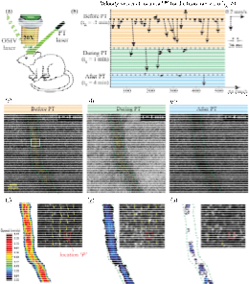
[Figure 2] A diagram showing cortical blood flow maps before and during photothrombosis as a quantitative velocity map by a method developed in a mouse model of photothrombosis.

In particular, this study utilized the principle that real-time movement of blood cells in blood vessels in living tissue is reflected in laser speckle. In other words, they succeeded in quantitatively finding the actual velocity by viewing the speckle as a kind of particle and analyzing spatial and temporal changes.

For this, an extremely short camera exposure time is required, and the research team was able to apply it to animal disease models by implementing an optical and acoustic modulator.

Professor Euiheon Chung said, "This study overcomes the limitations of existing laser speckle imaging and proposes a methodology that can quantitatively analyze the blood flow rate in vivo, and is expected to be applied to the development of animal models-based stroke therapy and clinical research for vascular diseases in the future."

This research was led by GIST Professor Euiheon Chung (corresponding author) and conducted by Ph.D. student Muhammad Mohsin Qureshi (first author) in the Department of Biomedical Science and Engineering with support from the National Research Foundation of Korea and the GIST Research Institute and was published online on August 13, 2021, in Optica a renowned academic journal in the field of optics.



