Professor Myung-Han Yoon's joint research team improves the performance of human-transplantable organic electrochemical transistors

- Expected to be used in high-performance and
high-efficiency bioelectronic devices

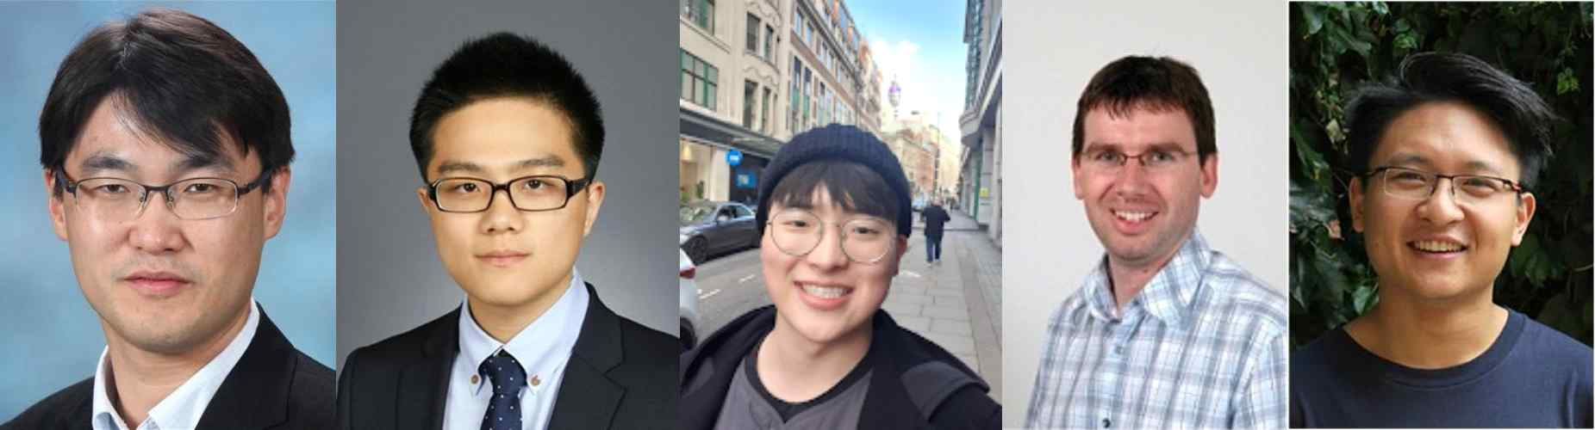
▲ [From left] GIST Professor Myung-Han Yoon, Ph.D. student Youngseok Kim, master's student Gunwoo Kim, Imperial College London Professor Martin Heeney,
and Ph.D. student Bowen Ding

Through international collaborative research, a South Korean research team has succeeded in improving the performance and stability of human-transplantable electronic devices, which are drawing attention as next-generation biomechanical interface devices.

GIST (Gwangju Institute of Science and Technology) School of Materials Science and Engineering Professor Myung-Han Yoon and Imperial College London Professor Martin Heeney's joint research team developed a new organic compound type conductor and investigated the effect of molecular structure shape control on the improvement of the electrical and electrochemical performance of organic electrochemical transistors.

An organic mixed conductor (OMIEC) is a material that has both ionic and electrical conductivity in an electrolyte, and it has recently been in the spotlight as an active layer of a bio-implantable electronic device that can effectively link bioelectrical signals and solid-state electric and electronic signals.

In particular, organic electrochemical transistors can be driven in electrolytes similar to the in vivo environment, so a number of studies related to the application of health care devices that can amplify and switch in vivo electrical signals such as the brain, heart, and muscles are being actively conducted.

In this study, the two newly synthesized mixed conductors controlled molecular shapes into linear and curved shapes using unshared bonds between sulfur-oxygen and sulfur-fluoride in molecular structures, and the effects of these shapes on electrical and electrochemical properties were analyzed through experiments and computational analysis.

Linear materials can induce high intermolecular crystallinity, improving electrical properties, while electrochemical properties have been reduced due to limited ion permeability, and vice versa for curved materials.

In addition, by controlling the energy level through the molecular structure in which the donor-acceptor structure is repeated, it was experimentally confirmed that effective device flicker switching and high electrochemical stabilization were possible by applying it as an accumulation mode transistor channel.

Professor Myung-Han Yoon said, "This study is meaningful in that it is the result of suggesting the direction of the development of new materials for organic electrochemical transistor active layers, which are considered as next-generation bioelectronic interface devices. This is expected to greatly contribute to the realization of high-performance and high-efficiency bioelectronic devices by overcoming the trade-off between electrical and electrochemical properties."

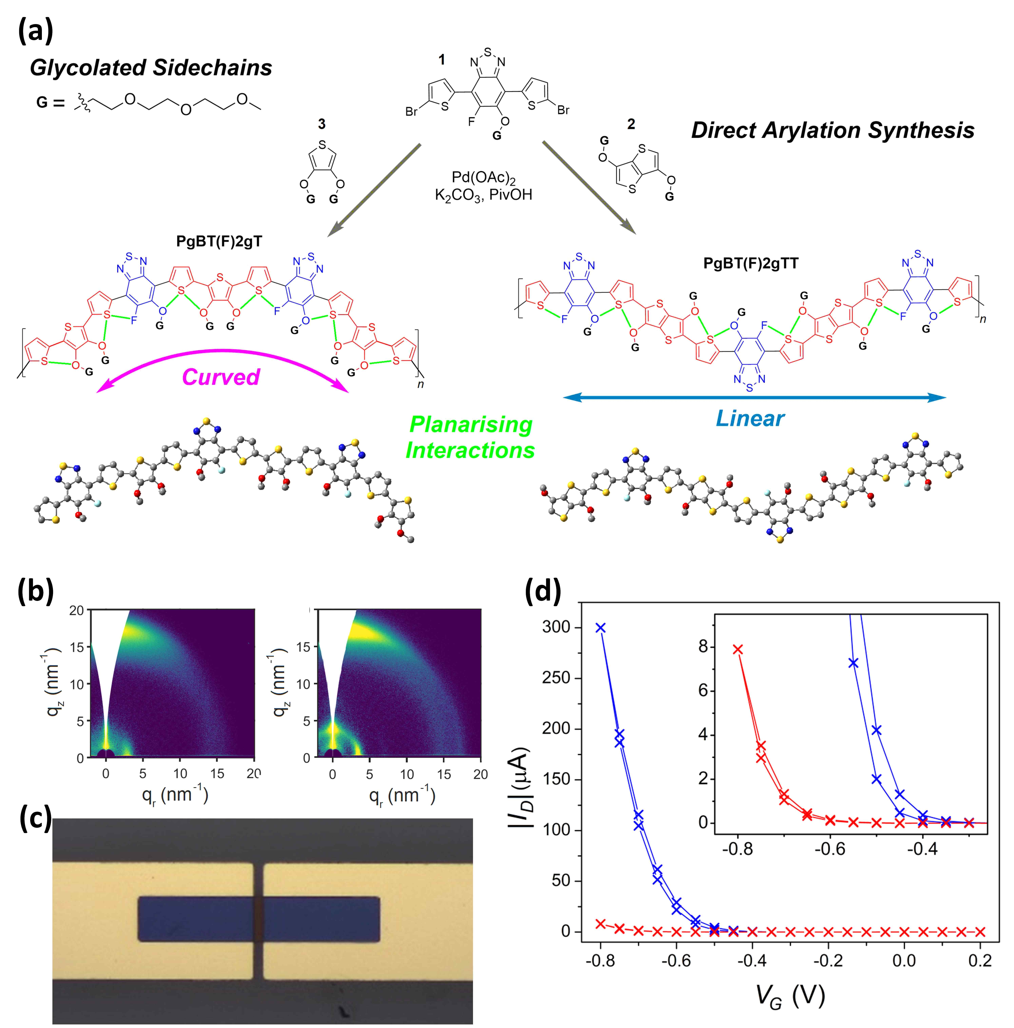
[Picture 1] (a) Molecular structure of an organic compound-type conductor in which the shape of the molecular structure is controlled by inducing non-covalent bonds in the molecule, and (b) crystallinity measurement results according to the shape proven by X-ray experiments. (c) The device structure of the organic electrochemical transistor, and (d) the measurement result of the transfer curve of the two materials.

This research was led by GIST Professor Myung-Han Yoon and Imperial College London Professor Martin Heeney and jointly carried out by Ph.D. student Bowen Ding, master's student Gunwoo Kim, and Ph.D. student Youngseok Kim with the support from the National Research Foundation of Korea and was published in the online edition of Angewandte Chemie, a journal specializing in chemistry, on August 5, 2021.



