Big data analysis reveals key genes
that exacerbate thyroid cancer

- International joint research between GIST and Sichuan University Hospital discovers key genes that cause cancer progression and opens possibilities for early diagnosis and new treatments

Through international joint research between a Korean research team and Sichuan University Hospital in China, early diagnosis and new treatment for undifferentiated thyroid cancer, a deadly rare cancer that rapidly progresses and causes death within a short period of time, were presented.

GIST (Gwangju Institute of Science and Technology) School of Life Sciences Professor Jihwan Park's joint research team discovered the possibility of early diagnosis and new treatment by discovering genes that cause progression to undifferentiated thyroid cancer* using the latest single-cell analysis technology**.

* undifferentiated thyroid cancer: Accounting for less than 1% of all thyroid cancers, it has the poorest prognosis with an average survival time of less than 1 year.

** single cell analysis technology: It is a technology that can analyze the expression of all genes expressed in tens of thousands of individual cells with a single experiment and has been recently considered to be one of the most important next-generation technologies in the fields of biology and medicine.

The research team followed the progression of thyroid cancer through single-cell analysis and genome analysis, and, as a result, revealed that CREB3L1 is a key factor in inducing undifferentiated thyroid cancer by regulating cancer metastasis and cancer cell metabolism.

Thyroid cancer is known to have a high survival rate, a slow progression rate, and a low chance of recurrence compared to other cancers. However, some can progress to undifferentiated thyroid cancer, a difficult-to-treat ‘bad cancer,’ which can be dangerous if left untreated. In addition, there have not been enough studies on how undifferentiated thyroid cancer progresses and what are the key regulatory genes.

The research team found a small number of cancer cells that are specific to undifferentiated thyroid cancer through single-cell analysis of patient tissues, and found that these cancer cells were derived from differentiated thyroid cancer cells, which have good prognosis. This study refutes the existing hypothesis that undifferentiated thyroid cancer and differentiated thyroid cancer progress through different pathways.

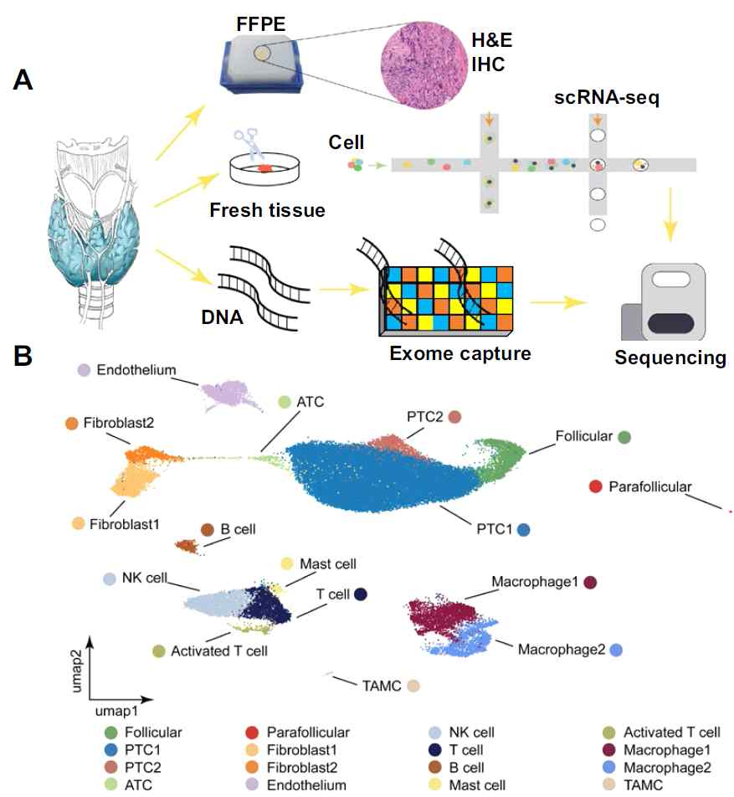
(A) Schematic diagram of a study performed single-cell analysis
and genome analysis using thyroid cancer patient tissue
(B) As a result of single cell analysis, undifferentiated thyroid
cancer and differentiated thyroid cancer-specific cancer cell
types and immune cells were identified.

A key factor inducing the progression to these undifferentiated thyroid cancer cells is CREB3L1, which has been shown to induce undifferentiated thyroid cancer by regulating the expression of other gene groups related to cancer metastasis and metabolism.

Professor Jihwan Park said, "The CREB3L1 gene discovered by our team was found to play an important role in the early stage of undifferentiated thyroid cancer. This is expected to present a new direction for the early diagnosis and development of therapeutic agents for undifferentiated thyroid cancer."

This research conducted by GIST Professor Jihwan Park's team through joint collaboration with Sichuan University Hospital in China was supported by the Samsung Future Technology Promotion Project and was published online on July 28, 2021, in Science Advances, an international renowned academic journal.



