
Gwangju Institute of Science and Technology
Official Press Release — https://www.gist.ac.kr

Senior Researcher Chang-Lyoul Lee's team develops high-stability core-shell perovskite quantum dot electroluminescent device

GIST (Gwangju Institute of Science and Technology) Advanced Photonics Research Institute (APRI, Director Yeung Lak Lee) Senior Researcher Chang-Lyoul Lee's team succeeded in developing core-shell* perovskite quantum dots with a very thin shell by controlling the crystal growth rate by identifying the growth mechanism of perovskite** quantum dots.



* core-shell perovskite quantum dots: To improve the low atmospheric and chemical stability of the perovskite quantum dot, it is a structure surrounding the perovskite quantum dot with an inorganic material with high stability against moisture, oxygen and polar solvents.

** perovskite: Rather than a name for a specific substance, it is a substance with a cubic structure composed of cations of two elements of different sizes and anions bound to them.

Perovskite quantum dots coated with very thin (<2 nm*) silica (SiO2) as a shell exhibited very high luminous efficiency and excellent chemical stability without rapid loss of optical properties even in polar solvents.

* nm: 1/1,000,000,000 meters, which is 1/100,000th the thickness of a human hair.

Perovskite quantum dot materials are attracting attention as a next-generation display light emitting material that can replace organic light emitting diodes (OLEDs) with advantages such as high luminous efficiency, high color purity, and low price due to solution process.

However, due to its ionic bonding properties, it is very easily decomposed under water, oxygen and polar solvents, so it is difficult to maintain luminous efficiency and color purity for a long period of time. In the case of core-shell perovskite quantum dots incorporating metal oxide or inorganic materials into the shell, they exhibited high chemical stability, which is an obstacle to the development of displays.

The research team succeeded in synthesizing high-stability core-cell perovskite quantum dots through crystallization of perovskite quantum dots by controlling the binding energy of the surface ligand* and control of the growth rate of the silica shell.

* ligand: A surfactant with various carbon lengths attached to the surface of quantum dots so that quantum dots can be stably dispersed in solution.

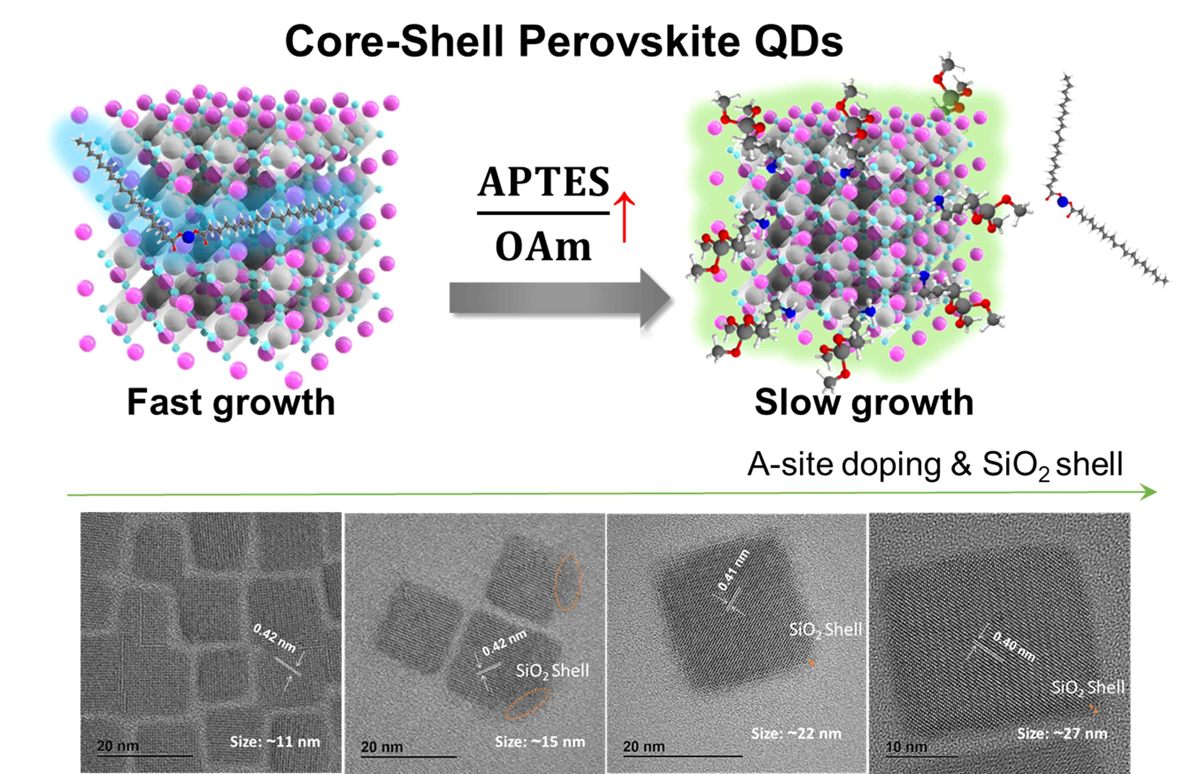
[Figure 1] Schematic diagram of crystal growth of core-shell
perovskite quantum dots through ligand binding energy control.

The crystallinity of the quantum dots was improved by controlling the binding energy between the ligands and the quantum dots by controlling the addition amount of three kinds of ligands used for the synthesis of core-shell perovskite quantum dots, and a very thin silica cell was formed.

Because of the high chemical stability of the core-shell perovskite quantum dots developed by the research team, the entire process of thin film fabrication of the perovskite quantum dot electroluminescent device could be implemented as a solution process. In addition, due to the very thin (<2 nm) thickness of the insulator-characterized silica cell, the decrease in charge transfer characteristics was not significant, making it possible to realize a high-efficiency electroluminescent device.

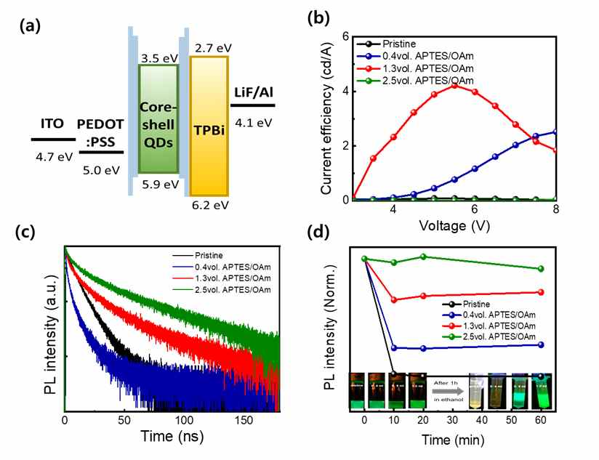
[Figure 2] (a) Energy level of core-shell perovskite quantum dot electroluminescent device and (b) device characteristics. (c) exciton lifetime and (d) chemical stability of core-shell perovskite quantum dots as a function of ligand ratio (addition amount).

GIST Senior Researcher Chang-Lyoul Lee said, "By developing a high-efficiency, high-stability core-cell perovskite quantum dot ink with a very thin silica shell, it was confirmed that a perovskite quantum dot electroluminescent device could be realized only by a solution process. It is expected that the commercialization of perovskite quantum dot materials will be accelerated in the future."

This research was led by Dr. Chang-Lyoul Lee (corresponding author) and conduced by Dr. Cuc Kim Trinh (first author) and Dr. Hanleem Lee (first author) with support from the Basic Science Research Program of National Research Foundation of Korea and the GIST Research Institute and was published on June 30, 2021, as a supplementary cover paper in ACS Applied Materials and Interfaces, which is a renowned academic journal in the field of materials.



