
Gwangju Institute of Science and Technology
Official Press Release — https://www.gist.ac.kr

Section of Dongsun Cho Nayeong Lee
Public Relations Section Chief Senior Administrator
062-715-2061 062-715-2062

Contact Person You Seung Su, Administrator
for this Article Section of Public Affairs
062-715-2025

Release Date 2021.06.09

GIST is 'World's Top 4' in science and technology research


□ In the '2022 QS World University Rankings' announced on June 9 (Korea time) by QS (Quacquarelli Symonds), a global university evaluation institution in the UK, GIST (Gwangju Institute of Science and Technology, President Kiseon Kim) was ranked 4th in the world and 1st in Korea for the 'Citations per Faculty' category.

∘ GIST was '2nd in the world' in 2016 QS and 2017 QS, '3rd in the world' in 2018 QS and 2019 QS, '5th in the world' in 2020 QS, and '4th in the world' for two consecutive year in 2021 QS and 2022. In terms of the number of citations per faculty, GIST has maintained its top position in Korea for 14 years, and is recognized for its world-class research capabilities.

□ The 'Citations per Faculty' category is also called the influence index, indicating how many papers other researchers have cited in their research. This year's 'Citations per Faculty' is a ranking based on the number of citations of papers published by a university from 2015 to 2020 divided by the total number of faculty. It is an index that can evaluate both quantity and quality.

∘ In particular, unlike evaluation categories in which the subjectivity of the survey respondents greatly affects the results, such as 'academic reputation' and 'reputation of graduates,' the average research performance of universities and their influence on other research in the field is evaluated as 'objectively.' It is considered the most reliable evaluation category in that it is presented as data.

□ The reason why GIST's research capabilities have been evaluated as world-class for several years is thanks to its efforts to attract researchers with excellent capabilities and create an optimal research environment for them to immerse themselves in research.

□ GIST President Kiseon Kim said, "GIST's remarkable research achievements are the result of the efforts and dedication of each student, professor, staff, and researcher in an optimal research environment. GIST will further grow into a model science and technology institute recognized by the nation and loved by the region by systematizing research innovation to improve research competitiveness and by establishing a science and engineering education innovation model that leads future education."

□ This year, the Indian Institute of Science ranked first in the category of 'Citations per Faculty,' followed by Princeton University and Harvard University, ranking second and third respectively, and GIST (Gwangju Institute of Science and Technology).

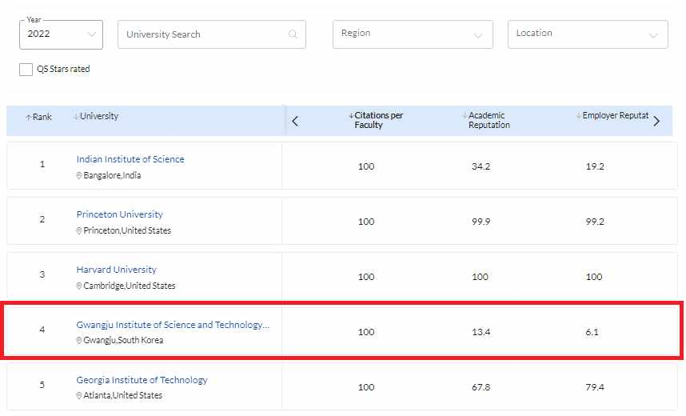
▲ Ranking for 'Citations per Faculty'

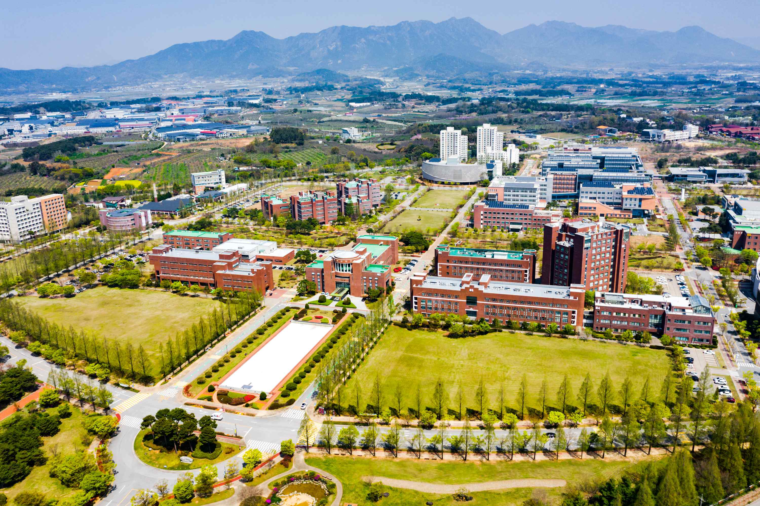
▲ GIST's campus view



