
Gwangju Institute of Science and Technology
Official Press Release — https://www.gist.ac.kr

Section of Dongsun Cho Nayeong Lee
Public Relations Section Chief Senior Administrator
062-715-2061 062-715-2062

Contact Person Kooksung Jun, Administrator
for this Article Health Care Robot Center
010-3837-6626

Release Date 2021.03.17

Professor Mun Sang Kim's research team developed a contactless gait analysis system based on artificial intelligence

□ GIST (Gwangju Institute of Science and Technology, President Kiseon Kim) Health Care Robot Center Professor Mun Sang Kim (School of Integrated Technology) succeeded in developing an artificial intelligence-based gait analysis system.



∘ The gait analysis system of this research team uses the RGB-D sensor that can acquire depth information of the object through the time it returns after sending the infrared beam. It is a practical system that dramatically complements the disadvantages of price and accuracy of current systems.

∘ Classification of cause of disease and long-term disease change can be accurately predicted through developed artificial intelligence technology. In particular, it is an ingenious system that can predict the possibility of a fall, which is of great concern to the elderly.

□ The research team realized more than 95% classification accuracy for six pathological gaits through deep learning-based big data analysis that inputs the acquired 3D skeletal information into recurrent neural networks.

∘ In particular, it was developed as a state-of-the-art system capable of autonomous service by attaching them to intelligent robots as well as sensor-only systems.

□ For this gait analysis system, the RGB-D sensor precisely measures the movement of all parts of the body while the subject naturally walks on the specified path. Through this study, a system using six RGB-D sensors, which was previously developed by the research team and installed and operated in the Gwangju Senior Citizenship Center, was eventually replaced with one sensor and was successful in practical use.

∘ From March of this year, it will be installed at Kosin University Hospital in Busan to analyze empirical data through data collection of more than 200 vestibular and orthopedic patients over the next three months. After completion, technology will be transferred to related companies.

□ GIST Professor Mun Sang Kim said, "I would like to contribute to healthcare R&D for the AI industrial complex construction project promoted by Gwangju Metropolitan City by installing additional systems in related hospitals in other regions."

□ This research achievement is the result of the Ministry of Trade, Industry and Energy's 'Development of Robot Technology for Stabilizing Emotional Behaviors and Enhancing Cognitive Functions in Patients with Mild Cognitive Disorder and Dementia' project conducted over the past four years, and two related SCI papers have been published.

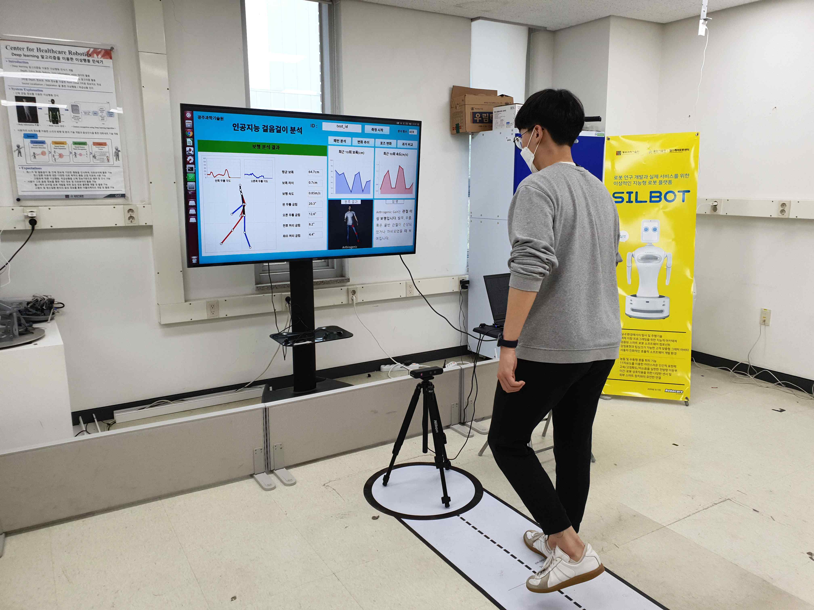
▲ Photo 1. Single-sensor gait analysis

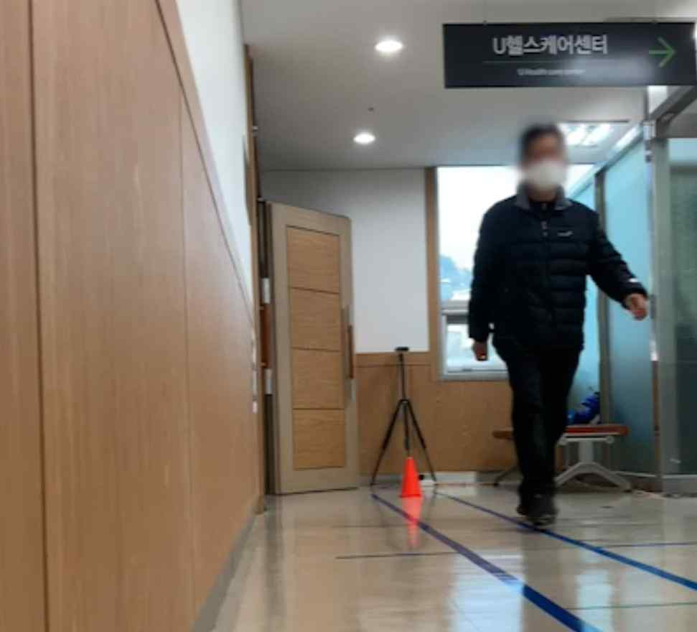
▲ Photo 2. On-site gait data collection at Kosin University

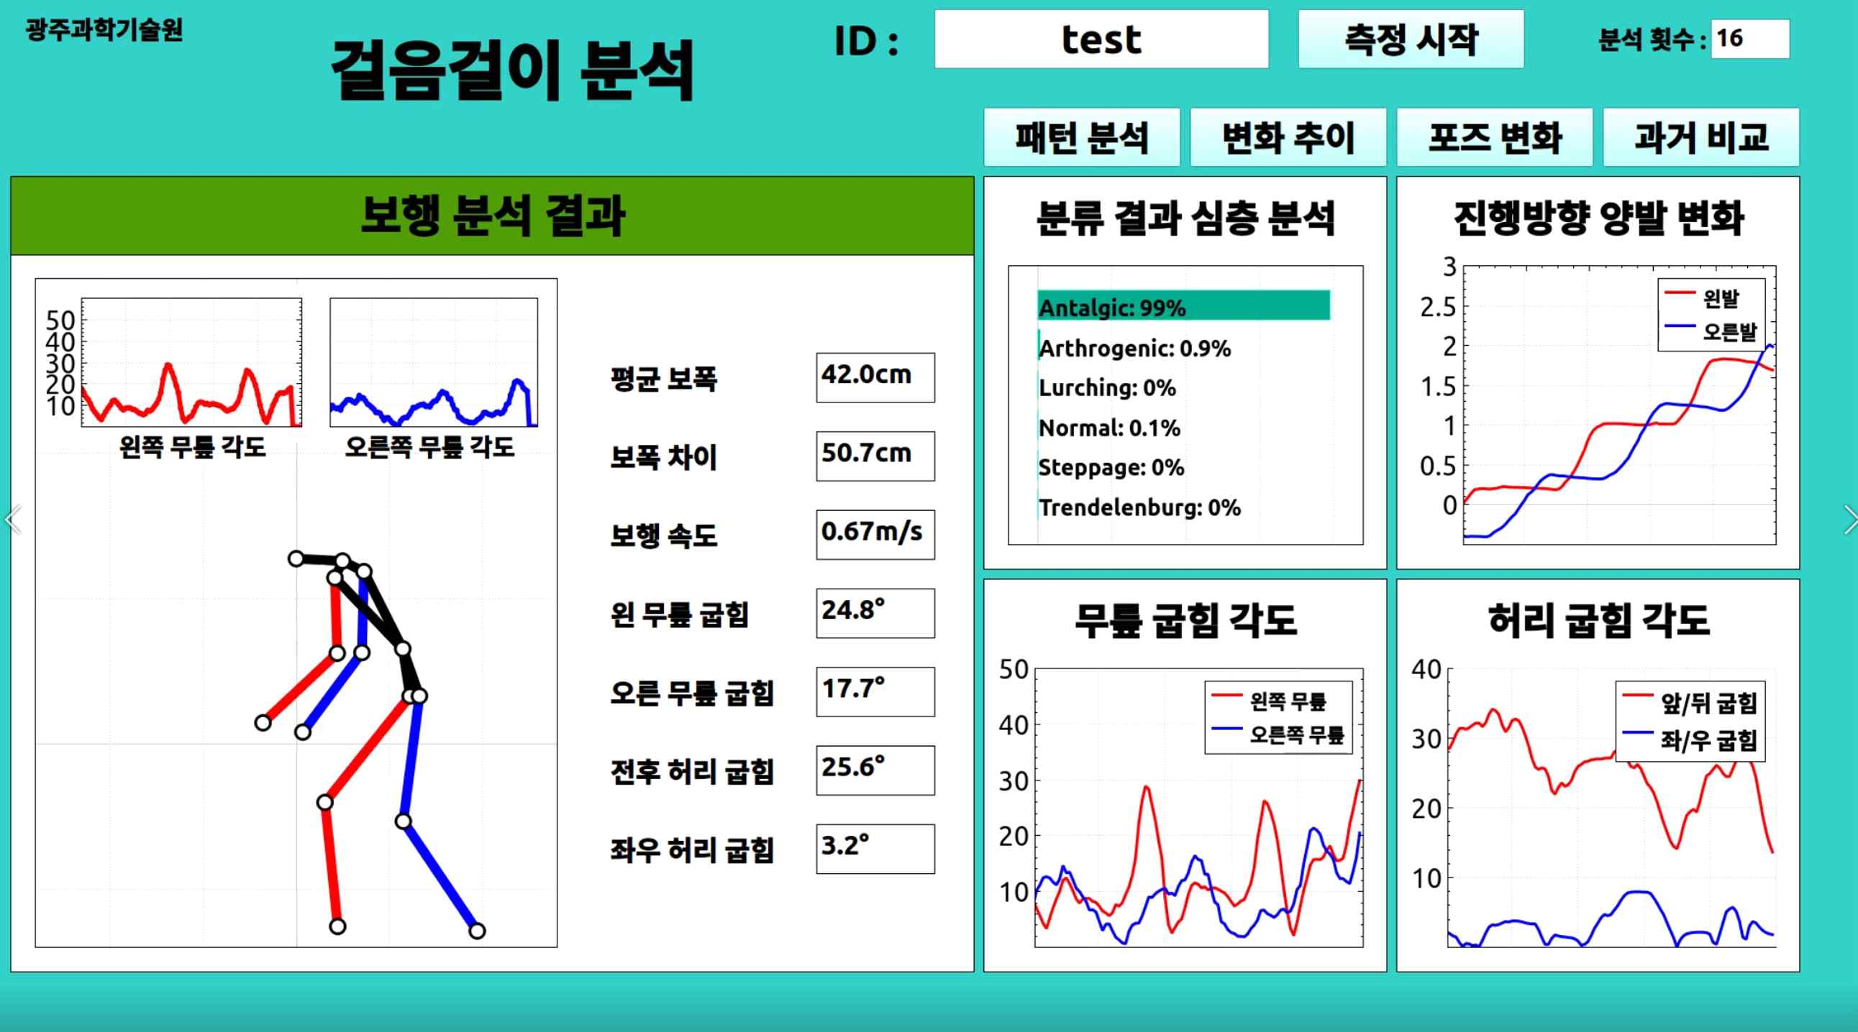
▲ Photo 3. Gait analysis results



