[2019 하반기(12월) 사이버 한국유학박람회 개최 안내]

교육부 국립국제교육원에서는 『2019 하반기(12월) 사이버 한국유학박람회』를 아래와 같이 개최합니다.
1. 행사명: 2019 하반기(12월) 사이버 한국유학박람회
2. 일자: 2019.12.10.(화) ~ 12.23.(월) <2주간>
* 등록: 2019.11.22.(금)~12.23.(월)
3. 주요메뉴소개
o 한국유학안내, 장학금제도, 대학정보, 온라인 입학신청, 온라인 상담, 실시간 상담 등
4. 참가대학: 53개교
5. 접속 및 참가방법(세부사항첨부파일참고)
O 한국유학종합시스템 웹사이트(www.studyinkorea.go.kr)에 접속하여 박람회 링크선택
O 등록(Registration) 후 박람회 기간 중 사이트방문

[The Second half of 2019(December) Study in Korea Online Education Fair]
It is our pleasure to announce that NIIED will hold “The Second half of 2019(December) Study in Korea Online Education Fair” for international students.
- Name of the event: The Second half of 2019(December) Study in Korea Online Education Fair
- Date: December 10th (Tue) ~ December 23th (Mon)
* Registration: November 22th(Fri) ~ December 23th (Mon)
3. Introduction of main contents
- Studying in Korea, scholarship programs, information about Korean Universities, online application, online consultation, Live Chat consultation
4. Participating universities: 53 universities
5. How to access and join the online education fair (Please see the attachment.)
- Visit the Study in Korea website (www.studyinkorea.go.kr) to select the online education fair link.
- Complete the registration and visit the website during the online education fair.
<Attachment>
How to register
“The Second half of 2019(December) Study in Korea Online Education Fair”
- Visit the Study in Korea website“www.studyinkorea.go.kr”
- Click “The Second half of 2019(December) Study in Korea Online Education Fair”
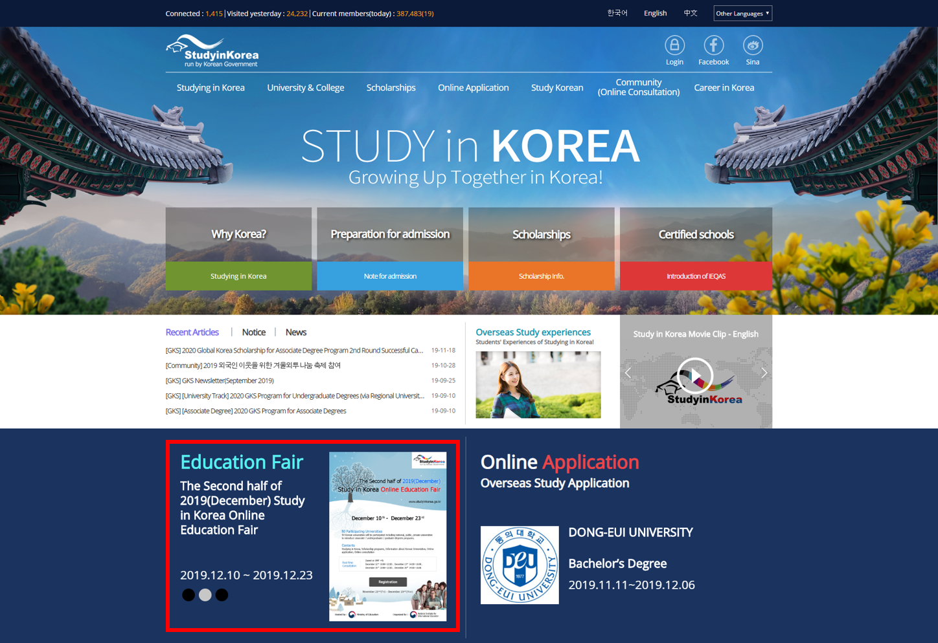
- Click “Registration” to join the Fair. “Registration” is available from Nobember 22th(Fri) ~ December 23th(Mon).
- Please visit the education fair page during the period of Nobember 22th(Fri) ~ ’20 January 6th(Mon). (Online consultation runs from December 10th (Tue) ~ December 23th (Mon))

