Translational Research in Polymer Science: Catalysts Development for Olefin Polymerization and CO₂/Epoxide Copolymerization

Bun Yeoul Lee
Department of Molecular Science and Technology, Ajou University, Suwon 443-749 Korea
bunyeoul@ajou.ac.kr

1) CO₂/epoxide copolymerization catalysts
A highly active catalyst was disclosed for the CO₂/propylene oxide (PO) copolymerization. It is a cobalt(III) complex prepared from a Salen-type ligand tethered by four quaternary ammonium salts, which adopts an unusual binding mode. The imine-nitrogens on the Salen-type ligand did not coordinate but, instead, the counter anions of the tethered quaternary ammonium coordinated to cobalt (1). Complex 1 showed a high TON up to 16000 and a high turnover frequency (TOF) of 16000 h⁻¹ that produced a strictly alternating copolymer with a high molecular weight (M_{n}) of up to 300000. These performances of 1 allow for constructing a pilot plant for continuous commercial process.

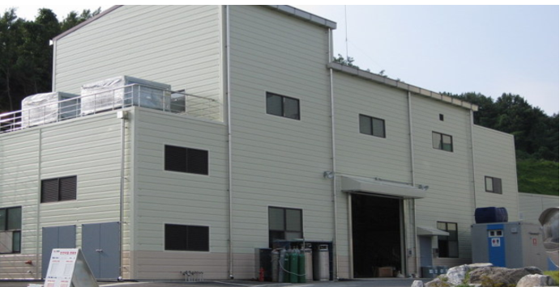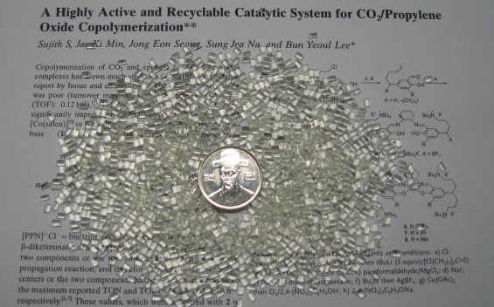

2) Olefin polymerization catalysts
We developed a synthetic route for o-phenylene-bridged (tetramethylcyclopentadienyl, indenyl, or fluorenyl)/amido titanium complexes. The complexes can be prepared in two steps in Kg-scale (eq. 1). Higher activity, higher α-olefin incorporation, and higher molecular weight than the CGC ([Me₂Si(η⁵-Me₄C₅)(N^{t}Bu)]TiCl₂) are achieved. These features enable the complex to be applicable in a commercial process.

Bun Yeoul Lee
Bun Yeoul Lee received his B.S., M.S. and Ph.D. (Supervisor, Y. K. Chung) from the Department of Chemistry, Seoul National University (1986-1994). After graduation, he worked for LG Chem for 5 years (1995-1999) on the development of polyolefin catalyst. He worked with G. C. Bazan at U.C. Santa Barbara as a post-doctoral researcher for 1.5 years. He has been an Assistant, Associate and Full Professor at Ajou University since 2001 to the present. His current research interests lie in the area of polymerization catalysts. He has published 80 original papers and 35 patents. He transferred the CO₂/epoxide copolymerization catalyst developed in his group to industrial sector (SK innovation) in 2008 with an affront fee of ~ half million dollar and 0.2% running royalty for sale. He also transferred the polyolefin catalyst to Honam Petrochemical Company in 2011 with a royalty of ~ half million dollar.

