Nano-Bio Mass Imaging Technology for Bio-applications

Tae Geol Lee
Center for Nanosafety, KRISS, Korea
tglee@kriss.re.kr

Time-of-flight secondary ion mass spectrometry (TOF-SIMS) imaging is a powerful technique for producing chemical images of small biomolecules (ex. metabolites, lipids, peptides) “as received” because of its high molecular specificity, high surface sensitivity, and submicron spatial resolution. In addition, matrix-assisted laser desorption and ionization time-of-flight (MALDI-TOF) imaging is an essential technique for producing chemical images of large biomolecules (ex. genes and proteins). For this talk, I will show that label-free mass imaging technique can be a platform technology for biomedical studies such as early detection/diagnostics, accurate histologic diagnosis, prediction of clinical outcome, stem cell therapy, biosensors, nanomedicine and drug screening [1-7]. In addition, I discuss the potential of using Ar₁₀₀₀⁺ as a primary ion beam in ToF-SIMS to be a key platform technique for metabolites and proteins analyses, together with tissue imaging. The Ar-cluster SIMS technique has the potential to be superior to MALDI-MS due to its matrix-free manner and high sensitivity to post-translational modification of proteins. The Ar-cluster SIMS could open up a new exciting era in ToF-SIMS studies for bio-applications.

References
[1] H. Min, Y. Kim, H. Yu, D. W. Moon, S. J. Lim, H.-J. Yoon, T. G. Lee, and S. K. Shin, Chem. Eur. J., 2008, 14, 8461-8464.
[2] Y.-P. Kim, E. Oh, Y.-H. Oh, D.W. Moon, T.G. Lee, H.-S. Kim, Angew. Chem. 2007, 46, 6816-6819.
[3] Y.-P. Kim, B. S. Lee, E. Kim, I. S. Choi, D. W. Moon, T. G. Lee, and H.-S. Kim, Anal. Chem., 2008, 80, 5094-5102.
[4] H.K. Shon, J. Park, I. Choi, H.M. Park, D.W. Moon, and T.G. Lee, J. Nanosci. Nanotech. 2011, 11(1), 638-641.
[5] H.J. Jung, H. Min, H. Yu, T.G. Lee, and T.D. Jung, Chem. Comm. 2010, 46, 3863-3865.
[6] H.J. Jung, I. Hwang, B.J. Kim, H. Min, H. Yu, T.G. Lee, and T.D. Jung, Langmuir, 2010, 26(19), 15087-15091.
[7] D. Hong, et. al., Langmuir, 2012, 28, 17-21.
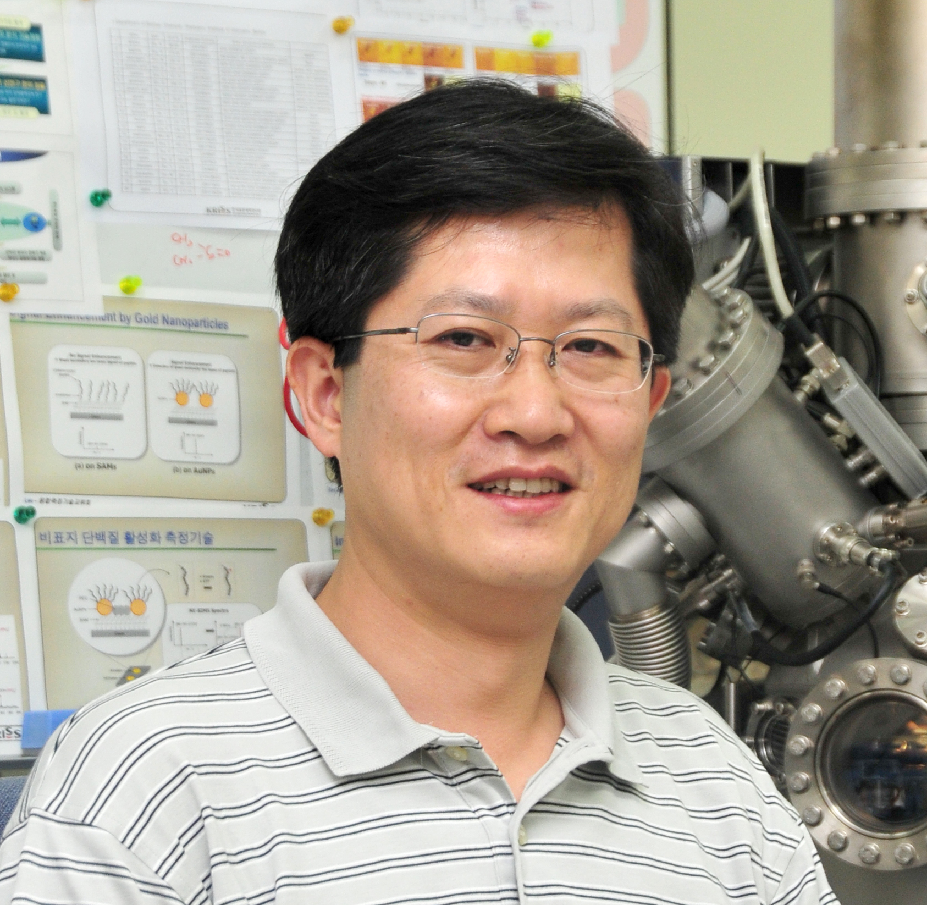

Dr. Tae Geol Lee
Tae G. Lee is a Principal Researcher at the Center for Nanosafety in the Korea Research Institute of Standards and Science (KRISS), and is the Project Manager of the Innovative Bio-Signal Analysis Technology Program and the Pioneer Research Program funded by the Ministry of Science, ICT & Future Planning (MSIP). Tae received his B.S. in chemistry, M.S. in physical chemistry and Ph.D. in physical chemistry from Seoul National University. His doctoral work involved the study of reaction dynamics by using tandem mass spectrometry and theoretical trajectory simulations. At the University of Toronto (Dept. of Chemistry), he was a member of group headed by Professor John Polanyi, which studied reaction dynamics of surface-aligned molecules by using time-of-flight mass spectrometry (TOF-MS). Since 2001, Tae has been at KRISS where he has been studying quantitative surface analysis/imaging of organic/bio-samples (bio-chips, cells and tissue, and nanoparticles, etc.) using ToF-SIMS, MALDI-TOF, XPS, MEIS and AFM techniques for medical applications and standardization. He has authored or co-authored more than 80 publications. He is an active member of the standard committee ISO/TC 229 (Nanomaterials) and works with medical doctors at the National Cancer Center, Severance Hospital and Seoul National Hospital.

Name  Tae Geol Lee | Institution  Center for Nanosafety, KRISS | Address  1 Doryong-Dong, Yuseong-Gu, Daejeon 305-340, Korea | Tel  +82-42-868-5129  Mobile  +82-10-3364-3304 | E-mail  tglee@kriss.re.kr

