Notice of the registration for the Winter Session of 2012

1. Duration of registration : 2012. 12. 27(Thur.) 9:00 ~ 12. 28.(Fri.) 23:59
2. How to register
ZEUS (https://zeus.gist.ac.kr) → Log in→ Register for Courses → Registration for Classes → 2012 Winter Session → Create → Choose(Look at the next page)→ Print out an application → Signed by a professor and an advisor → Submit an application to a Dept. office
3. Course registration request : Print out an application on the ZEUS after register.
4. Notice of classes: Refer to the attached files
5. Duration of modification: 2013. 1. 2.(Wed.) ~ 1. 8.(Tue.)
5. Duration of drop: 2012. 1. 9.(Wed.) ~ 1. 29.(Tue.)
6. Attention
- After registration, check your registered courses thoroughly.
- Limited credits are 6.
- If you drop a course, you will take the W record.

※ Contact us: Section of Academic and Student Affairs (☏ 2046, 2044),
※ Contact us: Section of Information Technology(☏ 2073, 2077),

Dean of Academic and Student Affairs

<New registration system>

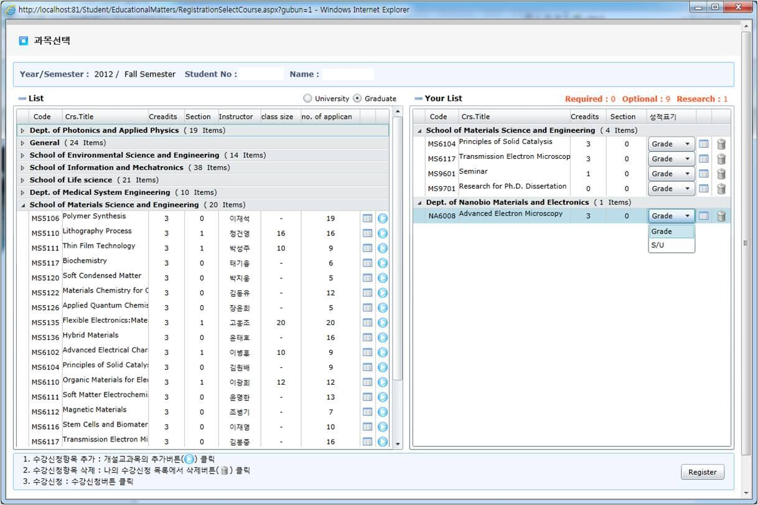

1. ZEUS(https://zeus.gist.ac.kr) → Log in → Register for Courses → Registration for Classes → 2012 Winter Session → Create → You can see this screen.
2. Find the subject you want in List and click the sky-blue button to add the subject to Your List, Click the wastebasket-shaped button to delete.
3. Click the calendar-shaped button to check details(syllabus, room etc.)
4. Click the Register button to confirm.

*sky-blue button:
*wastebasket-shaped button:
*calendar-shaped button:

