**World Friends Korea IT Volunteers Program 2025**

**Application Form**

If it is difficult to complete the application in one go, please note that you can exit and return later to continue and fill out the page again.

|  |
| --- |
| Please ensure that all necessary information is provided in the survey and submitted by midnight on **14th March 2025, according to Korean Standard Time (KST)**.  Once the surveys are collected, we will review and confirm organizations for the World Friends Korea IT Volunteers Programme in May. During the review process, we may contact you for additional inquiries, so please ensure that the contact details of the responsible person are provided.  If your organization is confirmed, the **National Information Society Agency (NIA)** will contact you before dispatching volunteers. |

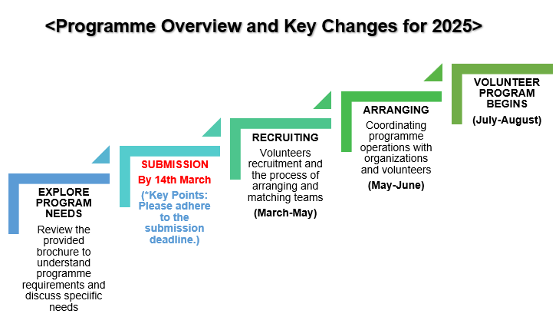

|  |
| --- |
| **< Programme Overview >**  The WFK IT Volunteer Corps organises two main types of volunteer activities. The activities are tailored and implemented according to the needs of each organization.   * **ICT Training:** Education through AI (Basic AI, Chat GPT, LLM, etc.), Programming (Arduino, Python, Scratch, etc.), Graphic Design (Photoshop, video editing, etc.), OA (Word, PowerPoint, Excel, etc.), and others. * **Korean culture**: Promoting Korean culture, including K-POP, K-DRAMA, and K-FOOD ※ Korean culture classes cannot be conducted independently and must be held in conjunction with ICT training   organised by each institution.   * **NOTE** : All classes are conducted in English, so trainees must have proficient communication skills. If needed, a coordinator can assist with interpretation between Korean, English, and the local language to improve learning effectiveness. |

|  |
| --- |
| **< Key Changes for 2025 >**   1. **Expansion of the minimum team size for each country's local volunteer programme (from at least 1 team to at least 3 teams)**  * Until last year, it was possible to submit volunteer requests for at least 1 team (4 members) per country. However, starting from 2025, the plan is to operate a minimum of 3 teams (approximately 12 members) per country. * The person responsible is kindly requested to confirm whether it is possible to accommodate 3 or more teams for volunteer activities by seeking cooperation from other institutions or improving the local volunteer environment when completing the application form.  1. **Activities related to ICT Projects have been discontinued.**  * ICT projects*, which were carried out based on the preferences of institutions until last year, have been excluded from the IT volunteer programme activities starting in 2025 due to constraints such as the short duration of volunteer periods and the difficulty in verifying the outcomes.   **\* [Definition]** ICT Projects: Volunteer activities involving website building, mobile app development, and other ICT-related projects (such as improving student ID systems, diabetes patient classification, visualisation projects, etc.). |

**<Volunteer Team Structure>**

|  |
| --- |
| Each dispatched team consists of 4 members and is responsible for one training subject. Each institution is kindly requested to prepare to accommodate at least 3 classes. These classes can be offered either as multiple sessions of the same IT subject or as separate IT courses, each covering a different topic, depending on the programme planning of the local dispatched volunteer teams. |

|  |
| --- |
| **A.** **Checklist for Volunteer Accommodation Capacity** |

|  |
| --- |
| In IT training, typically one team (usually consisting of 4 volunteers) is responsible for one class.  If a minimum of three different educational programs are requested, at least 3 teams (approximately 12 people) will visit the institution to conduct the classes.  **※ NOTE**  It is also possible to deploy a total of 3 or more IT volunteer teams. For example, if the institution can accommodate 5 teams (approximately 20 people), 5 subjects can be requested. However, please consider the capacity for additional personnel, such as local coordinators, when calculating the total number of people that can be accommodated.  Organizations able to deploy three or more IT volunteer teams will be prioritized in the selection process. Organizations applying with one or two teams may be placed in lower priority in the selection process. |

**Accommodation Capacity**

**A1.** Is your organization prepared and willing to **accommodate three or more IT volunteer teams**?

1) Yes

**※ NOTE**

Organizations able to deploy three or more IT volunteer teams will be prioritized in the selection process. Organizations applying with one or two teams may be placed in lower priority in the selection process.

**A2.** If *" No, but we can recommend candidate organizations within the same local area (within a 20km radius*" is selected above, **please provide recommendations for organizations within the same city** (within a 20 km radius of your organization). : 미응답

|  |  |  |
| --- | --- | --- |
| *Organization Name* | *Contact person* | *Email* |
|  |  |  |
|  |  |  |

|  |
| --- |
| **B. Checklist for Available Resources for On-Site Dispatch** |

**※ NOTE**

Please fill out **ALL** fields of interest below and indicate which areas in each field your organization would like to receive training on.

**Accommodations for VolunteersB1.** **Is your organization able to provide accommodations?** 2) No

**B2.** [B1=2 응답자] **If not, please check available accommodations.**  3) Hotel

**B3. Cost of accommodations** (for entire stay) 2) per week USD : 130

**※** Note: Please specify whether cost is per day, week, or month.

**B4. Distance from Office** (Approx.) : __6 _ km

**B5. [Daily transportation to Office]** **Is your organization able to provide transportation?** 1) Yes

**Risk Assessment**

**B6. What kinds of hazards is your organization prone to?** 9) none

**※** Note: Please check all hazards to which your organization is prone.

**B7.** **Available emergency procedures or drills.** 9) none

**B8.** **Frequency of emergency drills per month** 1) Do not conduct emergency drills

**If volunteers are dispatched to your organization, it will be mandatory for the organization to conduct emergency drills concerning all hazards for the volunteers.**

I understand and agree to conduct emergency drills for the volunteers.

**B9. Distance from Office and Available Emergency/Rescue Services** (approx.)

|  |  |
| --- | --- |
|  | Distance |
| 1) Health service room/nurse’s room | 4km |
| 2) Hospital | 6km |
| 3) Fire Department | 6km |
| 4) Police Department | 6km |
| 5) Onsite security office | 6km |

**B10.** **Is your organization capable of providing a Safety Manager?** 1) Yes

**B10-1.** [B10=1응답자] **Number of Safety Manager** 2) 2

**※** NOTE

The Safety Manager's primary role is to prevent accidents and unauthorized departures of volunteers. They are responsible for monitoring potential risks on-site and intervening to prevent dangerous behaviors, ensuring the safety and well-being of all volunteers under their supervision.

|  |
| --- |
| **C. Demand for Training Courses** |

|  |
| --- |
| IT volunteers provide education through **AI** (Basic AI, Chat GPT, LLM, etc), **Programming** (Arduino, Python, scratch, etc.), **Graphic design** (Photoshop, Video editing, etc.), **OA** (Word, PowerPoint, Excel, etc.), and Others.  **※ NOTE**  Please fill out **ALL** fields of interest below and indicate which areas in each field your organization would like to receive training on. |

**C1. [Volunteer Type] Preferred Type of Volunteer Teams** 1) On-Site

**※** NOTE

Although you select the 'On-Site' type, it may be transitioned to the 'Online' type depending on the circumstances

[C1 = 1 응답자] **[On-Site] Capacity and topics**

**C2. [Volunteer Teams] Desired number of volunteer teams (1 class per 1 team)** 3) 3

**C3. [Training Level & Topic] Preferred IT Training topics and number of students per class**

Note: Please match the number of groups to the number of selected volunteer teams.   
(e.g, if you request 3 volunteer teams, you need to provide details for 3 classes in the table.)

|  |  |  |  |
| --- | --- | --- | --- |
| **Class Name** | **Level** | **Topic** | **Number  of trainees** |
| Class A | 2) Intermediate | 3) Graphic design | 30 |
| Class B | 2) Intermediate | 1) AI | 30 |
| Class C | 1) Basic | 3) Graphic design | 30 |
| Class D |  |  |  |
| Class E |  |  |  |

[C1 = 1 응답자] **[On-Site] Training Environment**

**C4. Device** 1) Laptops

**C5. How many trainees per device** 3) 3 to 5 trainees

**C6. Network (Internet) Availability** 3) Participating in video conferences (e.g., Zoom)

4) Uploading/Downloading large files (100MB or more)

5) None of the options are available

**C7. Number of coordinators able to assistance.**  2) 1

[C1 = 1 응답자] **[On-Site] Trainee**

**C8. Expected trainees** 5) 50 or more

**C9. Expected group** 1) Students

**C10. Expected age** 2) 11 ~ 15

**C11. Expected trainees level**

|  |  |
| --- | --- |
| **C11-1.  ICT Knowledge** | 2) Intermediate |
| **C11-2. English proficiency** | 2) Intermediate |

|  |
| --- |
| **D. Cultural Exchange Program** |

**D1과 D2 한페이지 제시, D3와 D4 한페이지 제시**

|  |  |
| --- | --- |
| **D1. [Our Side]**  **Request for Korean cultural experience** | 1) Yes |
| **D2. [D1=1응답자] Topics** | 1) K-Pop, 2) K-Food, 3) K-Culture, 4) Korean |
| **D3. [Your Side]**  **Availability to prepare a cultural exchange program** | 1) Yes |
| **D4. [D3=1응답자] Topics** | 2) Foods, 3) Cultures, 4) Languages |

|  |
| --- |
| **E. Applicant's Basic Information** |

|  |  |  |  |
| --- | --- | --- | --- |
| **Name of Country** | *(Official full name of Country)*  Lao PDR | **Capital City** | *(full name)*  Vientiane |
| **National Language** | Lao | | |

**Organization**

|  |  |  |
| --- | --- | --- |
| **Name of Organization** | *(Official full name)*  Vangvieng Ethnic school | |
| **Type of Organization** | 5) High School 6) University  7) Public sector 8) Private sector  9) NGO 10) Other ( ) | |
| **Address of Organization** | Vangvieng | |
| **Description of Organization** | *(Briefly describe your organization’s main activities as well as history, size, role, etc.)*  Secondary school | |
| Website | None |

**Coordinator for Volunteers (Main Contact Point)**

|  |  |
| --- | --- |
| Name | *(full name)*  2) Ms. Toula |
| Position | English teacher |
| English proficiency | 2) Intermediate |
| Mobile | *(including country code)*  (+856) 209-519-967 |
| Office | *(including country code)*  (+856) 209-519-967 |
| Email | *(provide two emails, if available)*  Mail 1: TJtoula1991@gmail.com |
| SNS | 1) WhatsApp |
| ID: Tou02095199679 |

**Responsible Person(Management and Decision-making)**

|  |  |
| --- | --- |
| Name | *(full name)*  2) Ms. Toula |
| Position | English teacher |
| Mobile | *(including country code)*  (+856) 209-519-967 |
| Office | *(including country code)*  (+856) 209-519-967 |
| Email | *(provide two emails, if available)*  Mail 1: TJtoula1991@gmail.com |

**Preferred Program Schedule**

|  |
| --- |
| **1. Duration :** 2) 3 weeks  **※ NOTE**  This is a short-term volunteer program, so the duration can only be within one month. It includes the entire duration of the Preferred Training Program. |
| **2. Start Week**  3) July Week 3    **※ NOTE**  The program must be completed within the months of July and August. It is not possible to proceed with the program in September. |

|  |
| --- |
| **F. Photo Attachments (REQUIRED)** |

**F1. Pictures of your organization (full view)**

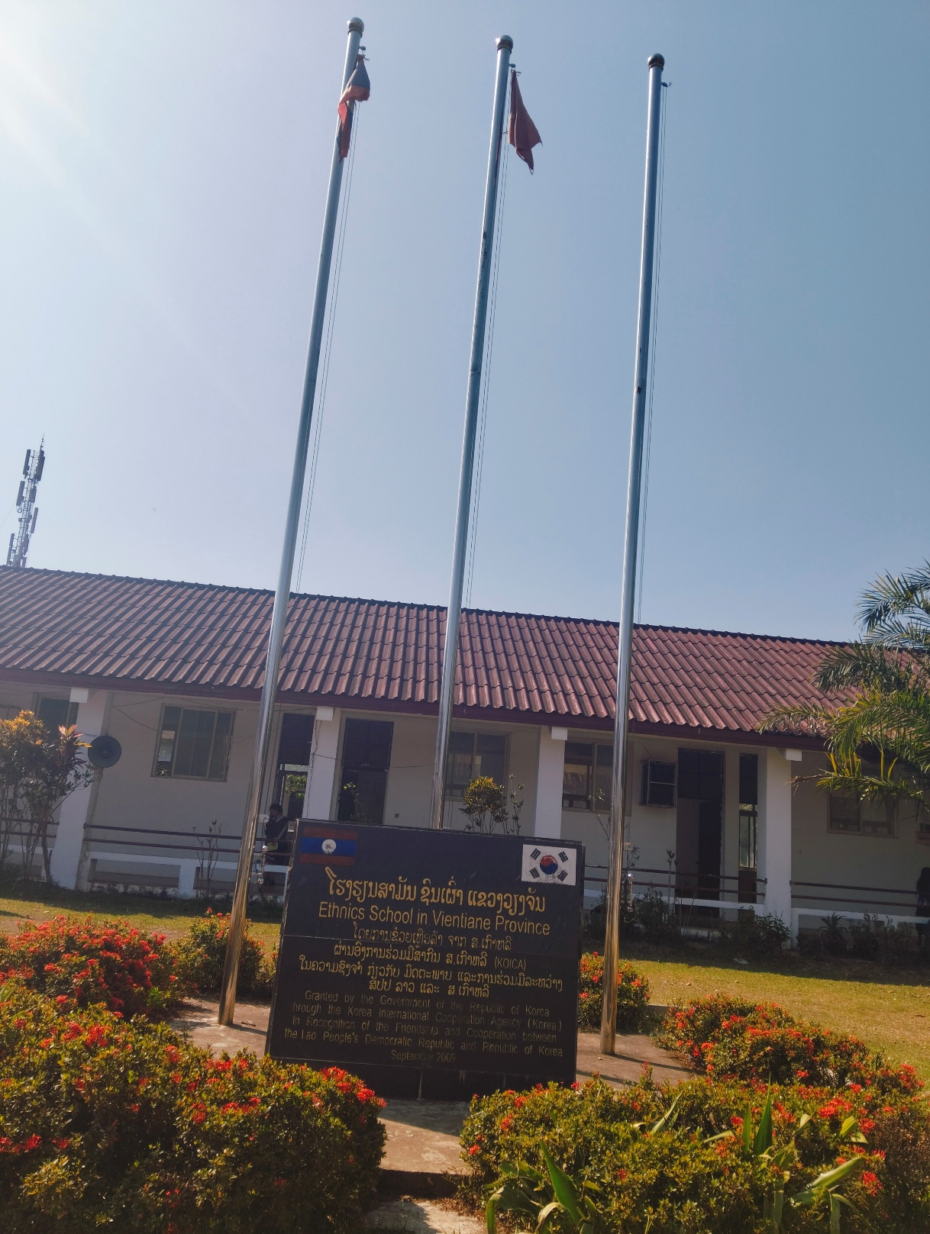

**F2. Pictures of the expected ICT project or training facility**

**F3. Pictures of Internet and computer facilities at your organization**

|  |
| --- |
| **I confirm that the information provided in this survey is accurate and truthful. I understand that any inaccuracies may affect the selection process for the 2025 World Friends Korea IT Volunteers from our organization.**양식의 맨 위  **_________________________________________**  (Institution Director’s Printed Name and Signature) |

**We appreciate your participation.**

**Contact**

If you have further questions, please feel free to contact us at any time.

National Information Society Agency (NIA)

Department of Global ICT Cooperation

Global Academy

Email. kiv@nia.or.kr